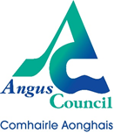
CPCO Forum

Information Session with the Children with Disabilities Team

Venue: Microsoft Teams

Wednesday 10th May 2023 from 4 – 5pm

Aims of Session

- Raise awareness of the Children with Disabilities Team and the services they provide.
- Consider the agreed definition of disability by Angus Council and planning partners.
- Raise awareness of referral criteria and how to refer.

Event hosts
Kim Anderson, Team Leader – Children with Disabilities Team
Fiona Milne, Senior Practitioner – Child Protection

Follow the link to book your place

https://www.eventbrite.co.uk/e/cpco-forum-information-session-with-the-children-with-disabilities-team-tickets-557676263717

