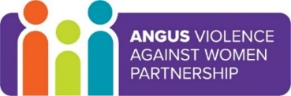
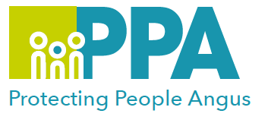

Angus Violence Against Women (AVAWP) Training Event
White Ribbon Angus - Speaker Training
Monday 6 March 2023 13:00-16:30 & Friday 10 March 2023 10:00- 13:00

The White Ribbon campaign is a male-led campaign against gender-based violence. The campaign recognises that most men do not commit violence against women, but all men have a role to play in ending it.

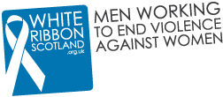

To become a recognised White Ribbon area in Angus, we plan to demonstrate that we are making every effort to spread the messages of the campaign and ask as many people as we can to sign the White Ribbon Pledge:

‘I pledge never to commit, condone or remain silent about violence against women in all its forms.’

We are delighted to have White Ribbon Scotland join us in March to offer speaker training to those interested in the Angus Campaign.

The speaker training covers;

An introduction to violence against women
How to be an ‘active bystander’ and challenge language or behaviour which excuses or encourages violence against women
How to talk to men about violence against women and give short talks in workplaces or community venues

The speaker training will take place via zoom over 2 half days.
Monday 6th March 1300 - 1630 & Friday 10th March 1000 -1300.

We are looking to get as many Angus ‘speakers’ trained up as possible and are looking for people from all council departments, health & emergency services, third sector organisations, community groups, schools and the general public to attend this training and help spread the messages of the campaign throughout Angus communities.

For more information on the White Ribbon Campaign, please visit;
https://www.whiteribbonscotland.org.uk/

To book a place on the training please use the Eventbrite link below: https://www.eventbrite.co.uk/e/white-ribbon-angus-speaker-training-tickets-547527959867

