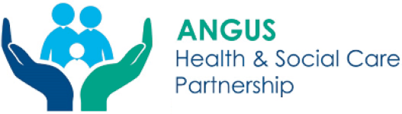

Angus Adult Protection Committee
Adult Protection Day 2023

Safeguarding Adults at Risk: A Case Study from Angus Community Mental Health service
Wednesday 15 February 2023 2.30pm – 3.30pm
via MS Teams

The session will be delivered by social work staff from the Community Mental Health Services in Angus. This session will look at the interplay of different services to address issues raised under Adult Support and Protection Legislation to safeguard a vulnerable individual. During this session we hope to encompass the complexities of this case and the decision-making process that was implemented in safeguard this individual.

Please note this is not a session regarding mental health specifically but is looking at the intricacies of a case with various concerns and potentially multiple types of abuse. The case will be anonymised for the purpose of this session.

This session aims to:
- Highlight and discuss the different competing factors in engaging adults with ASP legislation.
- Undertake a case study from the CMHS perspective and
- highlight issues that are apparent in adults engaged with CMHS and the impact this has on safeguarding them.
- Highlight the role of legislation in the safeguarding of vulnerable adults

The session will include an opportunity to ask questions.

This training is open to all multiagency staff working in Angus.
Please use the link below to book a space:

https://www.eventbrite.co.uk/e/safeguarding-adults-at-risk-a-case-study-from-acmhs-tickets-528497067957

