
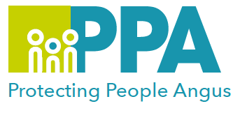
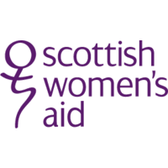

Angus Violence Against Women (AVAWP)
Training Event
Shifting Our Practice – Making Perpetrators Visible and Accountable
Tuesday 28 February 2023
1pm - 3.30pm via MS Teams

Gender inequality is a root cause of violence against women and girls. Gender-based violence is committed disproportionality by men against women and covers a range of violence and abuse.


Scottish Women’s Aid will lead the training.

“Making perpetrators visible…. holding perpetrators accountable” commendable aims in many domestic abuse policies and approaches, but what does this actually mean, and how can it be achieved? What if your role does not involve working directly with the perpetrator? How can you contribute to keeping the perpetrator in the frame, ensuring perpetrators are visible and recognised as accountable for the entirety of their actions, impacts and harms?

This session will explore how good documentation and use of domestic abuse informed language can be pivotal role in securing good, safe outcomes that ensure the focus is on the perpetrators risk and responsibility for harm they pose to children and families not the survivor and their perceived ‘failure to protect’.

This training is open to all multiagency staff that work in Angus.

To book a place on the training:
Eventbrite use the link below
https://www.eventbrite.co.uk/e/shifting-our-practice-making-perpetrators-visible-and-accountable-tickets-506258602107

