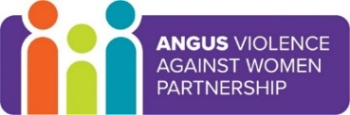
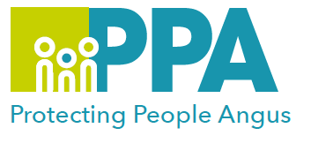
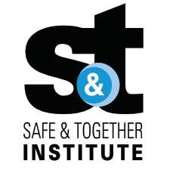
Angus Violence Against Women (AVAWP)
Good Practice in Domestic Abuse and Safe & Together Principles
Multi-Agency Learning Events on MS Teams

Gender inequality is a root cause of violence against women and girls. Gender-based violence is committed disproportionality by men against women and covers a range of violence and abuse.
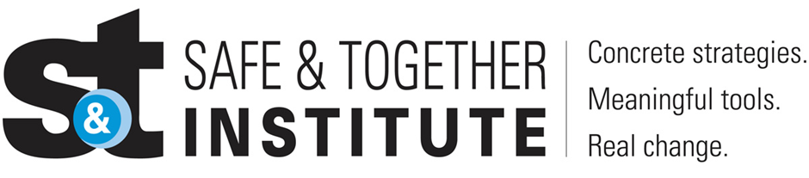

The Safe and Together model provides a framework for working in partnership with the non offending parent; while holding the perpetrator accountable to achieve better outcomes for families. https://safeandtogetherinstitute.com/

Event hosts
Angus Safe and Together Champions.

Learning outcomes
- To understand how Good Practice in Domestic abuse applies in Angus services.
- To learn about the principles of Safe and Together.

Audience
This multi-agency learning session will be ideal for any worker in Angus who may come into contact with survivors in the course of their work.

To book a place on the training:
Monday 13 February 2023 11am-12.30pm: https://www.eventbrite.co.uk/e/good-practice-in-domestic-abuse-and-safe-together-principles-tickets-504358348397

Wednesday 5 April 2023 9.30am-11am: https://www.eventbrite.co.uk/e/good-practice-in-domestic-abuse-and-safe-together-principles-tickets-504370173767

Wednesday 7 June 2023 2.30pm-4pm: https://www.eventbrite.co.uk/e/good-practice-in-domestic-abuse-and-safe-together-principles-tickets-504372721387

Tuesday 15 August 2023 1pm-2.30pm: https://www.eventbrite.co.uk/e/good-practice-in-domestic-abuse-and-safe-together-principles-tickets-504373624087

Monday 23 October 2023 2pm-3.30pm: https://www.eventbrite.co.uk/e/good-practice-in-domestic-abuse-and-safe-together-principles-tickets-504374617057

Friday 8 December 2023 11am-12.30pm: https://www.eventbrite.co.uk/e/good-practice-in-domestic-abuse-and-safe-together-principles-tickets-504375389367

