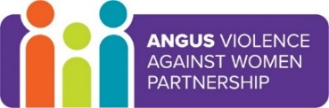
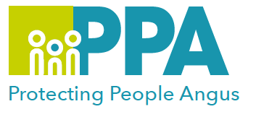
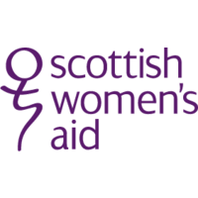

Angus Violence Against Women (AVAWP)
Training Event
Domestic Abuse (Coercive Control) - Impact on Children and Young People
Tuesday 21 February 2023
10am - 12.30pm via MS Teams

Gender inequality is a root cause of violence against women and girls. Gender-based violence is committed disproportionality by men against women and covers a range of violence and abuse.


Scottish Women’s Aid will lead the training.

Learning Outcomes
- Understanding through theory, research and survivor testimony how children and young people experience domestic abuse
- Understanding the physiological impacts of domestic abuse on children, and how to mitigate this as professionals
- Knowledge of how domestic abuse impacts on the child’s relationship with the abusing parent and the non-abusing parent, and the role children take in this family dynamic
- Supporting children and young people experiencing domestic abuse
- Introduction to the key concepts of the Safe and Together Model
- Understand the possible impact of domestic abuse in young people’s own relationships
This training is open to all multiagency staff that work in Angus.

To book a place on the training:

Eventbrite use the link below
https://www.eventbrite.co.uk/e/domestic-abuse-coercive-control-impact-on-children-and-young-people-tickets-506230558227

