
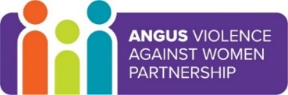
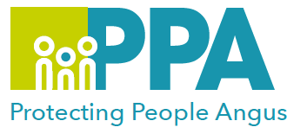

Angus Violence Against Women (AVAWP)
Training event
Tuesday 29 March 2022
10:00 – 11:30
via MS Teams
Introduction to Commercial Sexual Exploitation

Gender inequality is a root cause of violence against women and girls. Gender-based violence is committed disproportionality by men against women and covers a range of violence and abuse.
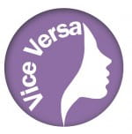



Dundee and Angus Womens’ Rape & Sexual Abuse Centre is a member of AVAWP. They are a specialist agency in Angus that offers a free, confidential service to all women that live in Dundee or Angus.
They have a Dundee and Angus Young Survivors Project that provides support to anyone aged 11 to 18 who lives in Dundee or Angus who has experienced sexual abuse of any kind.

Trainer
Jenna Lawrence will lead the training.

Learning outcomes
This training aims to:
- Define CSE,
- Outline the law around CSE
- Identify the impact of CSE
- Describe the Vice Versa and Click services

Audience
This is introductory training is open to all multiagency workers who work in Angus.
It is for workers and placement students who want to find out more about Commercial Sexual Exploitation and who may be supporting women who are at risk of or currently involved in Commercial Sexual Exploitation.

To book a place on the training contact: https://www.eventbrite.co.uk/e/introduction-to-commercial-sexual-exploitation-tickets-272860863187

