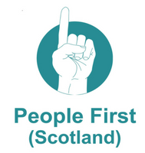
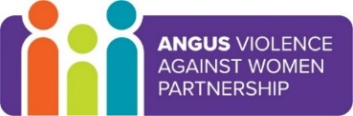
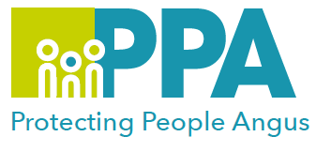
Angus Violence Against Women (AVAWP) Training event
Thursday 24 March 10:30-12:00
Thursday 31 March 10:30-12:00
via MS Teams

The experience of gender based
violence for women with a learning disability
Gender inequality is a root cause of violence against women and girls. Gender-based violence is committed disproportionality by men against women and covers a range of violence and abuse.


People First (Scotland) works for the human rights of people who have the labels of Learning Disability or Intellectual Impairment. People First (Scotland) is a disabled people’s organisation (DPO) and is controlled by its members who all have a Learning Disability.
We give people with learning disabilities a voice. We meet in local groups and discuss issues that are important to us. We give each other advice, support and campaign to improve the lives of people with learning disabilities.

Trainer
People First

Learning outcomes
- Greater understanding of what a learning disability is
- Increased awareness of the lived experiences of adults with a learning disability
- Recognise and understand the factors that make women and girls with learning disabilities more at risk
- How to support and work with women with learning disabilities who experience gender based violence

Audience
This training will be for workers who want to have an informed approach to their work and who might be meeting and working with clients and service users who have experienced sexual violence, and also have a learning disability.

Places can be booked on Eventbrite as follows:
24/03/2022 – https://www.eventbrite.co.uk/e/angus-violence-against-women-avawp-training-event-tickets-275600216667

31/03/2022 - https://www.eventbrite.co.uk/e/angus-violence-against-women-avawp-training-event-tickets-275603717137

