
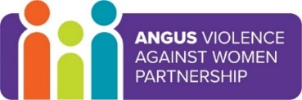
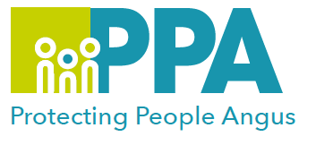

Angus Violence Against Women (AVAWP)
Training event
Monday 14th March 2022
1pm – 3pm
via MS Teams
Young People and Pornography

Gender inequality is a root cause of violence against women and girls. Gender-based violence is committed disproportionality by men against women and covers a range of violence and abuse.


Dundee and Angus Womens’ Rape & Sexual Abuse Centre is a member of AVAWP. They are a specialist agency in Angus that offers a free, confidential service to all women that live in Dundee or Angus.
They have a Dundee and Angus Young Survivors Project that provides support to anyone aged 11 to 18 who lives in Dundee or Angus who has experienced sexual abuse of any kind.

Trainer
Lauren McLachlan, WRASAC Prevention Worker, will lead the training.

Learning outcomes
There will be focus on the realities of the porn industry and its links to violence against women, the impacts the porn industry has on people (particularly younger generations) and the wider societal impacts. There will be real life examples and case studies included in the training. Please note that some of the content in this training can be particularly distressing and to be mindful of this before signing up.

Audience
This training is open to multiagency professionals who work in Angus.

Places can be booked as follows:
Resourcelink: Angus Council staff only

Eventbrite use the link below
https://www.eventbrite.co.uk/e/young-people-and-pornography-tickets-229359690007

