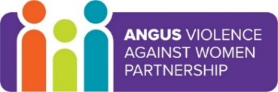
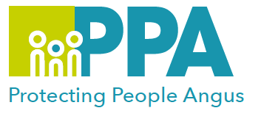
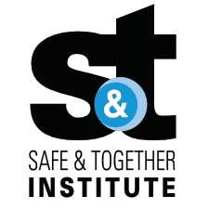

Angus Violence Against Women (AVAWP)
Good Practice in Domestic Abuse and Safe & Together Principles
Multi-Agency Learning Events on MS Teams
Wednesday 16th March 2022 3.30pm – 5pm

Gender inequality is a root cause of violence against women and girls. Gender-based violence is committed disproportionality by men against women and covers a range of violence and abuse.
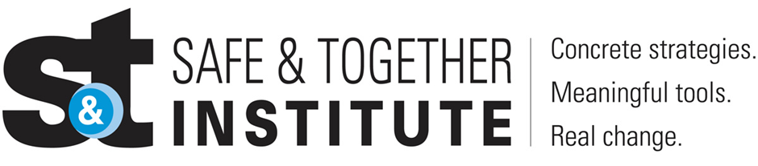

The Safe and Together model provides a framework for working in partnership with the non offending parent; while holding the perpetrator accountable to achieve better outcomes for families. https://safeandtogetherinstitute.com/

Event hosts
Angus Safe and Together Champions.

Learning outcomes
- To understand how Good Practice in Domestic abuse applies in Angus services.
- To learn about the principles of Safe and Together.

Audience
This multi-agency learning session will be ideal for any worker in Angus who may come into contact with survivors in the course of their work.

To book a place on the training:

https://www.eventbrite.co.uk/e/good-practice-in-domestic-abuse-and-safe-together-principles-tickets-217608090657

