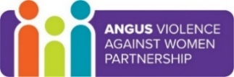

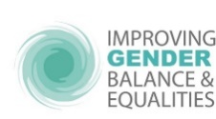

Springing the Gender Trap –
Improving Outcomes for Everyone

“The problem with gender is that it prescribes how we should be, rather than recognising who we are” – Chimamanda Ngozi Adichie, author

Gender stereotypes, bias and inequality impact all of us, whether we recognise it or not. This training programme is a safe space to explore our thoughts and experiences around gender. We will support you to recognise stereotypes; consider the impact of them throughout life and to explore ways we can think, feel and act differently to improve outcomes for ourselves and the people around us.

The training is run over 3 sessions, each 90 minutes long.
Participants need to attend all 3 sessions.

The aims of the sessions are to:
- recognise gender stereotypes and bias for boys & girls; men and women
- understand the short - and long- term impacts of gender stereotypes and bias on children and young people, including learning; work; relationships ...
- support participants to think and act differently in relation to gender

Sessions:
- Session 1 Gendered Assumptions and Culture
- Session 2 Gendered Language and outcomes for girls/boys; men/women
- Session 3 What next – what do we need to do differently?

Dates:
- Thurs 17 Feb 2022 16:00 to 17:30
- Thurs 24 Feb 2022 16:00 to 17:30
- Thurs 03 Mar 2022 16:00 to 17:30
The trainers for this programme are Mhairi Brodie, Education Scotland and Linzi McKerrecher, NHS Tayside.

This training is open to all workers and volunteers in Angus.

Places are booked via Eventbrite: https://www.eventbrite.co.uk/e/springing-the-gender-trap-improving-outcomes-for-everyone-tickets-213489903047

