
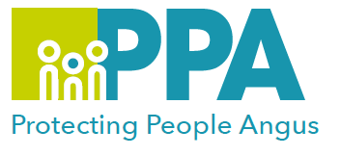

Angus Violence Against Women (AVAWP)
Training event
Wednesday 2 February 2022
10am – 12.30 pm
via MS Teams
Domestic Abuse (Coercive Control) and the Law

Gender inequality is a root cause of violence against women and girls. Gender-based violence is committed disproportionality by men against women and covers a range of violence and abuse that includes domestic abuse (coercive control).

The trainer for this session will be by Marianne Osborne from Renfrewshire Women’s Aid.

Marianne Osborne has worked with Renfrewshire Women’s Aid since 2002 as a refuge worker, supporting women, children and young people subjected to domestic abuse. She has been delivering training and awareness raising on Domestic Abuse and other forms of gender-based violence since 2004 locally on behalf of RWA and Renfrewshire’s GBV Strategy Group. Nationally, Marianne is an associate network trainer for Scottish Women’s Aid delivering to a range of multi-agency partners, including Social Work, Health, Caledonia Programme and Women’s Aid workers.

The learning outcomes from the session are to understand the following:
- To introduce and understand the Domestic Abuse (Scotland) 2018 Act, and its implementation
- Exploration of the Police Scotland disclosure system
- To understand the barriers to survivors to reporting under domestic abuse legislation
- To introduce public sector duties and what the Act means for practitioners
- To understand how civil and criminal legislation on domestic abuse interacts and where the gaps lie
This training is open to all multiagency staff that work in Angus. You need to have already undertaken learning which has given you a basic understanding of the dynamics of domestic abuse.

To book a place on the training:

Eventbrite use the link below
https://www.eventbrite.co.uk/e/domestic-abuse-coercive-control-and-the-law-tickets-213688667557

