
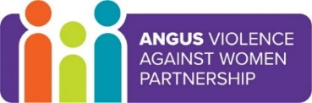
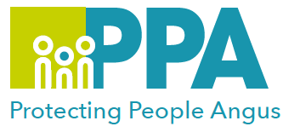

Angus Violence Against Women (AVAWP)
Training event
Tuesday 8th February 2022
10.30am – 12noon
via MS Teams
Introduction to trauma (sexual violence)

Gender inequality is a root cause of violence against women and girls. Gender-based violence is committed disproportionality by men against women and covers a range of violence and abuse.


Dundee and Angus Womens’ Rape & Sexual Abuse Centre is a member of AVAWP. They are a specialist agency in Angus that offers a free, confidential service to all women that live in Dundee or Angus.
They have a Dundee and Angus Young Survivors Project that provides support to anyone aged 11 to 18 who lives in Dundee or Angus who has experienced sexual abuse of any kind.

Trainer
Gillian Ross - WRASAC

Learning outcomes
Learn, about psychological trauma and how it affects people. Be able to explore how someone with trauma might present in their own workplace. Learn about the work of WRASAC through a case example. Start to consider how this knowledge can help them in their work. Explore how trauma and working with people affected by trauma can impact workers. Look at self-care and the broader issues that may impact them in their workplaces.

Audience
This training will be for workers who want to have a trauma informed approach to their work and who might be meeting and working with clients and service users who have experienced sexual violence. It is not for those working therapeutically with survivors.

To book a place on the training:

Eventbrite use the link below
https://www.eventbrite.co.uk/e/introduction-to-trauma-sexual-violence-tickets-229357884607

