

Angus Adult Protection Committee
Adult Protection Day 2022 Learning Input
Thursday 17th February 2022
2pm – 3pm
via MS Teams
NHS Tayside Adult Protection Team

The NHS Tayside Adult Protection Team are members of the Angus Adult Protection Committee. The team has recently expanded to include additional staff members and this session is an opportunity to meet your Angus team and hear about their roles.

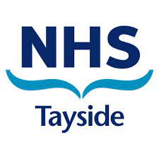

The NHS Tayside Adult Protection Team will lead the session.

This training is open to all multiagency staff working in Angus.

To book a place on the training contact: https://www.eventbrite.co.uk/e/ap-day-2022-nhs-tayside-adult-protection-team-tickets-245708188807

