

Angus Adult Protection Committee
Adult Protection Day 2022 Learning Input
Thursday 17th February 2022
10am – 1130am
via MS Teams
Police response to Adult Support and Protection incidents in residential care and hospital settings

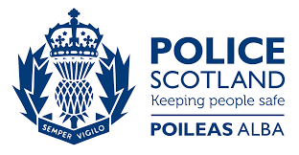

Key Learning Points:
-Police involvement in Adult Support and Protection measures
-Reporting to the police
-Actions that may be taken in care facilities and hospital settings
-Brief overview of capacity
-Opportunity for Q+A

Police Scotland, Adult Support and Protection Officers will lead the session.

This training is open to all multiagency staff working in Angus.

To book a place on the training contact: https://www.eventbrite.co.uk/e/ap-day-22-police-response-to-asp-incidents-in-residential-care-hospitals-tickets-245712632097

