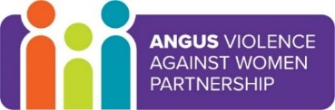
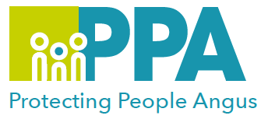

Angus Violence Against Women (AVAWP)
Multi-Agency Learning Events on MS Teams
Wednesday 8 December 2021 2pm – 3pm

‘An Audience with Kirsty and Jordan’. A conversation about Children and Families; Justice; Domestic Abuse; Partnerships; and Professional Journeys……

Event hosts
Lisa McMahon, Jordan Burns and Kirsty Boyd

Learning outcomes
- To hear about partnership working across teams
- Time for Q&A

Audience
This multi-agency learning session will be ideal for any worker who may come into contact with families and domestic abuse within their role.

To book a place on the training
https://www.eventbrite.co.uk/e/an-audience-with-kirsty-and-jordan-tickets-189689314847

