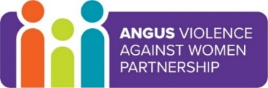

Angus Violence Against Women (AVAWP)
Multi-Agency Learning Events on MS Teams
Q&A with Chair and Lead Officer of Angus Violence Against Women Partnership
Tuesday 7th December 2021 11.30am – 12.30pm

Angus Violence Against Women Partnership (AVAWP) is the multi-agency forum to deliver on Equally Safe: Scotland’s strategy for preventing and eradicating violence against women and girls at a local strategic level. No single partner alone has the resource, skill or reach to achieve the aims of Equally Safe and it is only through strong partnership working that this can be achieved.

The national Violence Against Women Partnership Guidance is designed to promote an effective and strategic approach to reducing violence against women and its negative impact on individuals and communities and support local partnerships to develop effective local strategies and activities in keeping with Equally Safe to tackle violence against women and girls in all its forms. The guidance notes 6 minimum standards that Local VAWPs are expected to work towards and identifies the core activities that all VAW partners will be expected to undertake.

Event hosts
Ewen West, Independent Chair, Angus Violence Against Women Partnership
Niki McNamee, Lead Officer, Angus Violence Against Women Partnership

Learning outcomes
- An opportunity to broaden your knowledge an understanding of AVAWP by attending an open session with the Independent Chair and Lead Officer.

Audience
This multi-agency learning session will be ideal for any worker who may come into contact with victims/survivors/perpetrators in the course of their work.

To book a place on the training:

https://www.eventbrite.co.uk/e/q-a-with-chair-and-lead-officer-of-angus-violence-against-women-partnersh-tickets-190902734217

