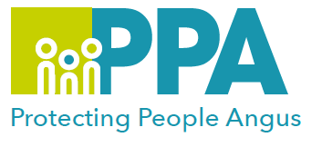
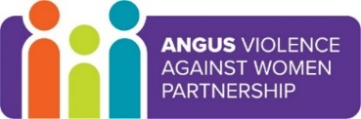
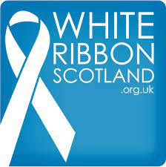
Angus Violence Against Women (AVAWP)
White Ribbon Status Campaign in Angus
Multi-Agency Learning Events on MS Teams
Monday 6th December 2021 4pm-5pm

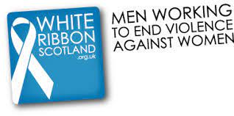
What is White Ribbon Scotland?
White Ribbon Scotland is a campaign to involve men in tackling violence against women
https://www.whiteribbonscotland.org.uk/

In Angus during 16 Days of Action, and into 2022 we will be asking men to sign up to “Pledge never to commit, condone or remain silent about violence against women in all its forms”.

Most men in Scotland are not violent towards women, but many of us ignore the problem or see it as something that has nothing to do with us. A simple first step you can take is to sign our personal pledge.

Come along to hear more about White Ribbon, the pledge and how you can help begin to end GBV within Angus.

Event host
Laura Findleton, AVAWP Development Worker

Audience
This multi-agency learning session will be ideal for any male who wants to pledge towards ending GBV in Angus or anyone who wants to hear more about the campaign.

To book a place on the training
Monday 6th December 2021 4pm-5pm
https://www.eventbrite.co.uk/e/white-ribbon-status-campaign-in-angus-tickets-188493387797

