
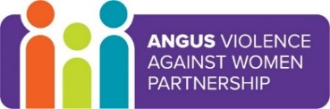
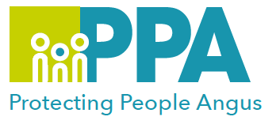

Angus Violence Against Women (AVAWP)
Training event
Tuesday 9th November 2021
1pm – 2.30pm
via MS Teams
WRASAC Advocacy Service and the Criminal Justice System

Gender inequality is a root cause of violence against women and girls. Gender-based violence is committed disproportionality by men against women and covers a range of violence and abuse.


Dundee and Angus Womens’ Rape & Sexual Abuse Centre is a member of AVAWP. They are a specialist agency in Angus that offers a free, confidential service to all women that live in Dundee or Angus.
They have a Dundee and Angus Young Survivors Project that provides support to anyone aged 11 to 18 who lives in Dundee or Angus who has experienced sexual abuse of any kind.

Trainer
A WRASAC advocacy worker will lead the training.

Learning outcomes
To give an overview of WRASAC’s Advocacy service including the National Advocacy Project which we are part of and explain our role.
Provide an overview of the Criminal Justice process and discuss some of the challenges for survivors in accessing this.

Audience
This training is open to multiagency professionals who work in Angus.

To book a place on the training contact:
https://www.eventbrite.co.uk/e/wrasac-advocacy-service-and-the-criminal-justice-system-tickets-180861390287

