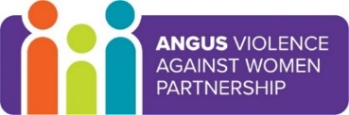
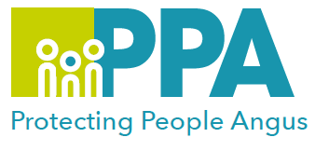
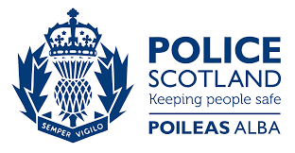

Angus Violence Against Women (AVAWP)
Multi-Agency Learning Events on MS Teams
Monday 6th December 2021 various times

11am – 11.30am – The role of the Domestic Abuse Liaison Officer (DALO)

11.30am – 12noon - Disclosure Scheme for Domestic Abuse Scotland (DSDAS)
The Disclosure Scheme for Domestic Abuse Scotland aims to provide a way of sharing information about a partner’s abusive past, with a potential victim. It gives people at risk of Domestic Abuse the information needed to make an informed decision on whether to continue the relationship. Professionals have an important part to play in this.

The Disclosure Scheme for Domestic Abuse Scotland has two main triggers for disclosure – the Right to Ask and the Power to Tell.

1.30pm – 2pm – The role of Sexual offences Liaison officer

Event hosts
Police Scotland, Public Protection Unit

Learning outcomes
- To understand the police roles within domestic abuse in Angus.
- To learn about the Disclosure Scheme for Domestic Abuse Scotland (DSDAS) and how to access this in Angus.

Audience
This multi-agency learning session will be ideal for any worker who may come into contact with victims/survivors/perpetrators in the course of their work.

To book a place on the training:
11am – 11.30am - Role of the Domestic Abuse Liaison Officer (DALO)
https://www.eventbrite.co.uk/e/the-role-of-the-domestic-abuse-liaison-officer-dalo-tickets-188410118737
11.30am – 12 noon - Disclosure Scheme for Domestic Abuse Scotland (DSDAS)
https://www.eventbrite.co.uk/e/disclosure-scheme-for-domestic-abuse-scotland-dsdas-tickets-188415695417
1.30pm – 2pm – The role of Sexual offences Liaison officer
https://www.eventbrite.co.uk/e/the-role-of-sexual-offences-liaison-officer-tickets-188418062497

