


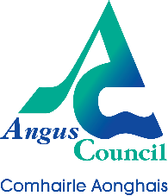

Date: 2 sessions available in November 2021
Wednesday 17th 2pm - 3pm
Tuesday 23rd 12pm - 1pm

Topic: Corporate Parenting and The Promise
Spaces: 30 per session
Reserve a place: 17/11/2021: https://www.eventbrite.co.uk/e/corporate-parenting-and-the-promise-tickets-203908895997
23/11/2021: https://www.eventbrite.co.uk/e/corporate-parenting-and-the-promise-tickets-203915716397
Venue: Microsoft Teams
Angus Council Corporate Parenting Board and Horizons Team are hosting joint sessions on Microsoft Teams to explore:
-What throughcare and aftercare are
-What services Horizons can offer
-What it means to be a Corporate Parent
-How does being a Corporate Parent fit with ‘The Promise’

Care Experienced Young People in Angus
Feed your knowledge through
bite-sized learning

