Suicide Prevention is Everybody’s Business

Tayside Wellbeing and Suicide Prevention - Virtual Learning & Development Event
Tuesday 23 November 2021: - 09:00 – 12:30

Who is the event for: It is inclusive and aimed at ALL Tayside organisations and partners, whether you have any knowledge around suicide or not.
It is an opportunity to hear about, National and Local Suicide Prevention work including current research, learning and outcomes that are specific to suicide prevention.
Additionally, it’s an opportunity to contribute to future plans and shape suicide prevention work within Tayside.
What needs to be done/ what would help you contribute/ what support is needed for change?

The Program:
- Details of current research on the affects of suicide on society, friends and family.
- Update from the National Suicide Prevention Team
- COVID-19, wellbeing and suicide in 2021 - what do we know?
- What works to prevent suicide?
There will be facilitated discussion to capture feedback and views that reflect the changes we can make in our communities and organisations.

How to book and access: Please email: - alan.clark2@nhs.scot and you will be provided with a link to access the event.

Suicide is preventable: to reduce suicide deaths in Tayside EVERYONE must play their part.

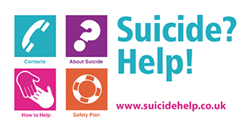
(Visit the website or Download the free app)

