Creating an Internet Down Receipt-https://tags.txdmv.gov/receipts

Internet down receipts are issued when the internet or the application is down. These receipts must be printed prior to the application being unavailable. After printing an internet down receipt, it must be kept in a safe and secure location. The internet down receipt must be manually completed prior to providing a plate to a customer. An internet down receipt must be assigned to a vehicle, purchaser, and license plate when the application becomes available.

- Select the Internet Down Receipt from the Plates tab.
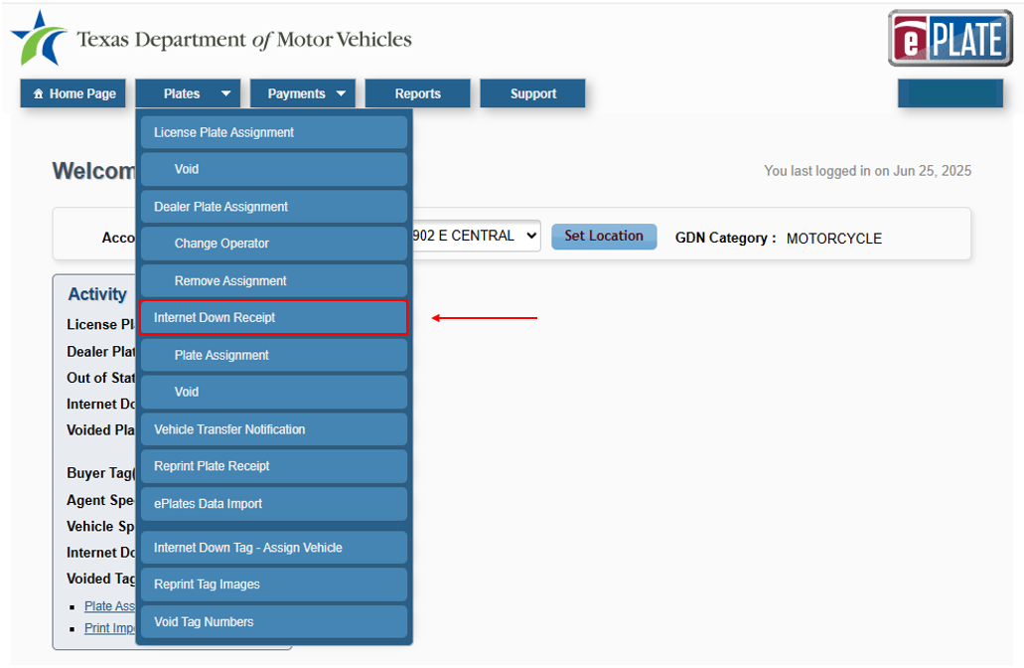
- The application displays the Internet Down Receipt page.
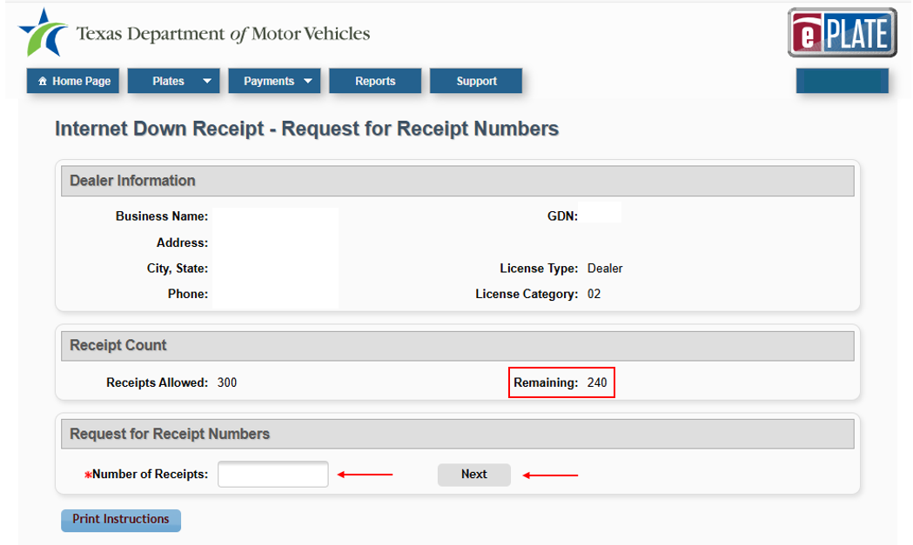
- Ensure the number of remaining receipts is greater than 0.
- Enter the number of receipts equal to or less than the number of remaining receipts. Then click Next.
- The application displays the Internet Down Receipts – Print Receipts page.
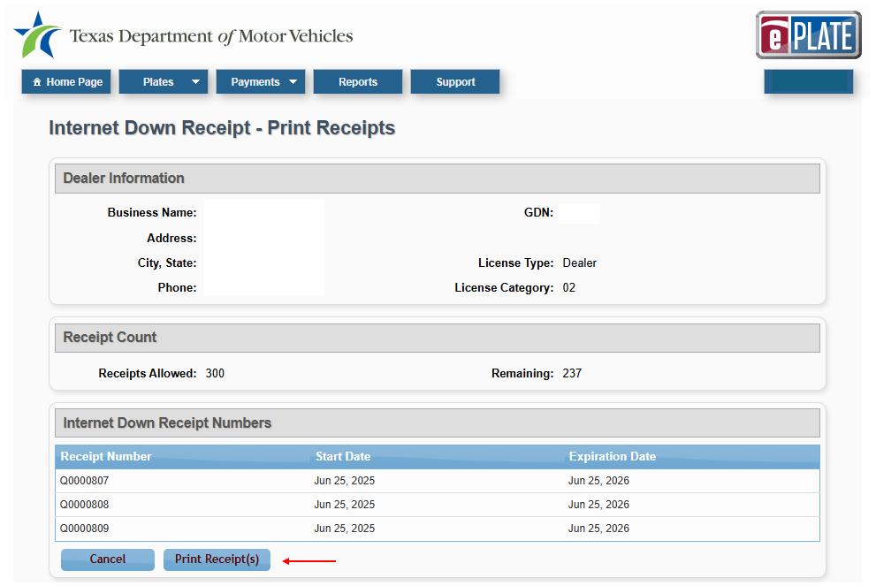
- Print receipts by selecting Print Receipt(s)
- Manually enter the required information in both the Dealer and Buyer copy of the receipt.
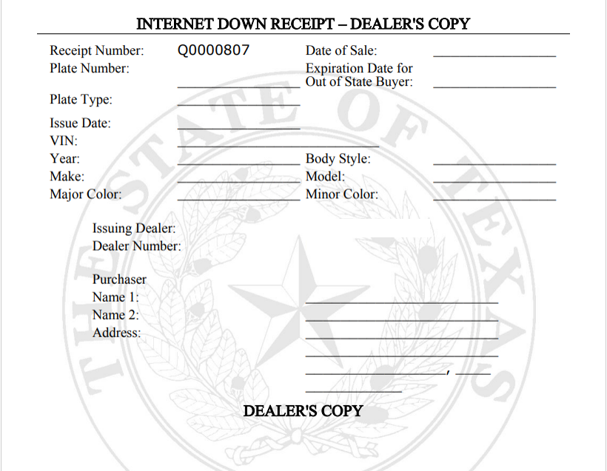
- Provide the customer with the Buyer copy and the license plate for the transaction conducted. Keep the Dealer copy. If an incorrect license plate for the transaction conducted was provided to the customer, it is the dealer’s responsibility to retrieve the incorrect plate and assign a correct plate. This can be decided once the application becomes available via the plate assignment process.

Assigning an Internet Down Receipt - ePLATE
When the application becomes available, you will access ePLATE to complete the assignment. An Internet Down Receipt must have been previously issued to be assigned. This process is completed when the Internet Down Receipt number has been assigned to a specific vehicle, purchaser, and plate number in the application. During the completion process, you will complete the same information as required by the License Plate Assignment process. Upon completing the assignment process, the Internet Down Receipt will be restored to the dealerships’ Internet Down Receipt inventory, allowing the dealership to have a continuous Internet Down Receipt supply. Once you have assigned an Internet Down Receipt, you can begin a title application in webDEALER.

- Select the Internet Down Receipt – Plate Assignment process from the Plates tab.
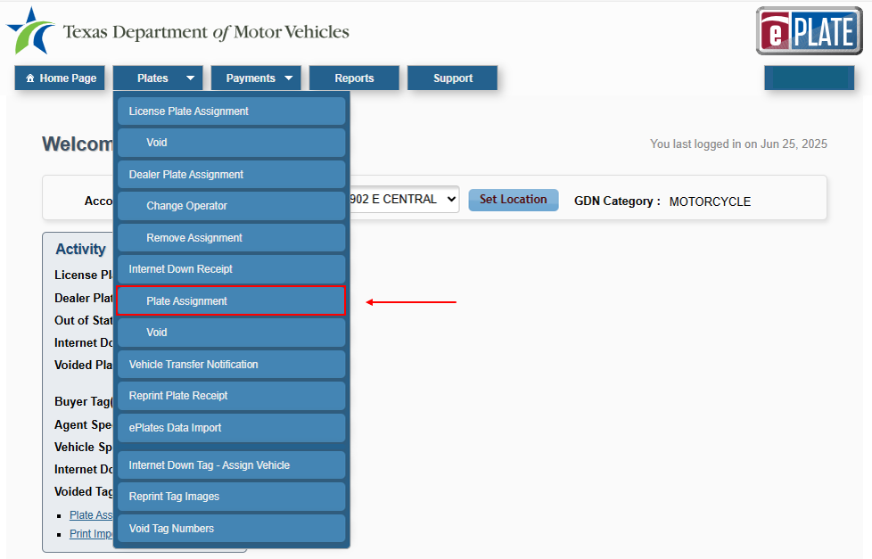
- The application displays the License Plate Assignment – VIN Search page.
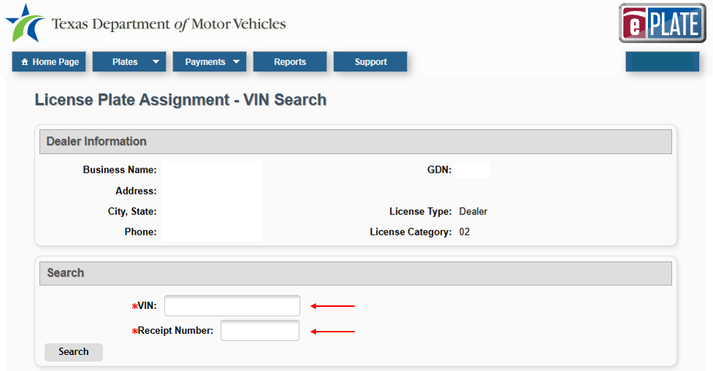
- Enter vehicle VIN and Internet Down Receipt number.
- Select search and complete the License Plate Assignment process.

