Please click on the report title for Week/Month – to -date Fees Report
Then Enter Report Selection criteria and click Finish.
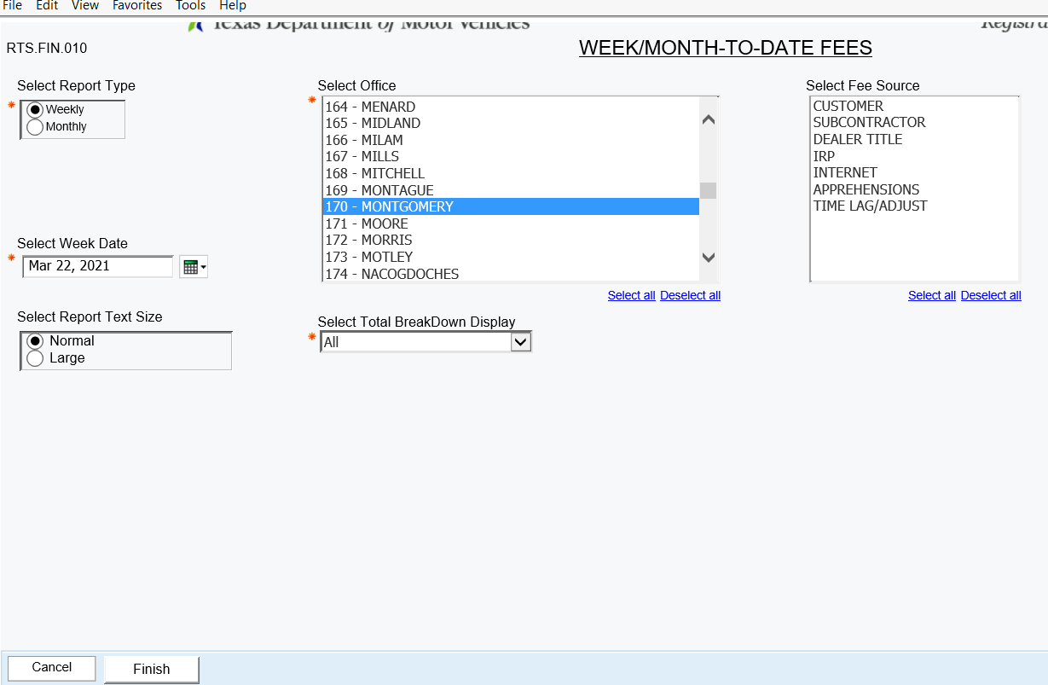
While the report is running you will see the following options

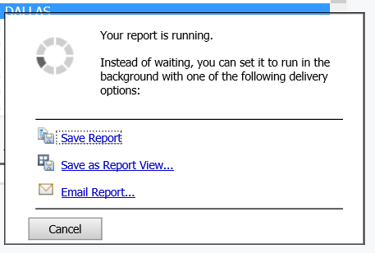
Please select Email Report. You will have an option to enter your email. Select OK for the report to be delivered to your inbox.
