

Registration and Title System

Point of Sale  
County Release Notes

Release 9.7.0

06/20/2020

Contents

1 Legislative Change in RTS POS 9.7.0 4

1.1 Original Title 4

1.2 Corrected - Original Title 10

1.3 Correct Title Rejection 11

1.4 Stolen Transaction 12

1.5 Non-Titled Transaction 14

2 Enhancements in RTS POS 9.7.0 15

2.1 Permit Error Message in RTS 15

2.2 Permit Error Message in webPERMITS 16

2.3 Cash Register Receipt for Multiple Transactions 16

2.4 The Form VTR-331-INS Available on the Ownership Evidence List 17

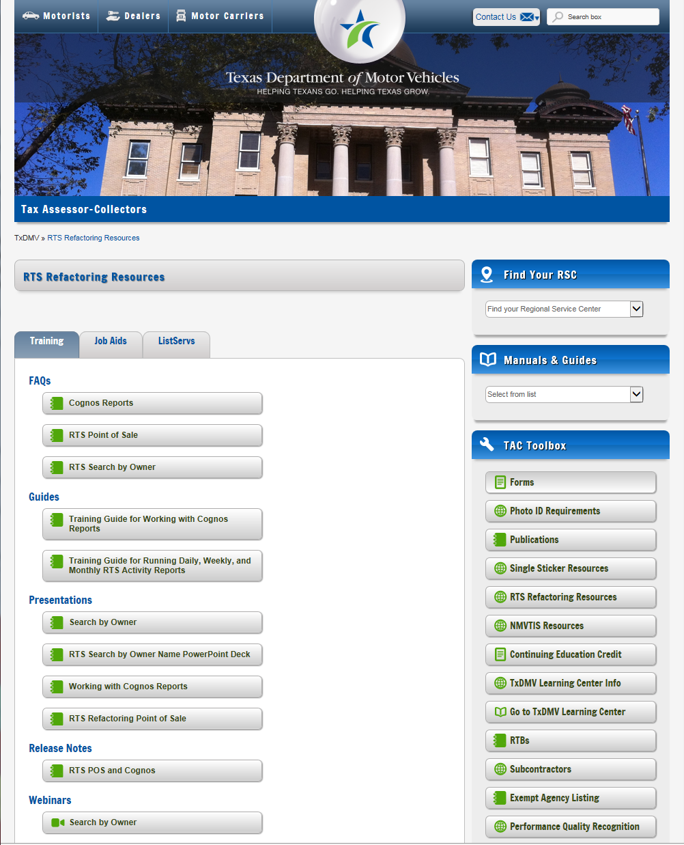About the Release

These Release Notes contain information about new features, enhancements, and reported issues resolved in this release of the Registration and Title System Point of Sale (RTS POS).

For more information about the RTS POS, refer to the **Online Help** and to the original Release Notes on the RTS Refactoring Resources page of the TAC Hub ([www.txdmv.gov/tax-assessor-collectors](http://www.txdmv.gov/tax-assessor-collectors)).

RTS POS Overview

The refactored RTS POS is a web-based application designed to process vehicle registrations, titles, and temporary permits for Texas motorists through a series of web pages. The RTS POS system provides functions for cash accounting, funds allocations, and a full audit trail along with inventory control for license plates, windshield/plate stickers and temporary permits.

The RTS POS application displays when you log in to the RTS workstation.

To display reference information about using the RTS POS, click  in the upper right corner of the web browser to minimize the application and click the  RTS Refactoring Help icon on your desktop.

The RTS Refactoring Resources page (on the TAC Hub) displays FAQ documents composed of questions submitted by the county tax offices, as well as materials presented during RTS POS webinars (including the training guides, slide decks for presentations, and other recorded webinar sessions). The original Release Notes are also available on this page.

Click the **Job Aids** tab to locate important quick references to help you log in and work with the RTS POS.

When logged in to the RTS POS, you can get specific application level help by clicking Help on the page you are viewing or the entire user assistance web site by selecting **Help** > **User Guide** on the main page action bar.

**NOTE:** It is important to visit this Resources page frequently for updates and new materials.

# Legislative Change in RTS POS 9.7.0

**HB 1755** requires a person to apply for title and registration for a newly assembled vehicle.

|  |  |
| --- | --- |
| 20448 | **Previous:** In RTS, assembled vehicles were not identified or tracked beyond the vehicle make.  **Change:** A **Newly Assembled** checkbox is now available in the Title/Registration event for Original (including Stolen) and Corrected-Original transactions and the Correct Title Rejection event. The checkbox must be selected when the applicant presents a letter from the Texas Department of Motor Vehicles (TxDMV) Regional Service Center (RSC) for the assembled vehicle.  **NOTE:** The **Newly Assembled** checkbox is disabled for Registration Purposes Only, Off-Highway Use, and Non-Titled vehicles. The system adds the “NOT FOR DEALER RESALE” remark to the vehicle record when the Newly Assembled checkbox is selected, and replica year/make is not entered and Reconstructed is not selected. The remark will print on the receipts, title, and reflect on the vehicle record. |

## Original Title

1. In RTS, click **Customer**>**Title/Registration**>**Title Application**.
2. In the **Inquiry Key** field, enter the Vehicle Identification Number (VIN).
3. Click **Enter**.
4. On the **Title Types TTL002** screen, select the type of title, and enter the Title Transaction Date.
5. If there is an existing record, on the **Title Record TTL003** screen, select the **Newly Assembled** checkbox, and update the vehicle information as appropriate based on the letter issued by the TxDMV RSC.

**NOTE**: Selection of the **Newly Assembled** checkbox will default the odometer brand to NOT ACTUAL MILEAGE and cannot be modified.

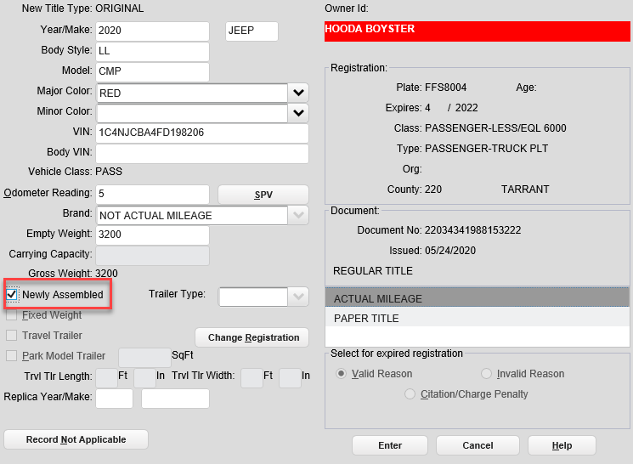

Title Record TTL003

1. If there is not an existing record, on the **Title Record TTL004** screen, select the **Newly Assembled** checkbox, and enter the vehicle information as appropriate based on the letter issued by the TxDMV RSC.

**NOTE**: Selection of the **Newly Assembled** checkbox will default the odometer brand to NOT ACTUAL MILEAGE and cannot be modified.

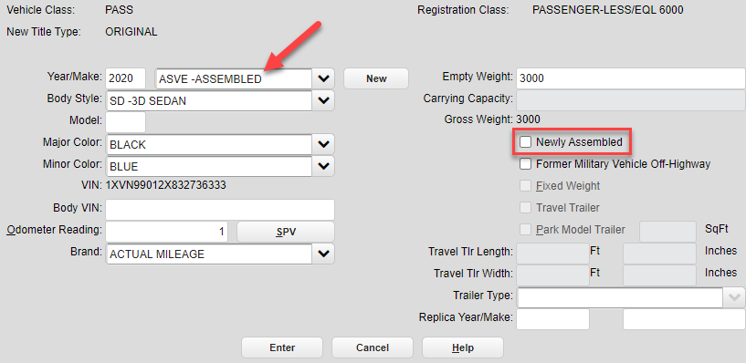

Title Record TTL004

1. When the **Newly Assembled** checkbox has been selected on the **Title Parsed Names TTL007N** screen, the previous owner type will be preselected as “**Entity,**” and the previous owner name will be populated with “**None**” and cannot be modified. This information will be carried forward to the **TTL007** screen.

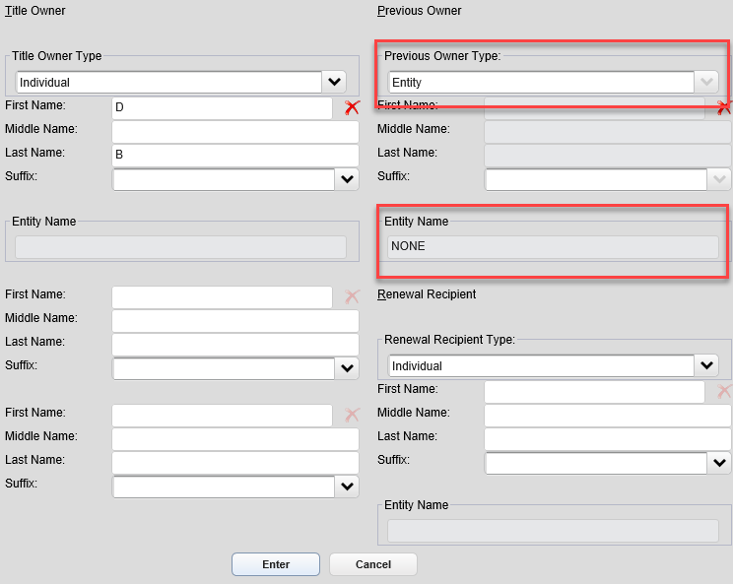

Title Parsed Names TTL007N

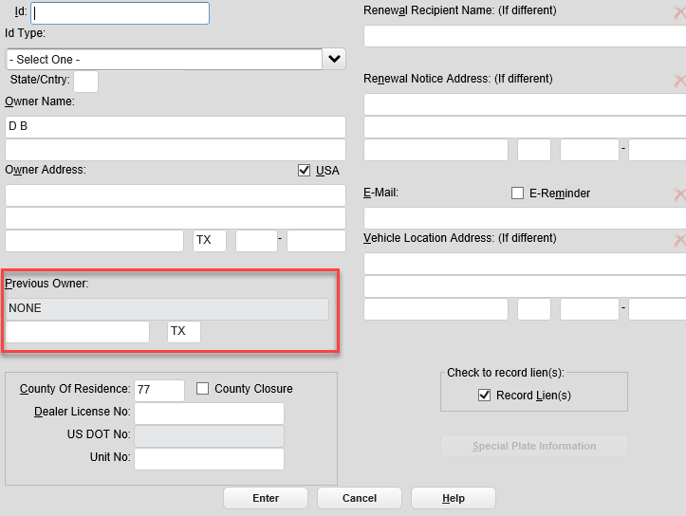

Owner Entry TTL007

1. For an existing vehicle record with a **NOT FOR DEALER RESALE** remark, if a Dealer License No. is entered on the **TTL007** screen, an error message will display, and processing cannot continue. A licensed motor vehicle dealer is prohibited from purchasing or selling an assembled vehicle with a **NOT FOR DEALER RESALE** remark.

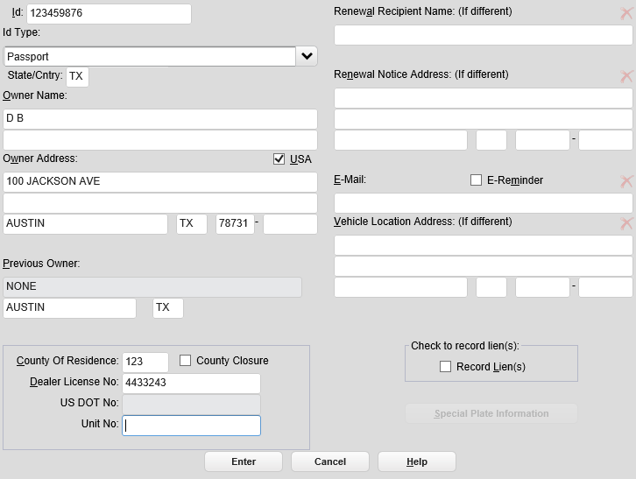

Owner Entry TTL007

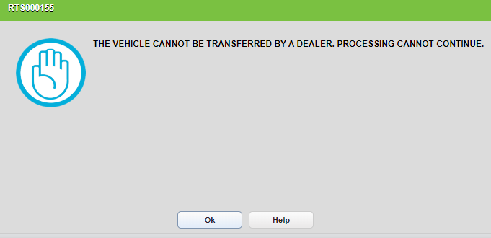

RTS000155

1. If the **Newly Assembled** checkbox was selected, and replica year/make is not entered on the **Title Record** **TTL003 or Title Record TTL004** screen, the **NOT FOR DEALER RESALE** remark will be added to the vehicle record unless **Reconstructed** is selected on the **Title Additional Info TTL008** screen.

Additionally, if the **Newly Assembled** checkbox was selected, no replica year/make was entered, and Reconstructed is not selected on **TTL008** screen, but a Dealer License No. was entered on the **Owner Entry TTL007** screen, an error message will display and prevent further processing. The vehicle record will contain the **NOT FOR DEALER RESALE** remark, and a licensed motor vehicle dealer is prohibited from purchasing or selling an assembled vehicle with this remark.

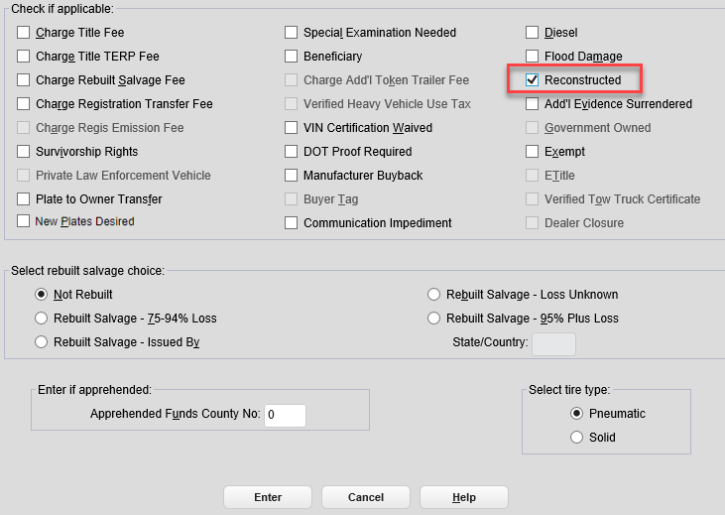

Title Additional Info TTL008

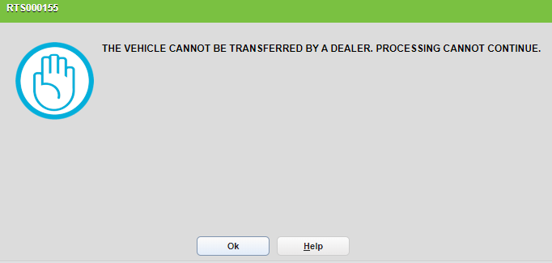

RTS000155

1. If all the entered information is correct, continue and complete the transaction.

## Corrected - Original Title

1. In RTS, click **Customer**>**Title/Registration**>**Title Application**.
2. In the **Inquiry Key** field, enter the Vehicle Identification Number (VIN).
3. Click **Enter**.
4. On the **Title Types TTL002** screen, select the type of title as Corrected – Original, and enter the Title Transaction Date.
5. On the **Title Record TTL003** screen, the **Newly Assembled** checkbox will be available for selection if the checkbox was not selected during the original transaction. Selection of the checkbox will trigger the same requirements outlined in the steps above for an Original transaction.

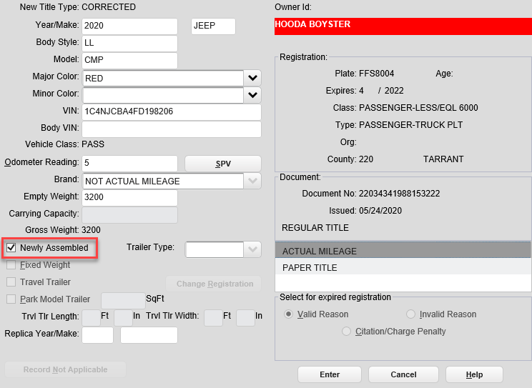

Title Record TTL003

## Correct Title Rejection

1. In RTS, click **Customer**>**Title/Registration**>**Correct Title Rejection**.
2. In the **Inquiry Key** field, enter the Vehicle Identification Number (VIN).
3. Click **Enter**.
4. On the **Title Types TTL002** screen, select the type of title, and enter the Title Transaction Date.
5. On the **Title Record TTL003** screen, the **Newly Assembled** checkbox will be available for selection, if the checkbox was not selected during the original transaction. Selection of the checkbox will trigger the same requirements outlined in the steps above for an Original transaction.

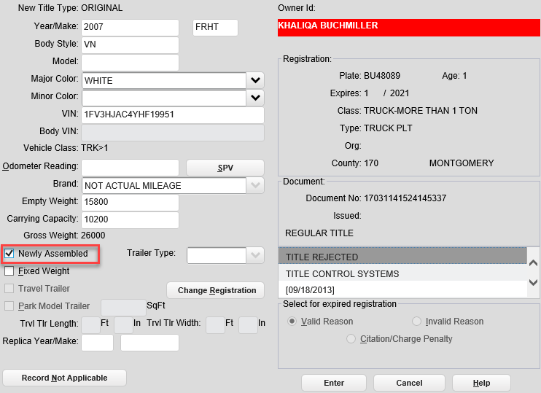

Title Record TTL003

## Stolen Transaction

1. In RTS, click **Customer**>**Title/Registration**>**Title Application**.
2. In the **Inquiry Key** field, enter the VIN.
3. Click **Enter**.
4. On the **Title Types TTL002** screen, select the **Vehicle stolen – Waive registration** checkbox, and enter the Title Transaction Date.

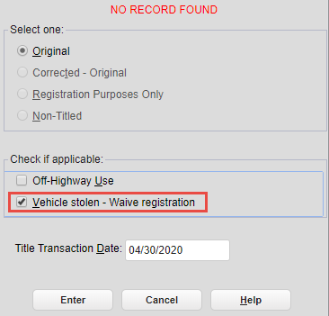

Title Types TTL002

1. On the **Title Record TTL004** screen, the **Newly Assembled** checkbox will be available. Selection of the checkbox will trigger the same requirements outlined in the steps above for an Original transaction.

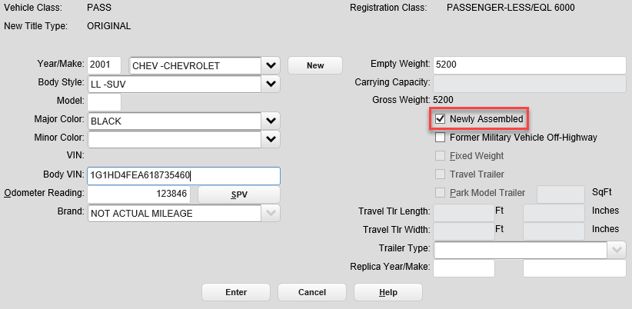

Title Record TTL004

## Non-Titled Transaction

1. In RTS, click **Customer**>**Title/Registration**>**Title Application**.
2. In the **Inquiry Key** field, enter the VIN.
3. Click **Enter**.
4. On the **Title Types TTL002** screen, select Non-Titled, and enter the Title Transaction Date.
5. If no record exists, a pop-up will display asking if the vehicle is newly assembled on the **Non-Title Record TTL004** screen if the vehicle make is entered as HMDE. If yes, then processing will stop, and the assembled trailer must be titled. If no, then processing may continue.

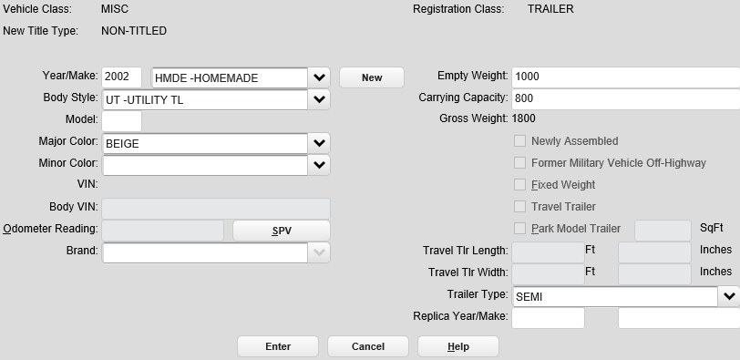

No Title Record TTL004

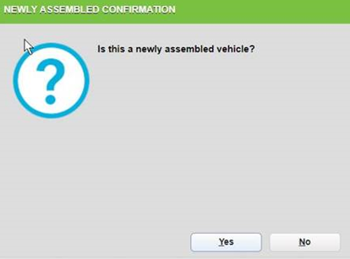

# Enhancements in RTS POS 9.7.0

|  |  |  |  |  |  |  |  |  |  |
| --- | --- | --- | --- | --- | --- | --- | --- | --- | --- |
| 23822 | **Previous:** The Register to Vote Specialty License Plate did not exist in RTS and IVTRS.  **Change:** The Register to Vote Specialty license plate is available for the following Registration Classes.   |  |  | | --- | --- | | **25**, **26** | **Passenger** | | **35**, **36** | **Truck** | | **20**, **22** | **Moped**, **Motorcycle** | | **37**, **38** | **Trailer**, **Travel Trailer** | |
| 17523 | **Previous:** RTS and webPERMITS allowed 72-Hour Permits and 144-Hour Permits to be requested for motorcycles, mopeds, motor scooters, or off-highway vehicles.  **Change:** 72-Hour Permits, and 144-Hour Permits are not available in RTS and webPERMITS for motorcycles, mopeds, motor scooters, or off-highway vehicles. |

## Permit Error Message in RTS

If a 72-Hour or 144-Hour Permit request for a motorcycle, motor scooter, moped, or off-highway vehicle is submitted in RTS, a pop-up message displays the message “This vehicle is not eligible for the permit type selected.”

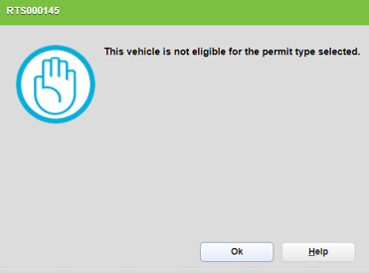

RTS000145

## Permit Error Message in webPERMITS

If a 72-Hour or 144-Hour Permit request for a motorcycle, motor scooter, moped, or off-highway vehicle is submitted in webPERMITS, a pop-up message displays the message, “This vehicle is not eligible for the permit type selected.”

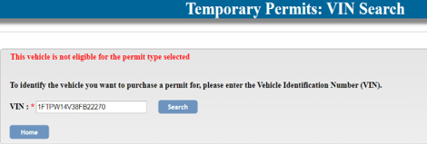

|  |  |
| --- | --- |
| 22108 | **Previous:** The cash register receipt printed only the transaction ID and the total.  **Change:** The cash register receipt prints detailed information included in the transaction set.  RTS will now limit the number of transactions per ‘Customer Set’ to 30. |

## Cash Register Receipt for Multiple Transactions

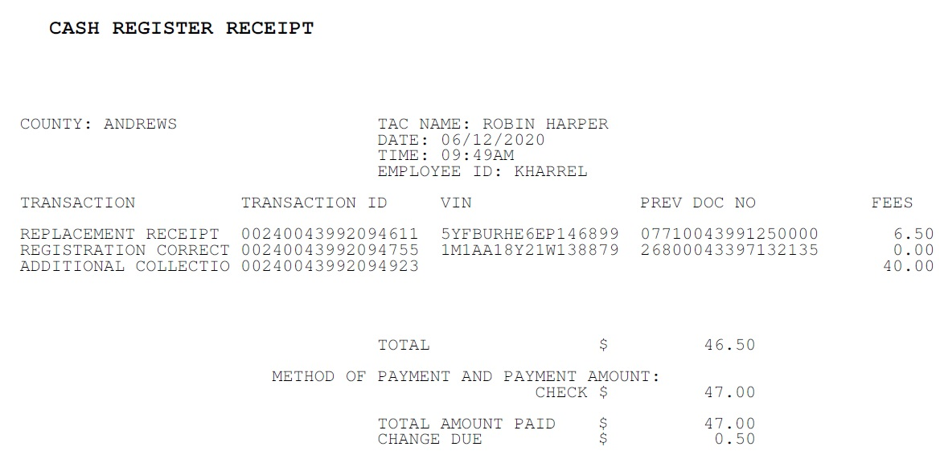

|  |  |
| --- | --- |
| 24333 | **Previous:** The Insurance Company Statement of Fact (Form VTR-331-INS) was not available for selection as ownership evidence when processing a title application.  **Change:** Now when a user processes a title application and the completed Form VTR-331-INS is submitted, the user will have the ability on the Ownership Evidence List to select Form VTR-331-INS as the evidence being surrendered in lieu of selecting Other. |

## The Form VTR-331-INS Available on the Ownership Evidence List

