Registration and Title System
  - Point of Sale
County Release Notes
  - Release 9.6.1
04/16/2020

Contents
1 Legislative Change in RTS POS 9.6.1 4
2 Enhancements in RTS POS 9.6.1 5
2.1 Out of County Registration Renewal 5
2.2 Out of County Title and/or Registration 7
3 Defects Fixed in RTS POS 9.6.1 9

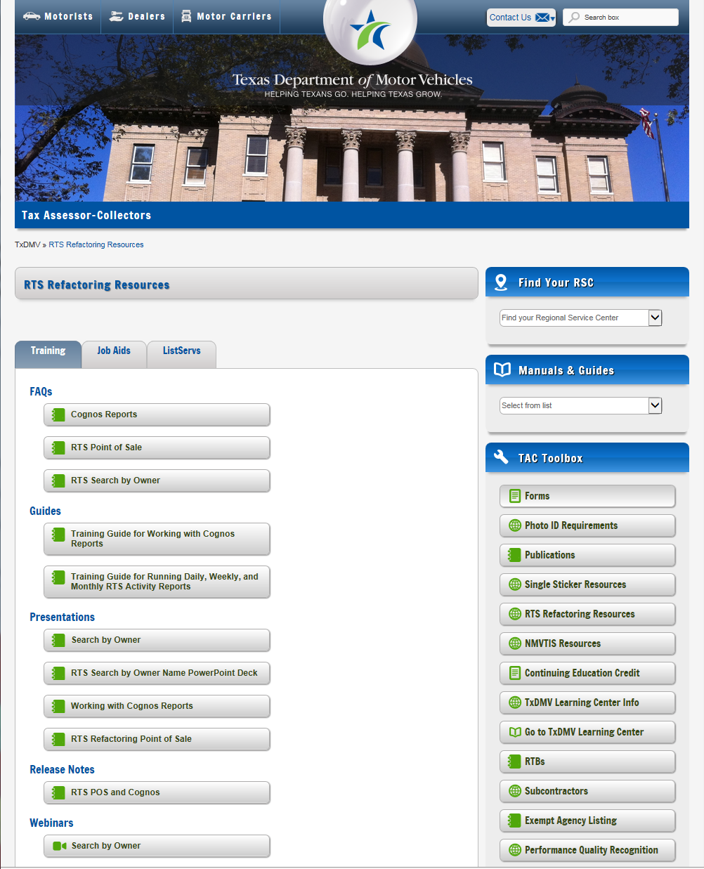
About the Release
These Release Notes contain information about new features, enhancements, and reported issues resolved in this release of the Registration and Title System Point of Sale (RTS POS).
For more information about the RTS POS, refer to the Online Help and to the original Release Notes on the RTS Refactoring Resources page of the TAC Hub (www.txdmv.gov/tax-assessor-collectors).
RTS POS Overview
The refactored RTS POS is a web-based application designed to process vehicle registrations, titles, and temporary permits for Texas motorists through a series of web pages. The RTS POS system provides functions for cash accounting, funds allocations, and a full audit trail along with inventory control for license plates, windshield/plate stickers, and temporary permits.
The RTS POS application displays when you log in to the RTS workstation.
To display reference information about using the RTS POS, click in the upper right corner of the web browser to minimize the application and click the RTS Refactoring Help icon on your desktop.
The RTS Refactoring Resources page (on the TAC Hub) displays FAQ documents composed of questions submitted by the county tax offices, as well as materials presented during RTS POS webinars (including the training guides, slide decks for presentations, and other recorded webinar sessions). The original Release Notes are also available on this page.
Click the Job Aids tab to locate important quick references to help you log in and work with the RTS POS.
When logged in to the RTS POS, you can get specific application level help by clicking Help on the page you are viewing or the entire user assistance web site by selecting Help > User Guide on the main page action bar.
NOTE: It is important to visit this Resources page frequently for updates and new materials.

Legislative Change in RTS POS 9.6.1
HB1262, which was implemented with RTS Release 9.5, authorized eligible trailers to be assigned registration periods of 12, 24, 36, 48, or 60 months including trailers registered through the Multi-Year Fleet Registration Program.
23601 | Previous: Registration Classes for trailers registered through the Multi-Year Fleet Registration Program were not available in RTS.  Change: The following Registration Class and Registration Plate Types have been added to RTS for trailers registered through the Multi-Year Fleet Registration Program:  Registration Class Plate Type  EXTND TRAVEL TRAILER FLEET EXTND TRAVEL TRLR PLT  EXTND TOKEN TRAILER FLEET EXTND TOKEN TRLR PLT  EXTND TRAILER FLEET EXTND TRAILER PLT

Enhancements in RTS POS 9.6.1
A customer may renew registration, title and/or register their vehicle outside of their county of residence when their county is closed for an extended period.
11483 | Previous: RTS did not allow customers to renew registration, title and/or register their vehicle outside of their county of residence.  Change: Customers may renew registration, title and/or register their vehicle outside of their county of residence when their county is closed for an extended period.  NOTE: The out of county feature is enabled or disabled by the department. When turned on, the out of county feature will be enabled statewide.

Out of County Registration Renewal
- In RTS, click Customer>Registration Only>Renewal.
- In the Inquiry Key field, enter the vehicle identification number (VIN).
- Click Enter.
- On the Registration REG003 screen, click Owner Address.
NOTE: The County of Residence automatically changes to the processing county. If the clerk does not select Out of County, the County of Residence field will be updated to show the residence county when returning to the Registration REG003 screen.
- On the Owner Address REG033 screen, select the Out of County checkbox.

- Click Enter.
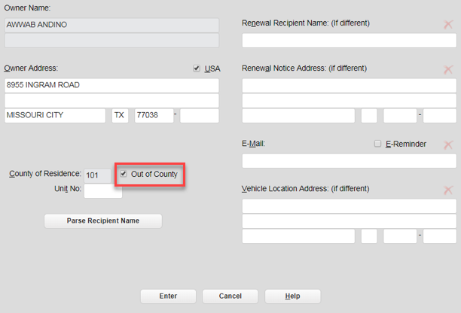
Owner Address REG033
- On the Registration REG003 screen, click Additional Information.
On the Registration Additional Info REG039 screen, the Apprehended fields are disabled.
- Click Enter.
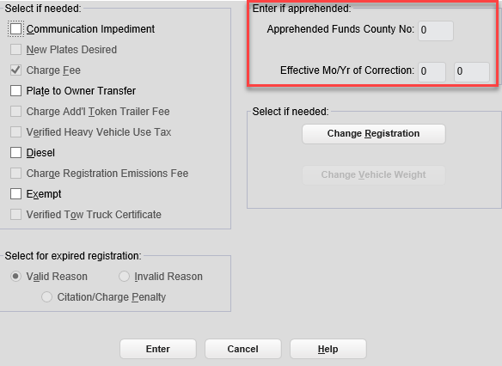
Registration Additional Info REG039
The county of residence is used to calculate the fees and will be printed on the receipt and the sticker, even though the registration was processed in another county.
NOTE: The processing county will receive the county portion of the Processing and Handling Fee, and the county of residence will receive the remainder of the funds.

Out of County Title and/or Registration
- In RTS, click Customer>Title/Registration>Title Application.
- On the VIN Key Selection KEY006 screen, in the VIN field, enter the vehicle identification number.
- On the Title Types TTL002 screen, select the type of title, and enter the Title Transaction Date.
- Continue processing the transaction until you reach the Owner Entry TTL007 screen.
- On the Owner Entry TTL007 screen, complete the required fields, and select the Out of County checkbox.
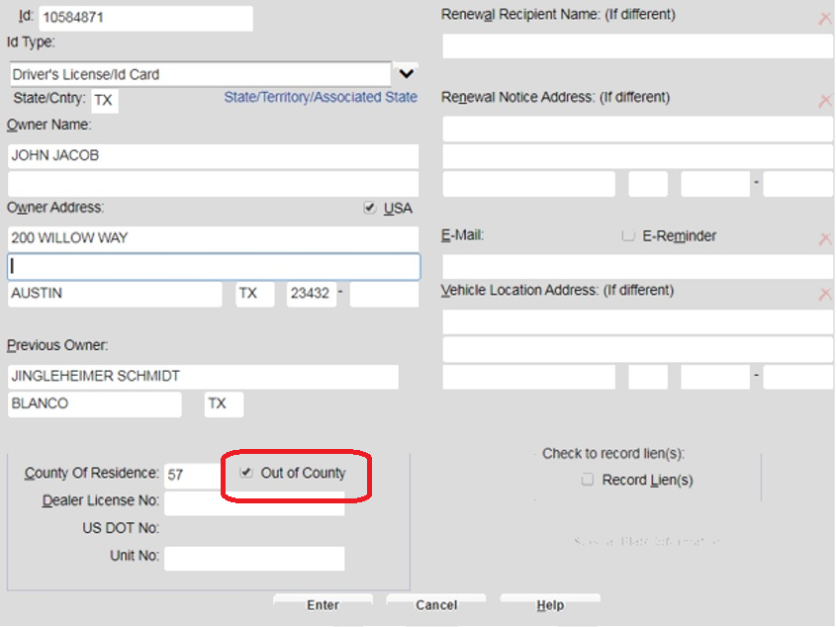
Owner Entry TTL007

NOTE: If the County of Residence Number and the Out of County Number are the same, the following pop-up message displays.
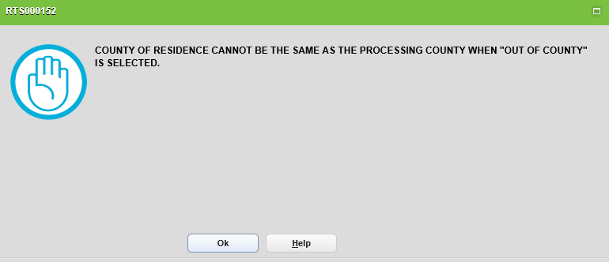
RTS000152
- On the Title Additional Info TTL008 screen, the Apprehended Funds County No. field is disabled.
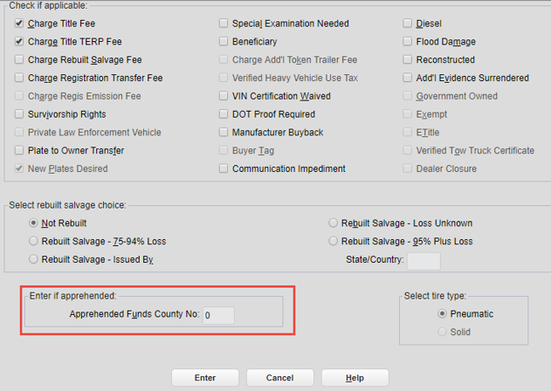
Title Additional Info TTL008
- Click Enter and complete the transaction.
NOTE: The processing county will receive the county portion of the Processing and Handling Fee, and the county of residence will receive the remainder of the funds.

Defects Fixed in RTS POS 9.6.1
18903 | Previous: When a 30-day permit was applied for in the Mountain time zone, the permit was printed with the incorrect date and time and gave the customer an extra day. However, the receipt printed the correct Mountain time zone expiration date and time.  Change: When a 30-day permit is applied for in the Mountain time zone, the permit will print with the correct expiration date and time.
22958 | Previous: RTS is not charging an inspection fee for a vehicle previously registered for 24 months that had a two-year inspection, when that inspection expires after the current registration.  Change: RTS will charge the inspection fee for a vehicle previously registered for 24 months that has a two-year inspection when that inspection expires after the current registration.
23670 | Previous: When processing a title transaction on a trailer, and the registration is within the renewal window, RTS was not allowing renewal for an Extended Registration period if the vehicle class, registration class, and/or the vehicle gross weight were changed.  Change: RTS will allow the renewal for an Extended Registration period in the Title Application event when the registration is within the renewal window if there is a change to the vehicle class, registration class, and/or the vehicle gross weight. RTS will calculate the maximum expiration month and year and include credit for any previous registration months.
23737 | Previous: In the Status Change event, RTS required an authorization code if a dealer license number was not validated. In addition, RTS required a supervisor override code if issuance of the buyer tag was not validated.  Change: RTS will display an error message if a dealer license number and/or buyer tag is not validated and will prevent processing of the transaction.

