 | 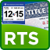 |  | How to Repair the Adobe Print Function
Follow these instructions in the order they are written if you cannot print:
- If the RTS application is open, close it by clicking Exit Sign Off.
- If the Internet Explorer browser is open, close it by clicking the “X” in the upper right corner of the browser.
- From your main computer screen, double click on the Adobe Reader icon.
- Click Help Repair Adobe Reader Installation.
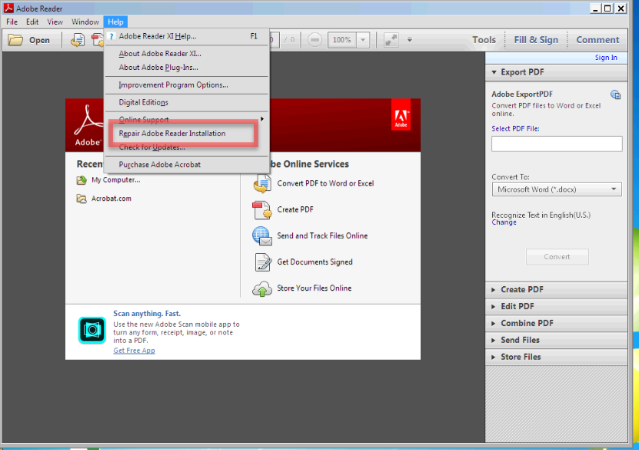

- Click Yes when it asks you if you want to repair the current installation:
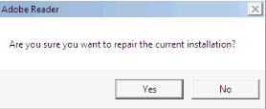
- The active repair window will display:
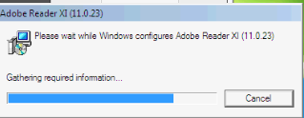
- Click Yes when it asks you to reboot your computer:
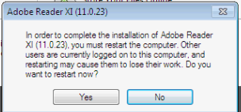
- Once your computer has rebooted, log on, open RTS and try to print a receipt. You may have to process a new transaction if you do not have an existing receipt to print. You will also need to void each transaction, if a receipt did not print.

- Please contact TxDMV at 512-465-3351, if you have an open ticket, and advise the Customer Service Representative if your ticket can be closed, or if you continue to experience problems.

Note: Each user experiencing issues must follow these instructions on all workstations they use to process transactions.

