  
  
Registration and Title System

Point of Sale System   
Release Notes for Counties

Release 9.2.0

12/21/2018

About Release Notes

These Release Notes contain information about new features, enhancements, and reported issues resolved in this release of the Registration and Title System Point of Sale (RTS POS).

For more information about the RTS POS, refer to the **Online Help** and to the original Release Notes on the **RTS Refactoring Resources page** of the TAC Hub [(www.txdmv.gov/tax-assessor](http://www.txdmv.gov/tax-assessor-collectors)-[collectors)](http://www.txdmv.gov/tax-assessor-collectors).

**Contents**

About Release Notes i

RTS POS Overview 1

1 Enhancements and Updates in RTS POS 2

1.1 New and Redesigned License Plates Issued 2

1.1.1 Smokey Bear 2

1.1.2 Redesigned US Army 2

1.1.3 Redesigned US Army Honorably Discharged 2

1.1.4 Redesigned US Army Retired 3

1.1.5 Redesigned Disabled Veteran US Army 3

1.2 Entry of Last Four of Texas Document Number 4

1.3 Compensation Amounts Now Shown on Fees Reports 5

1.4 webPERMITS Vehicle Confirmation 6

1.5 Delinquent Transfer Penalty Fee Collection 7

1.6 Month/Year of Registration Expiration Disabled 8

1.7 One-Trip Permit Requires Texas Origination or Destination 9

1.8 Non-Titled Transaction Disabled for Previously Titled Vehicles 10

RTS POS Overview

The refactored RTS POS is a web-based application designed to process vehicle registrations, titles, and temporary permits for Texas motorists through a series of web pages. The RTS POS system provides functions for cash accounting, funds allocations, and a full audit trail along with inventory control for license plates, windshield/plate stickers, and temporary permits.

The RTS POS application displays when you log into the RTS workstation.

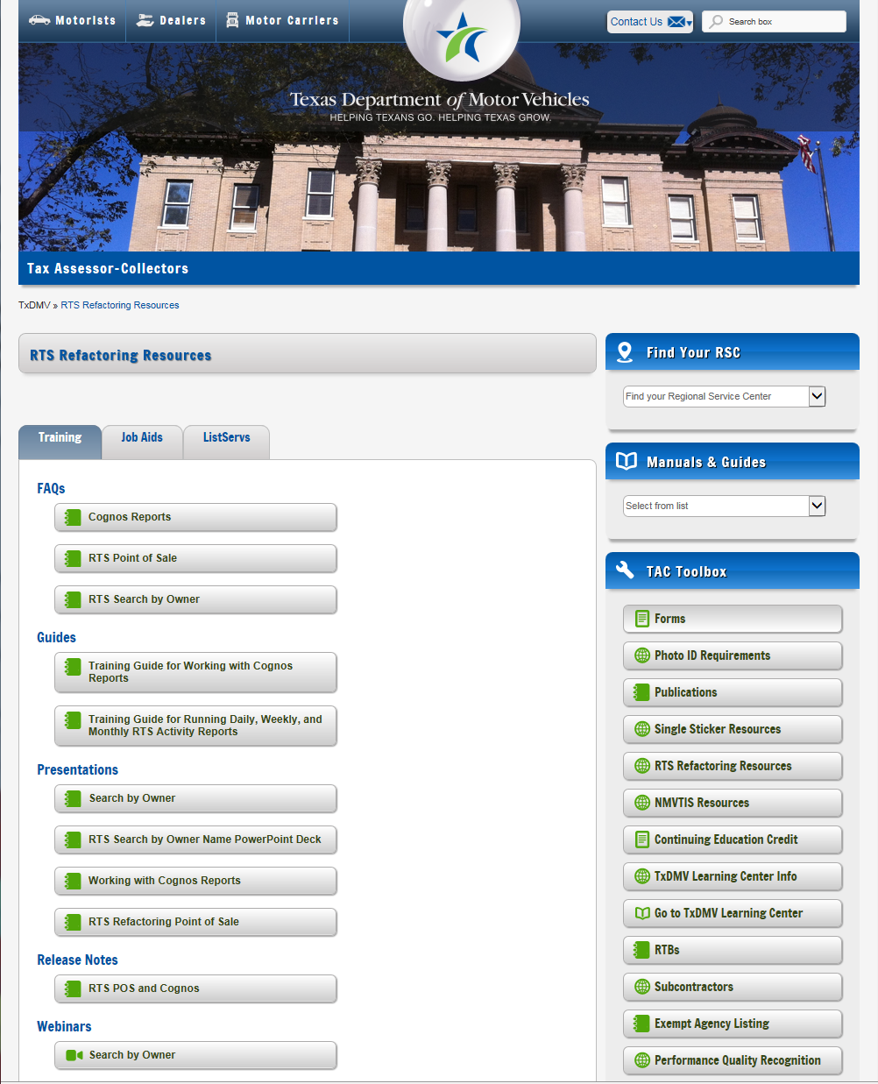To display reference information about using the RTS POS, you can click  in the upper right corner of the web browser to minimize the application and click the  RTS Refactoring Help icon on your desktop.

The RTS Refactoring Resources page (on the TAC Hub) will display FAQ documents composed of questions submitted by the county tax offices, as well as materials presented during RTS POS webinars (including the training guides, slide decks for presentations, and other recorded webinar sessions). The original Release Notes are also available on this page.

Click the **Job Aids** tab to locate important quick references to help you log in and work with the RTS POS.

When logged into the RTS POS, you can get specific application level help by clicking the Help button on the page you are viewing or the entire user assistance web site by selecting **Help > User Guide** on the main page action bar.

**Note:** It is important to visit this Resources page frequently for updates and new materials.

# Enhancements and Updates in RTS POS

The following sections explain the changes in RTS 9.2.0.

## New and Redesigned License Plates Issued

### Smokey Bear

|  |  |
| --- | --- |
| The Smokey Bear license plate is available to be ordered for passenger vehicles, trucks, mopeds, motorcycles, trailers, travel trailers, and private buses. |  |

### Redesigned US Army

|  |  |  |  |
| --- | --- | --- | --- |
| The redesigned US Army license plate is available to be ordered for passenger vehicles, trucks, mopeds, motorcycles, trailers, travel trailers, and private buses. |  | 🡪 |  |

### Redesigned US Army Honorably Discharged

|  |  |  |  |
| --- | --- | --- | --- |
| The redesigned US Army Honorably Discharged license plate is available to be ordered for passenger vehicles, trucks, mopeds, motorcycles, trailers, travel trailers, and private buses. |  | 🡪 | C:\Users\WBROCK\AppData\Local\Microsoft\Windows\Temporary Internet Files\Content.Word\US-ARMY-HONOR-DISCH-WEB.JPG |

### Redesigned US Army Retired

|  |  |  |  |
| --- | --- | --- | --- |
| The redesigned US Army Retired license plate is available to be ordered for passenger vehicles, trucks, mopeds, motorcycles, trailers, travel trailers, and private buses. |  | 🡪 | US-ARMY-RETIRED-WEB |

### Redesigned Disabled Veteran US Army

|  |  |  |  |
| --- | --- | --- | --- |
| The redesigned Disabled Veteran US Army license plate is available to be ordered for passenger vehicles, trucks, mopeds, motorcycles, trailers, travel trailers, and private buses. |  | 🡪 | DV-US-ARMY-WEB |

## Entry of Last Four of Texas Document Number

When any Texas ownership evidence type is selected on the **Ownership Evidence TTL011** screen of RTS POS, a new **Document Number Verification TTL022** screen displays that requires the user to enter the last four digits of the Texas Document Number. For example, if Texas Title, Certified Copy of Texas Title, etc. is selected, in all cases the **Document Number Verification TTL022** screen pops up. In this manner, the user verifies that the surrendered Texas document corresponds to the current record.

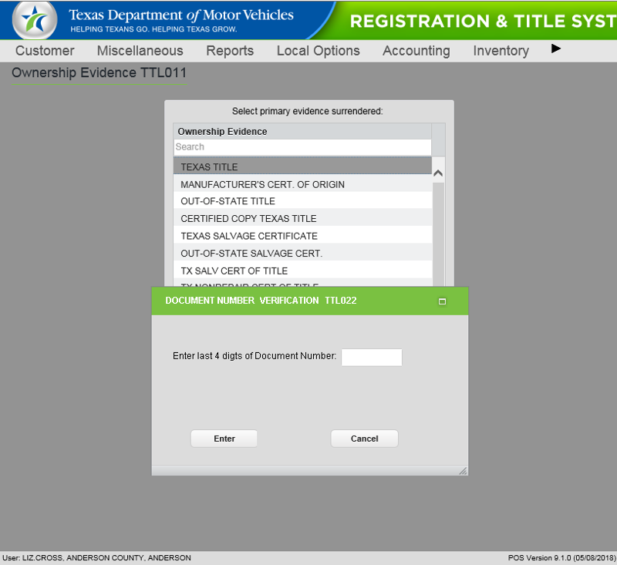

Figure 1: Document Number Verification TTL022 Screen

## Compensation Amounts Now Shown on Fees Reports

The Countywide and Workstation Fees Reports now show total deputy compensation amounts subtracted from the fees total. This means that the Fees Report total will now match the Payment Report total.

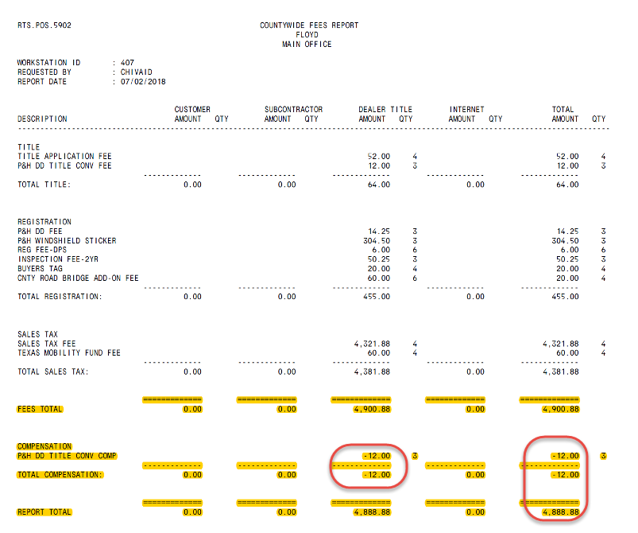

Figure 2: Compensation Amounts Now Appear on Fees Report

## webPERMITS Vehicle Confirmation

When a customer enters a VIN in webPERMITS, a confirmation pop-up now appears asking the user to verify the vehicle. If the customer selects “Yes,” they will be forwarded to the Insurance Information page. If the customer selects “No,” they will be asked for more information.

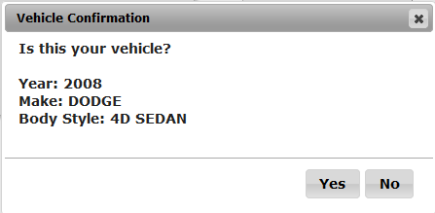

Figure 3: webPERMITS Confirmation Pop-Up

## Delinquent Transfer Penalty Fee Collection

When "NO RECORD FOUND" is returned following entry of a VIN in the Title Event, the **Title Types TTL002** screen displays. If you select the "Vehicle stolen - Waive registration” checkbox, the Delinquent Transfer Penalty Fee field and the associated options are enabled in the **Sales Tax TTL012** screen, allowing a penalty fee to be assessed. The “INS CO ON STOLEN VEHICLE CLAIM” remark has been removed.

|  |  |  |
| --- | --- | --- |
| Figure : TTL002 Screen | 🡪 | Figure 5: Delinquent Transfer Penalty Fee Can Now Be Assessed |

**Note:** Refer to RTB# 006-18 for more information on collection of delinquent transfer penalty for insurance companies.

## Month/Year of Registration Expiration Disabled

Previously RTS allowed the expiration month and year to be designated by the owner, but now RTS will not allow the expiration month and year to be modified except in the following cases:

* Seasonal Agricultural vehicles
* For private party title transfers for a vehicle in the renewal window.

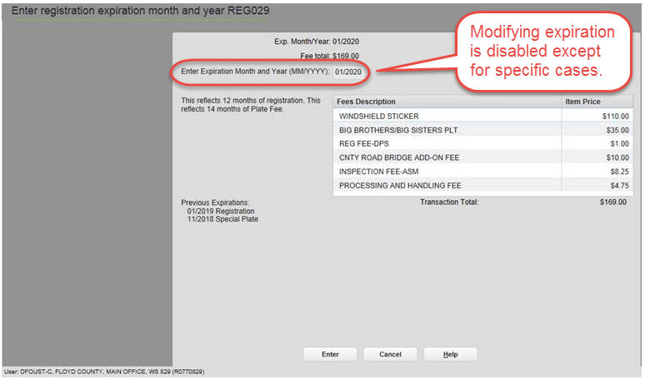

Figure 6: New REG029 Screen: Modifying Expiration Disabled

## One-Trip Permit Requires Texas Origination or Destination

When creating a One-Trip Permit, RTS now presents a drop-down in the Origination and Destination fields. Texas must be selected as either the origin or the destination. If Texas is not selected, the permit will not be issued.

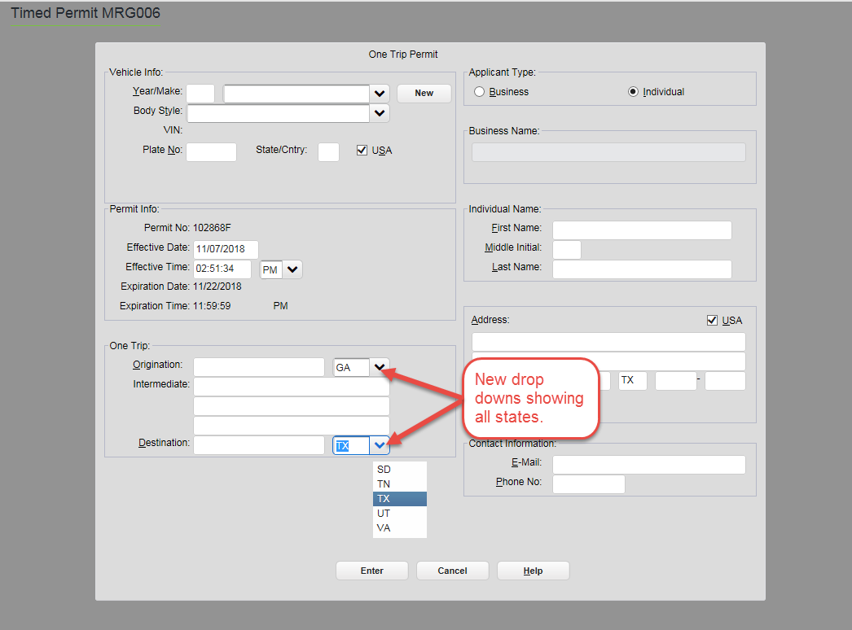

Figure 7: Texas Must Be Either the Origin or the Destination Selected from the Drop-Down Menu

## Non-Titled Transaction Disabled for Previously Titled Vehicles

The **Non-Titled** radio button is disabled for the **TTL002** screen when a record is found in RTS for which a title was issued. Once a vehicle is titled, it is always titled.

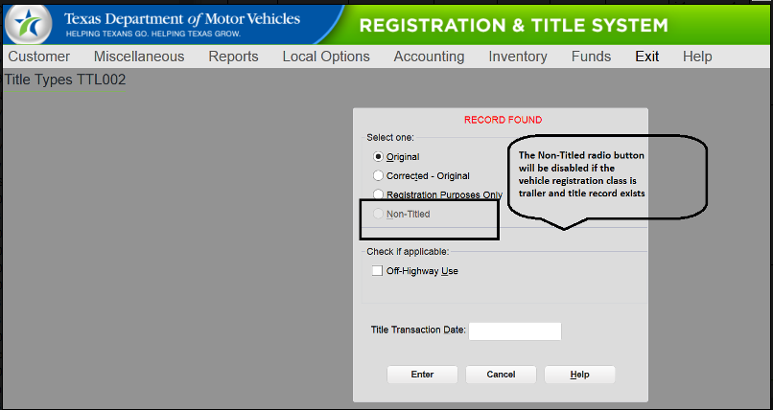

Figure 8: Non-Titled Button Disabled on the TTL002 Screen