Registration and Title System
Refactored Point of Sale System
Release Notes for County Offices
Release 9.0.0
12/28/2017

About Release Notes
These Release Notes contain information about new features, enhancements, and reported issues resolved in this release of the Registration and Title System Point of Sale (RTS POS).
For more information about the RTS POS, refer to the Online Help and to the original Release Notes on the RTS Refactoring Resources page of the TAC Hub (www.txdmv.gov/tax-assessor-collectors).
Contents
About Release Notes i
RTS POS Overview 1
1 Legislative Changes Mandated in RTS POS 2
1.1 Voluntary Contributions Authorized 2
1.2 Package Delivery License Plates 2
1.3 Process of Setting up Package Delivery License Plates 3
2 Non-Legislative Changes 7
2.1 Search by Owner 7
2.2 Antique License Plate Expiration Dates Staggered 7
2.3 Antique Plates 8
2.4 Annual Plate Change Reminder 11
2.5 IVTRS Registration Renewals 12
3 New Specialty License Plates 13

RTS POS Overview
The refactored RTS POS is a web-based application designed to process vehicle registrations, titles, and temporary permits for Texas motorists through a series of web pages. The RTS POS system provides functions for cash accounting, funds allocations, and a full audit trail along with inventory control for license plates, windshield/plate stickers, and temporary permits.
The RTS POS application displays when you log into the RTS workstation.
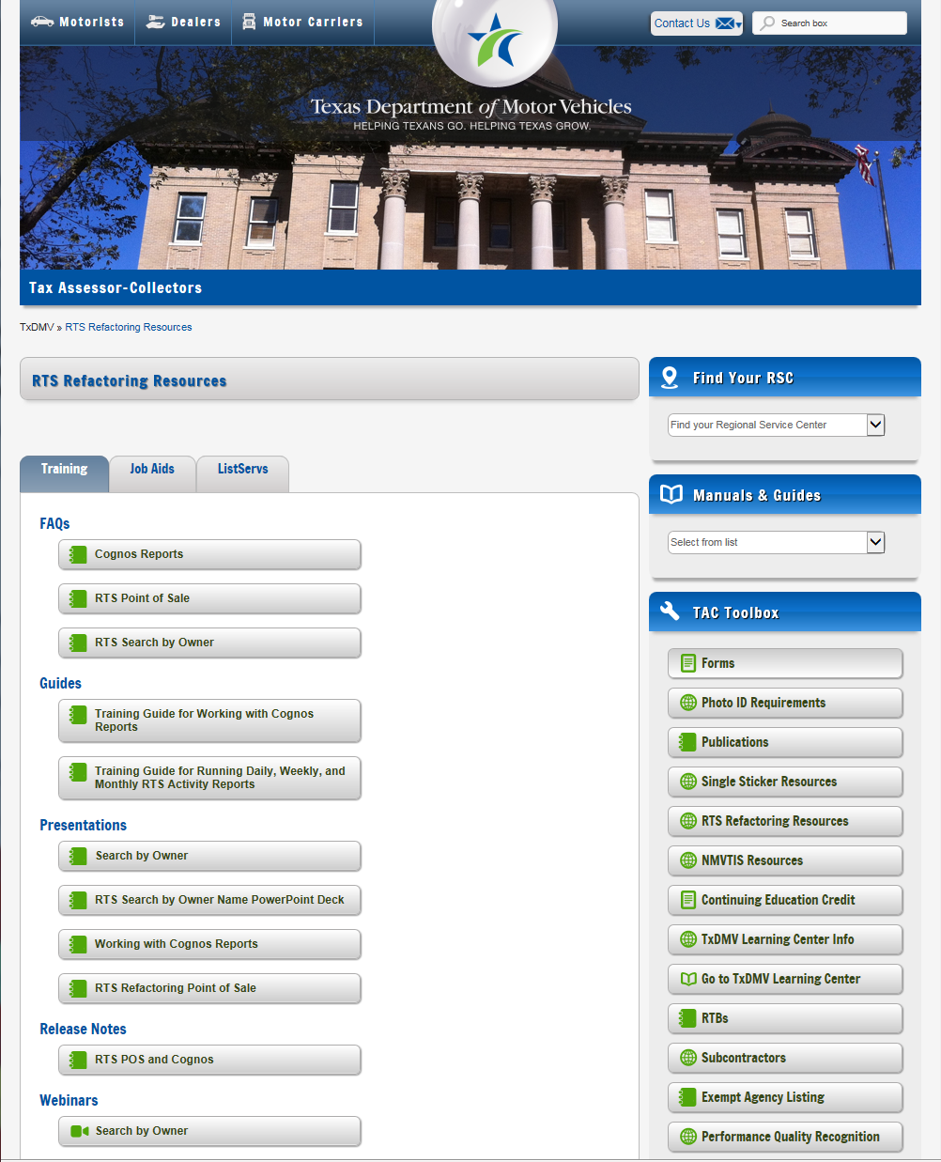
To display reference information about using the RTS POS, you can click in the upper right corner of the web browser to minimize the application and click the RTS Refactoring Help icon on your desktop.
The RTS Refactoring Resources page (on the TAC Hub) will display FAQ documents composed of questions submitted by the county tax offices, as well as materials presented during RTS POS webinars (including the training guides, slide decks for presentations, and other recorded webinar sessions). The original Release Notes are also available on this page.
Click the Job Aids tab to locate important quick references to help you log in and work with the RTS POS.
When logged into the RTS POS, you can get specific application level help by clicking the Help button on the page you are viewing or the entire user assistance web site by selecting Help > User Guide on the main page action bar.
Note: It is important to visit this Resources page frequently for updates and new materials.

Legislative Changes Mandated in RTS POS
Following are the changes in RTS 9.0.0 mandated by the 85th Legislative Session.

Voluntary Contributions Authorized
Customers can choose to donate to the Ending Homelessness Program or to the Evidence Testing Grant Program (HB 4102) at time of registration or renewal.

Package Delivery License Plates
Package Delivery License Plates will be available for vehicles operated by a package delivery service company (i.e. UPS and FedEx) for picking up and delivering mail, parcels, and packages. Vehicles eligible for Package Delivery License Plates are limited to:
- Neighborhood Electric Vehicles (NEV)
- All-Terrain Vehicles (ATV)
- Recreational Off-Highway Vehicles (ROV)
- Utility Vehicles (UTV)
- Golf Carts (GC)

This plate displays the words “Package Delivery” and requires a $25 annual plate fee and other applicable fees. A United States Department of Transportation (US DOT) number is required for the initial issuance of the license plate. The US DOT number is alpha numeric and has 8-10 characters.
Vehicles with Package Delivery License Plates will receive an annual registration renewal notice and can renew at the county, online through the Internet Vehicle Title and Registration Service, and by mail. Vehicles with Package Delivery License Plates are exempt vehicle inspection.

Process of Setting up Package Delivery License Plates
Before a Package Delivery License Plate can be issued, a special plate record must be created. Here are the steps to set up a special plate. Note this example shows setting up a Package Delivery Plate for an ATV or ROV.
Steps to Set Up a Package Delivery Plate
Step | Action | Screen
1 | Customer -> Special Plates -> Application | Begin the set up process.
2 | On the KEY001 screen, select “No Vehicle,” and click Enter. | 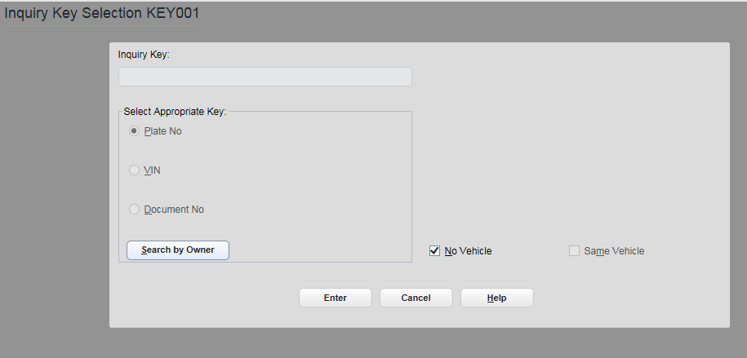
3 | On the Special Plate Application SPL001 screen, select MTRCYCLE for the Vehicle Class; select PACKAGE DELIVERY PLT for the Plate Type. The Organization field will default to PACKAGE DELIVERY, and the Request Type will default to ISSUE FROM INVENTORY.  Enter the plate number; click Enter. | 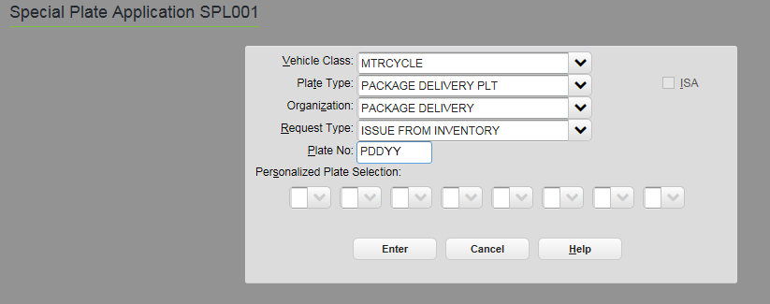
4 | On the Special Plate Information SPL002 screen, complete the owner information; click Enter. | 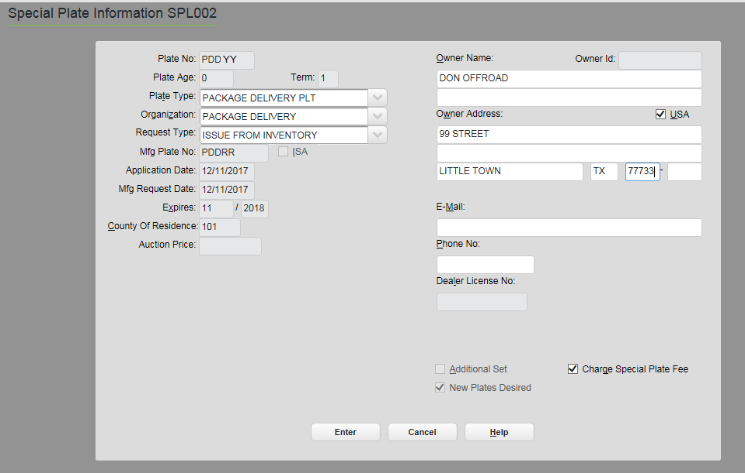
5 | On the Inventory – Registration Items INV007 screen, verify  the item is PACKAGE DELIVERY PLT; click Enter. | 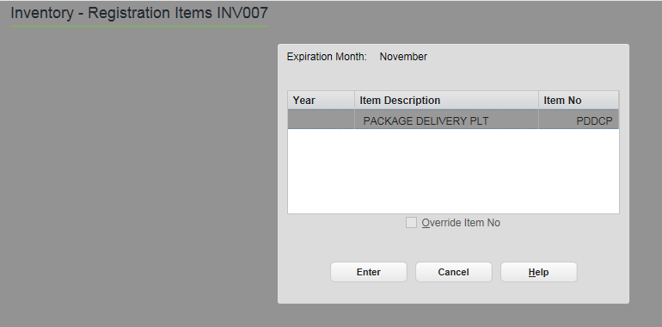
6 | On the Fees Due PMT004 screen, verify fees; click Enter. | 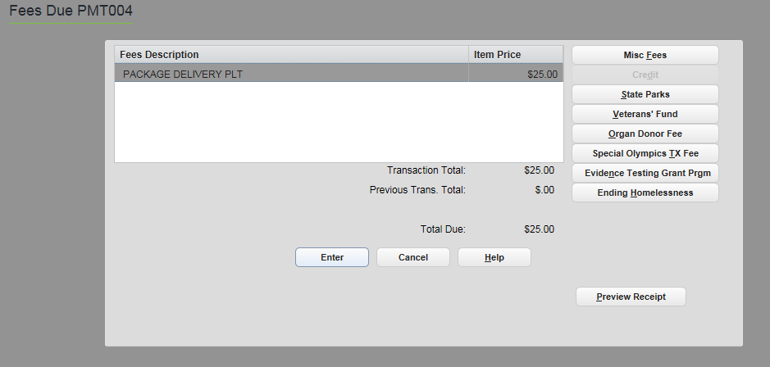
7 | This completes the set up of the Package Delivery Plate. From the pending transaction screen, select the appropriate RTS event (e.g. Exchange, Renewal, or Title); click Enter. | 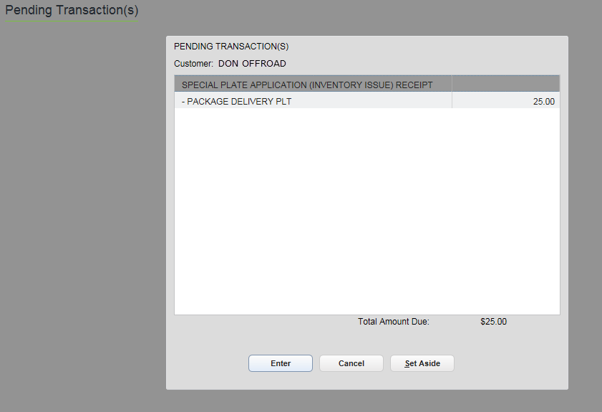
8 | This error message displays if you did not select the applicable event to link the plate to a vehicle. | 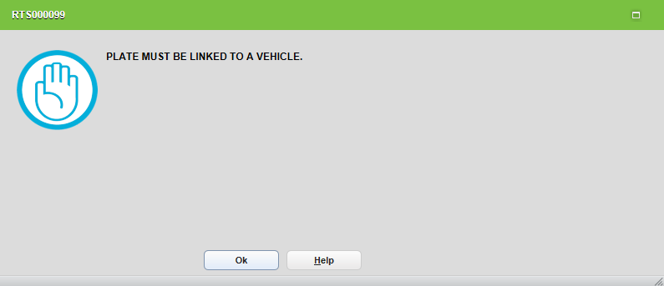
Linking the Package Delivery Plate:
- Existing ROVs and ATVs are linked through renewal events
- UTVs can be linked through the title event (non-titled)
- Existing NEVs can be linked through exchange and renewal events
- Golf Carts can be linked through the title event (non-titled)
- All vehicles can be linked to special plates via a title event
Note: The UTV registration class was created for Package Delivery Vehicles. The system will automatically mark UTVs as “Off-Highway Use Only.”

Non-Legislative Changes
Following are improvements to RTS 9.0.0 requested by users.

Search by Owner
If a record is not found in the Active records RTS, users can now search on owner information from Inactive and Archived records.
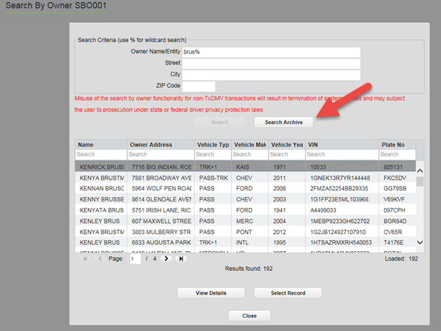

Antique License Plate Expiration Dates Staggered
Antique license plates with pre-printed expiration dates of March will no longer be issued. With this release, Antique plates will be manufactured on demand, and registration will be staggered for 60 months from the date of issuance. A speciality plate insignia will be issued displaying the same plate number that has been assigned in RTS, and the receipt will include the plate sticker.

Antique Plates
Before a new staggered Antique License Plate can be issued, a special plate record must be created. Here are the steps to set up an Antique Plate.
Steps to Set Up an Antique Plate for a Vehicle
Step | Action | Screen
1 | Customer -> Special Plates -> Application | Begin the set up process
2 | On the KEY001 screen, select “No Vehicle;” click ENTER.
3 | On the Special Plate Application SPL001 screen, select the applicable Vehicle Class and Plate Type for ANTIQUE PLT. The Organization field will default to ANTIQUE, and the Request Type will default to MANUFACTURE; click Enter. | 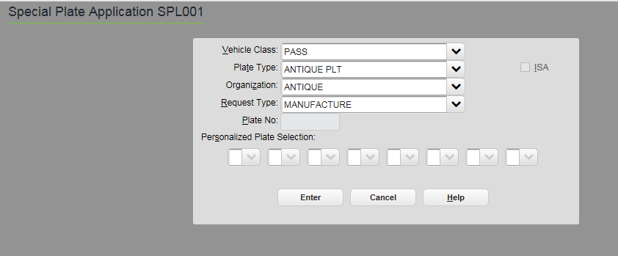
4 | On the Special Plate Information SPL002 screen, complete the owner information; click Enter. | 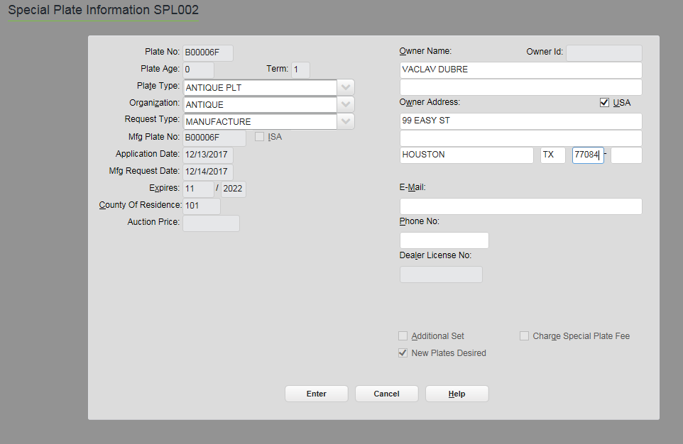
5 | On the Fees Due PMT004 screen; click Enter.  Note: The Antique plate fee will be collected when linked to a vehicle. | 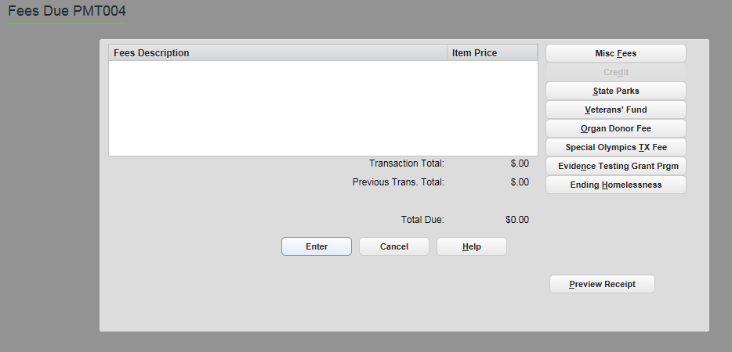
6 | This completes the set up of the Antique Plate. From the pending transaction screen, select the appropriate RTS event (e.g. Exchange, Renewal, or Title); click Enter. | 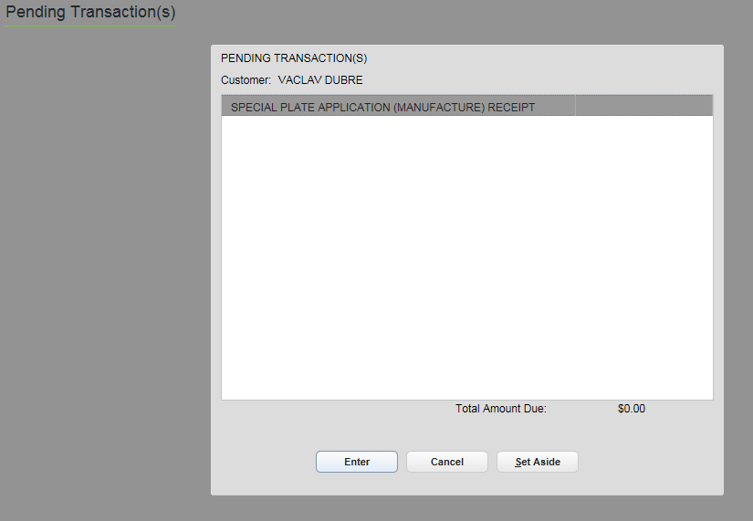
7 | This error message displays if you did not select the applicable event to link the plate to a vehicle.

Antique Truck
With this release the Antique Truck registration class has been added. For existing trucks registered as Antique, the registration class for the vehicle record must be updated to reflect the Antique Truck.

Annual Plate Change Reminder
With the 8.10 release that was deployed August 27, 2017, changes were made to the following annual plates by removing the Month/Year block from the license plate. As a reminder, a windshield or plate sticker will be included on the receipt.
- ANTIQUE MOTORCYCLE
- ANTIQUE BUS
- ANTIQUE
- FERTILIZER
- GO TEXAN 2 COMBINATION
- CONGRESSIONAL MEDAL OF HONOR AIR FORCE MC
- CONGRESSIONAL MEDAL OF HONOR AIR FORCE MC (FEE)
- CONGRESSIONAL MEDAL OF HONOR AIR FORCE
- CONGRESSIONAL MEDAL OF HONOR AIR FORCE (FEE)
- CONGRESSIONAL MEDAL OF HONOR ARMY MC
- CONGRESSIONAL MEDAL OF HONOR ARMY MC (FEE)
- CONGRESSIONAL MEDAL OF HONOR ARMY

- CONGRESSIONAL MEDAL OF HONOR ARMY (FEE)
- CONGRESSIONAL MEDAL OF HONOR NAVY MC
- CONGRESSIONAL MEDAL OF HONOR NAVY MC (FEE)
- CONGRESSIONAL MEDAL OF HONOR NAVY
- CONGRESSIONAL MEDAL OF HONOR NAVY (FEE)
- CONGRESSIONAL MEDAL OF HONOR
- HONORARY CONSUL
- FOREIGN ORGANIZATION
- DISASTER RELIEF
- COTTON

IVTRS Registration Renewals
The following registration class is now allowed registration renewal via IVTRS:
- Combination (GVW 54,999 lbs. or less)

New Specialty License Plates
The following specialty plates are available as of November 19, 2017, and their images can be viewed at http://www.txdmv.gov/motorists/license-plates/specialty-license-plates. The Eastern Star, Ducks Unlimited (Three Dogs), Colorado School of Mines, and Carbon Fiber plates can be ordered at the county or online.
Eastern Star: A new Eastern Star specialty plate is available. It can be ordered for passenger vehicles, trucks, motorcycles, mopeds, and trailers. | 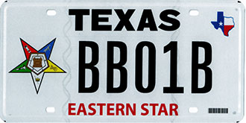
Ducks Unlimited: A new Ducks Unlimited (Three Dogs) specialty plate is available. It can be ordered for passenger vehicles, trucks, motorcycles, mopeds and trailers.. | 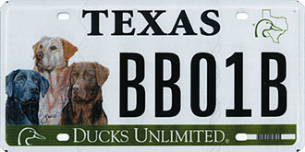
Blue Knights: A new Blue Knights specialty plate is available. Members of the Blue Knights motorcycle club must certify that they are members by certifying on Form VTR-415. This plate will not be available to order online. It can be ordered for passenger vehicles, trucks, motorcycles, and mopeds. | 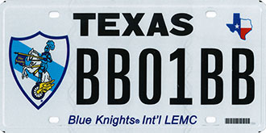
Colorado School of Mines: A new Colorado School of Mines specialty plate is available via My Plates. It can be ordered for passenger vehicles, trucks, motorcycles, mopeds and trailers. | 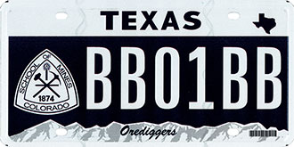
Carbon Fiber: A new Carbon Fiber specialty plate is available via My Plates. It can be ordered for passenger vehicles, trucks, motorcycles, mopeds and trailers. | 