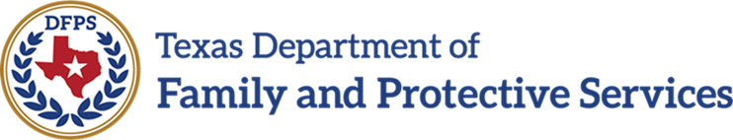

**Provider Portal – MyDAP**

Version Date: 4/22/2024

Version: 1.3

As of today (Before MyDAP is implemented) – Users are allowed to enter username (Email) and password to access to the Provider Portal.

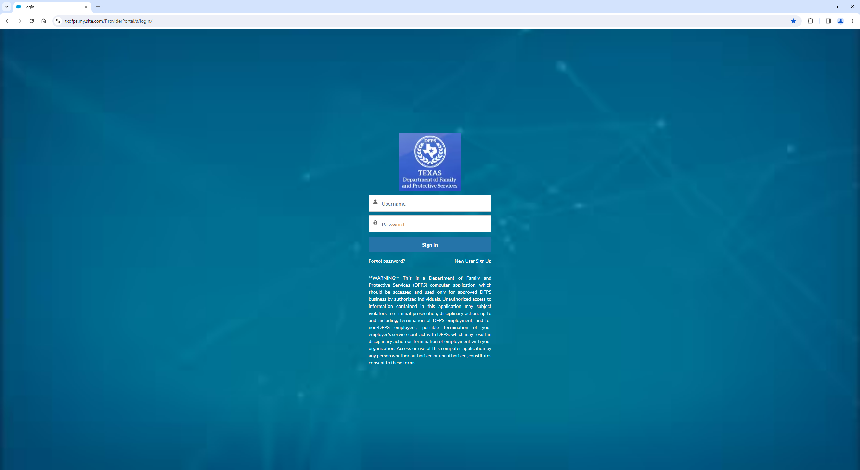

After MyDAP is implemented – Users will NO longer be able to enter username and password at the Provider Portal login page:

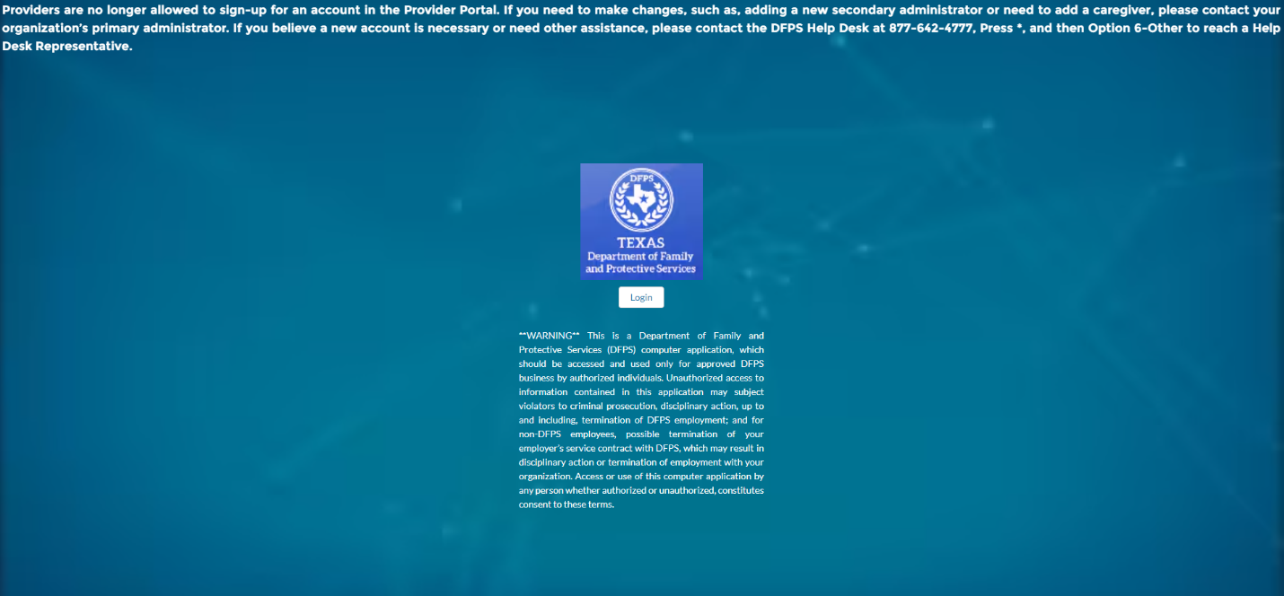

Users need to click on the “Login” button which will take the User to the MyDAP Provider Portal:

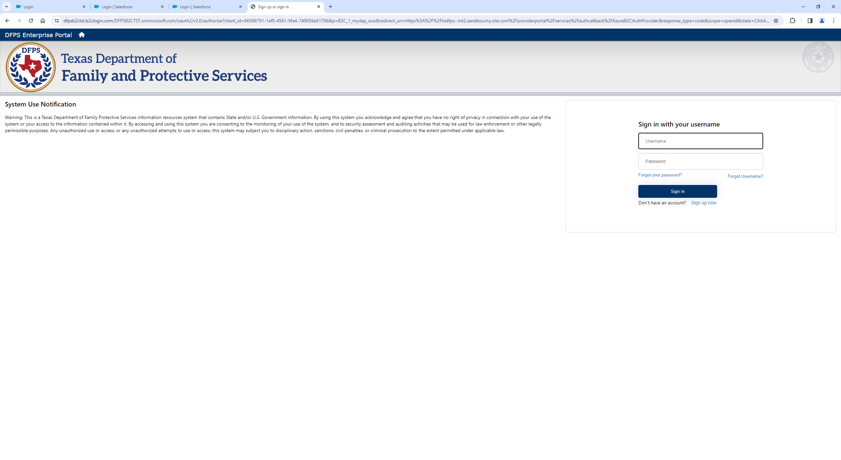

Users are expected to enter Username (Short Username Ex: jdoe, not the Email Address) and Password.

First Time Login users – Step 1) Users need to click on “Forgot Username” and enter email address to get the new short **Username**.

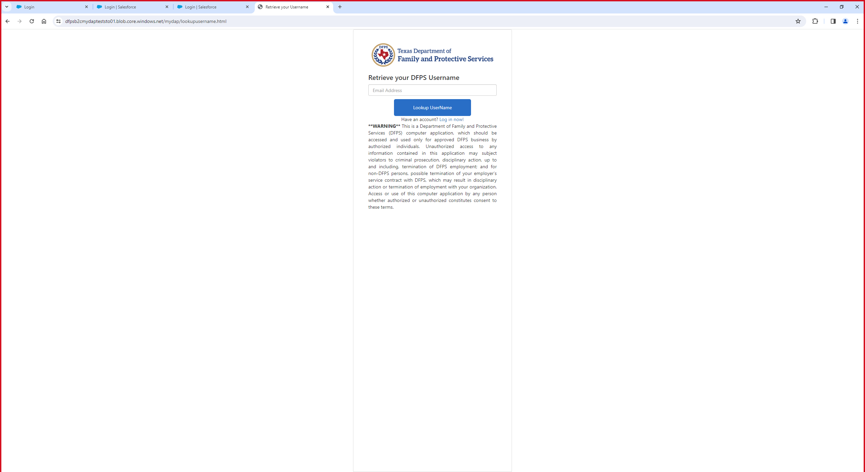

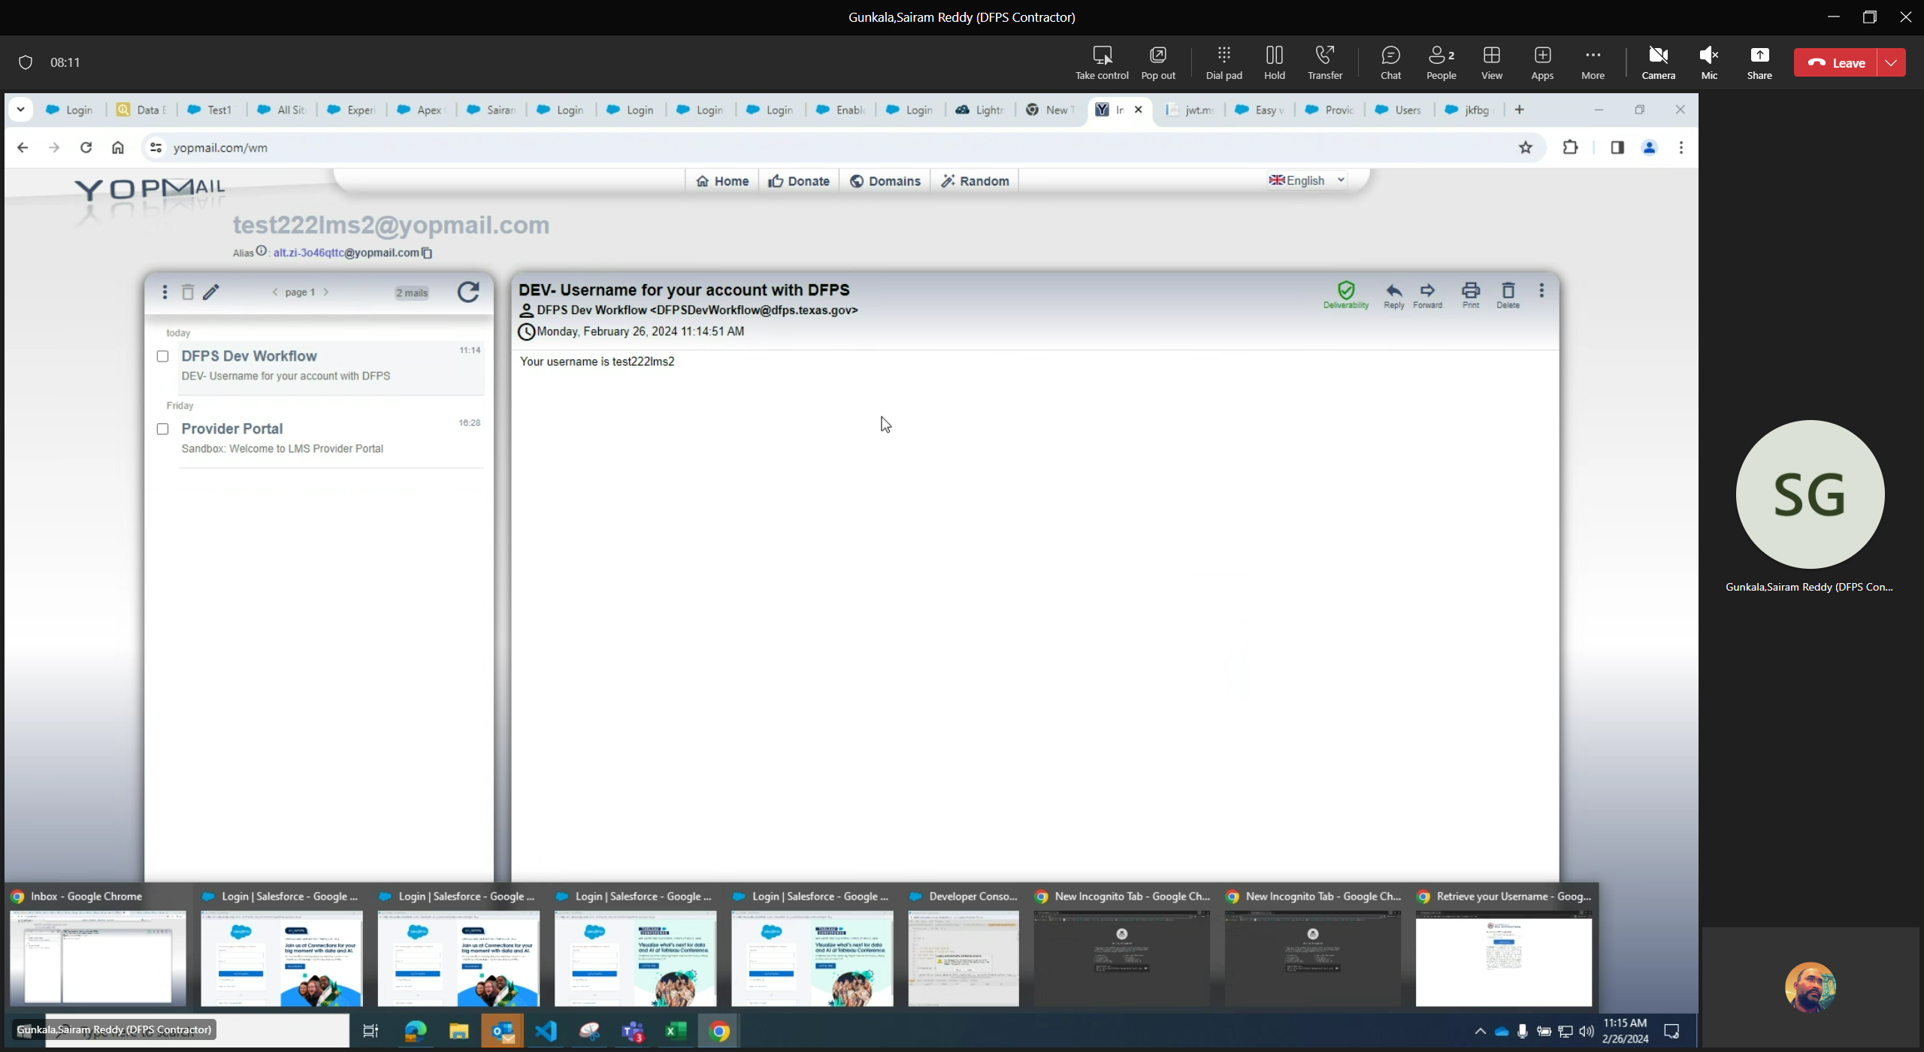

Step 2) Users need to click on “Forgot Password” to create/setup password.



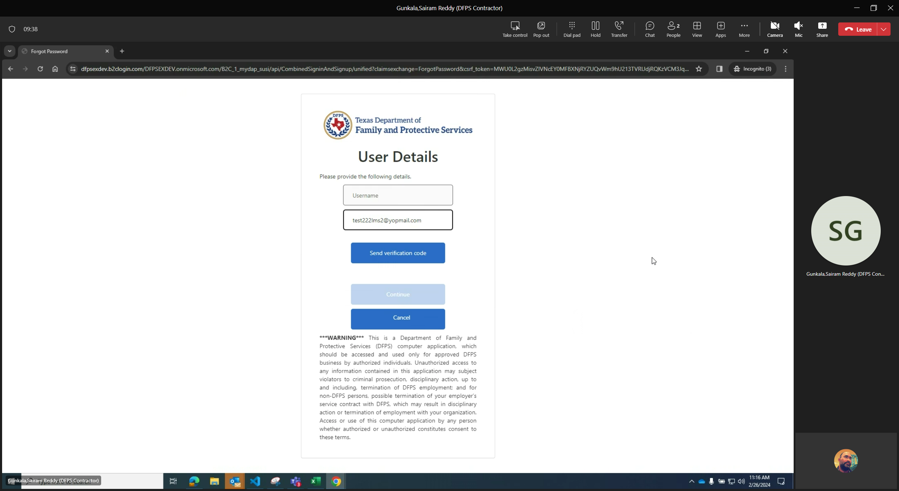

Enter the email address first and click on “Send Verification Code”.

Note: Username field is disabled at this point of time – User will not be able to enter Username at this point of time.

Email received with the code. Enter the code and click “Verify Code”

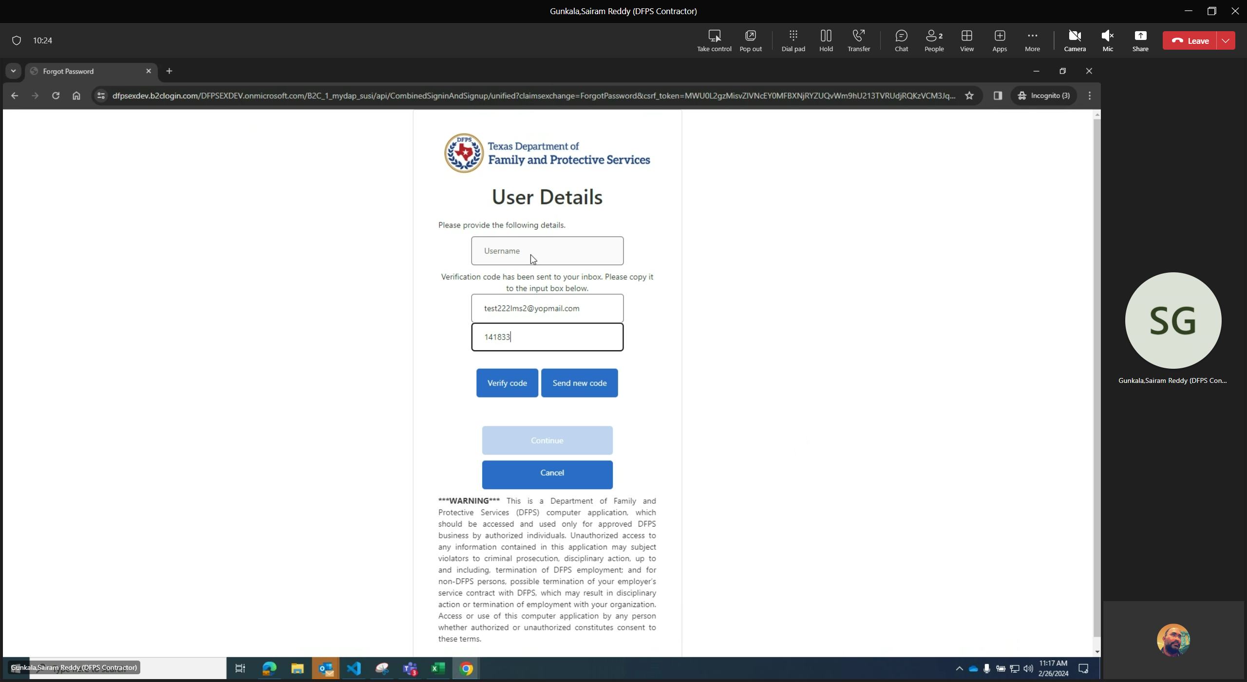

Only upon code is verified, User is allowed to enter the short username and click continue.

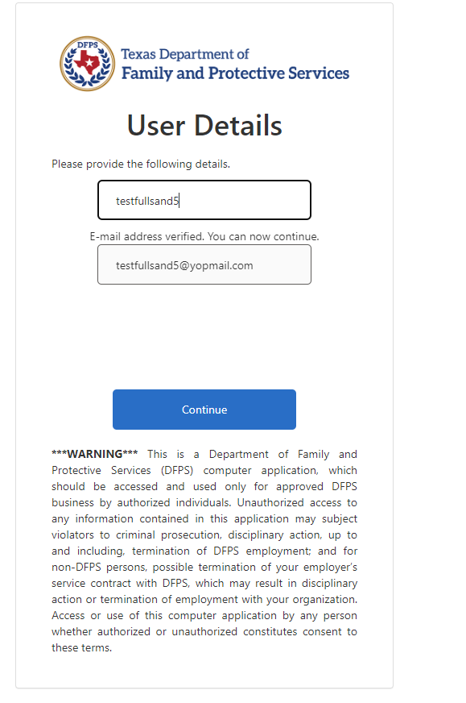

User is allowed to create **New Password.**

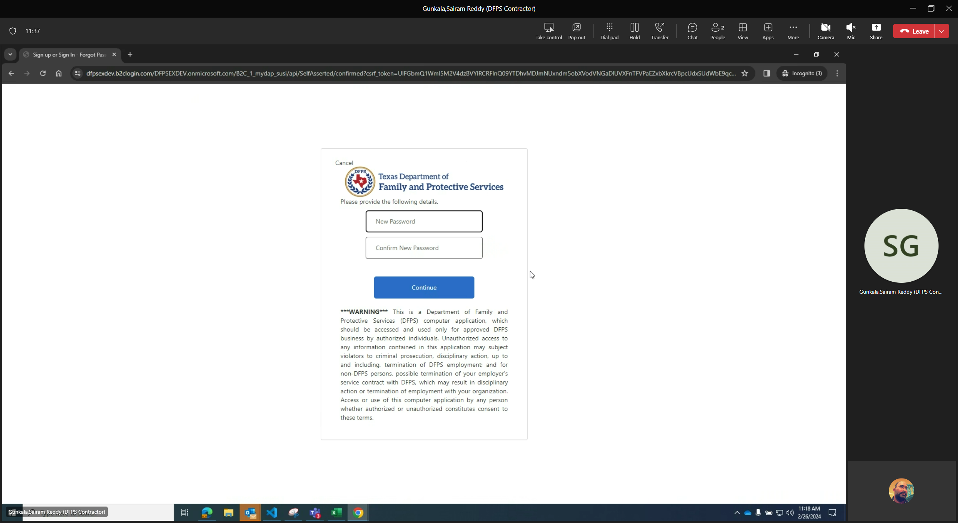

User is redirected to the Provider Portal Account page:

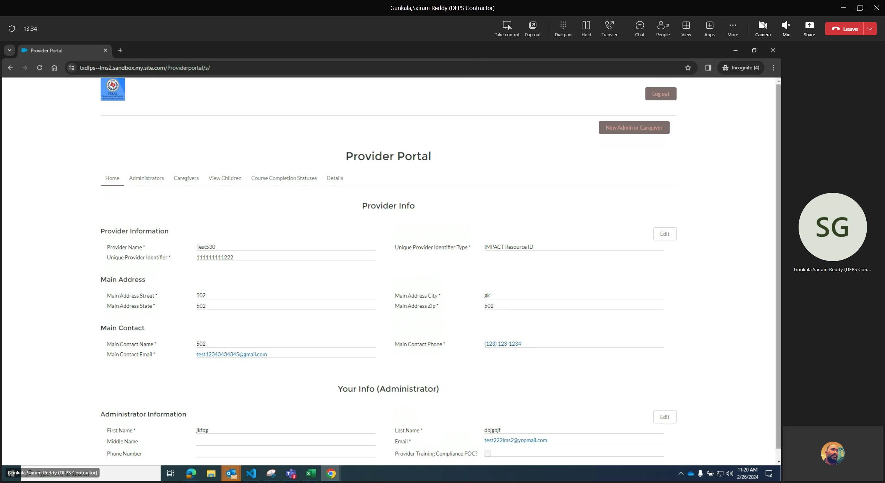

Note: Refer to the below screenshot - Provider Portal Users must NOT use “Sign up Now” to create new accounts in the MyDAP. If you believe a new account (setting up of an organization) is necessary, please contact help desk at 877-642-4777, Press *, and then Option6-Other to reach a Help Desk Representative.

