

TRAFFIC ADVISORY REPORT
Friday and Saturday, Dec. 9 & 10

Please be advised, a special event series included as part of the BMW Dallas Marathon, is scheduled to occur on Saturday, Dec. 9 in Downtown Dallas. The Coors Light 10K and 5K begin at 8 a.m. and the Oncor Mayor’s Race will begin at 11 a.m.

The following street closures will begin on Friday, Dec. 8 at 6 p.m.:
- Young Street from Evergreen Street to South Houston Street
- South Akard from Wood Street to Marilla Street
- South Field Street from Wood Street to Young Street
- Marilla Street from Young Street to South St. Paul Street
- Browder Street from Young Street to Canton Street
- South Ervay Street from Wood Street to Canton Street
The following street closures will begin on Saturday, Dec. 9 at 7 a.m.:
- Griffin Street at Young Street
- Wood Street from South Griffin to South Houston Street
- South Market from Main Street to Young Street
- South Record Street from Wood Street to Young Street
- South Lamar Street from Main Street to Young Street
- South Houston Street from Reunion Boulevard West to Reunion Boulevard East
- Reunion Boulevard East from Sports Drive to South Houston Street, north lane to remain open for Hyatt Regency access
- Sports Street northbound lanes from Reunion Boulevard East and Memorial Drive
- North Drive from Sports Street to Hotel Street
- Hyatt Regency Hotel Drive from Reunion Boulevard East to Memorial Drive
- North Riverfront Boulevard – northbound lanes from West Commerce Street to the Margaret Hunt Hill Bridge ramps
- Margaret Hunt Hill Bridge – inside lanes of eastbound and westbound sides
- Main Street from Main Street/Commerce Street to South Walton Street
- South Walton Street from Main Street to Commerce Street
- Commerce Street from South Houston to North Riverfront Boulevard and from South Walton to South Good Latimer Expressway
- South Cesar Chavez Boulevard at Main Street
- Elm Street from South Houston to Elm Street/Commerce Street
- South Good Latimer Expressway from Main Street to Canton Street
- Canton Street from South Good Latimer Expressway onto Young Street

Alternate Routes:
  - Westbound: Jackson Street, Elm Street, or Canton Street
  - Eastbound: Cadiz Street, Pacific Avenue, or Woodall Rogers Freeway
  - Northbound/Southbound: Griffin Street, U.S. 75 Central Expressway, I-35
North and South
- Access to Kay Bailey Hutchison Convention Center Dallas is available from the south: from R.L. Thornton (I-30) West, exit Ervay/Griffin Street to the convention center; From I-35E North, take exit 427D E to R. L. Thornton Freeway (I-30) and exit Griffin Street
- City Hall parking garage is accessible via DPD barricades at Akard Street and Canton Street with approved parking passes

Parking:
- Metered parking will be prohibited throughout the streets referenced above through Monday, Dec. 11 at 7 a.m.
- Pioneer Plaza parking lots are closed beginning Thursday, Dec. 7 at 4:30 a.m. through Monday, Dec. 11 at 7 a.m.

Staging and setup will impact traffic around City Hall Plaza all week beginning 10 a.m. on Friday, Dec. 1.

Please refer to the route maps attached and plan travel accordingly. If you have any questions or for more information, please contact at Marcus Grunewald at (214) 800-2087, ext. 2. Additionally, you may contact the Office of Special Events (Monday - Friday 8 a.m. – 5:30 p.m.) at specialevents@dallascityhall.com or by calling (214) 939-2701.

Coors Light 5K & 10K Race
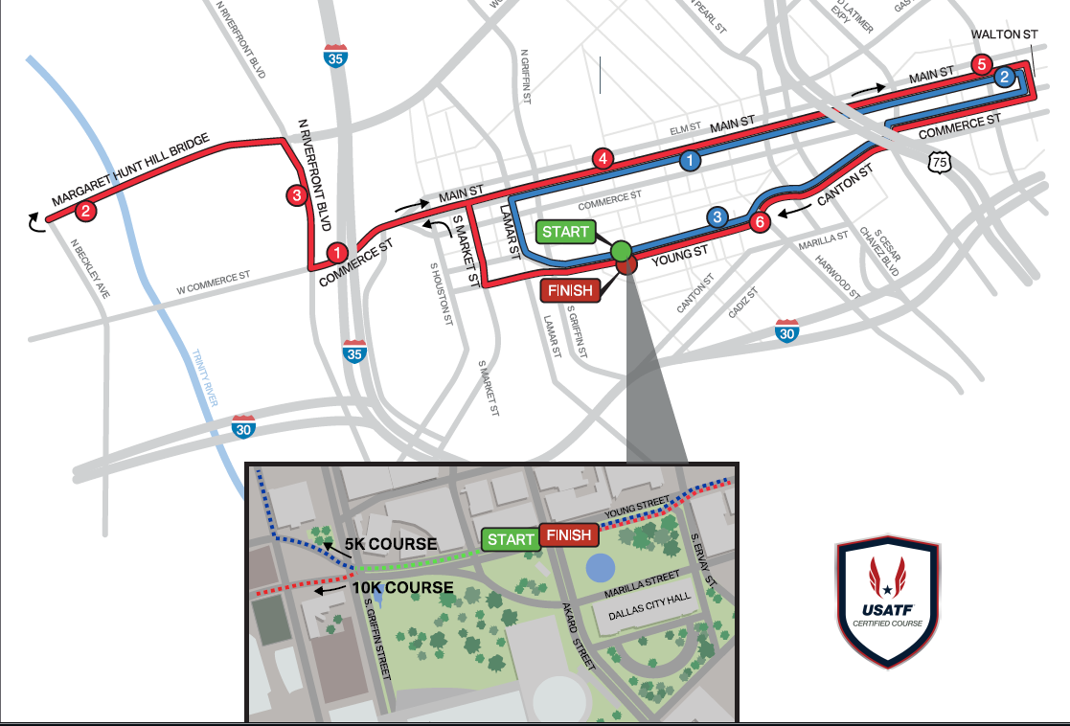

Oncor Mayor’s Race
