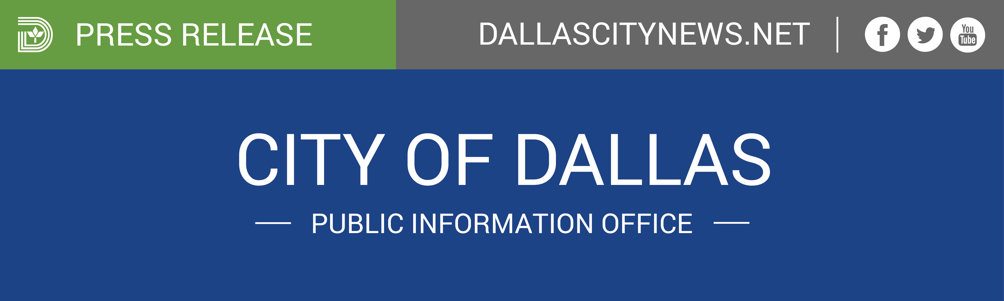
FOR IMMEDIATE RELEASE For more information contact:
March 30, 2017 Sanitation Services
(214) 670-3555

City of Dallas storm response/cleanup
Dallas – The Department of Sanitation Services will be collecting storm debris from the March 29 storms during resident’s established weekly bulk/brush collection schedule for the month of April. Sanitation Services is currently working on completing the March week 4 areas, which are estimated to be complete Saturday, April 1. April collection begins on Monday April 3.
Week 1 – Scheduled Collection for Bulk/Brush & Storm Debris (April 3-8)
Week 2 – Scheduled Collection for Bulk/Brush & Storm Debris (April 10-15)
Week 3 – Scheduled Collection for Bulk/Brush & Storm Debris (April 17-22)
Week 4 – Scheduled Collection for Bulk/Brush & Storm Debris (April 24- 29)
Sanitation Services will be working six days a week, with assistance from Code Compliance and outside resources (if needed), in the collection efforts. The department’s goal is to maintain the established weekly collection schedule for the month of April, but this could change based on the volume of debris. During April, if possible, we would ask residents to please limit bulky item setouts (appliances, carpet, etc.) as this will assist with the speed of the brush collection efforts.
Residents may begin placing storm debris curbside now for collections. Sanitation Services asks that residents enter a Storm Brush-Debris service request at www.dallascityhall.com or contact 311 after they place their set out. This will help document storm debris setouts and assist with identifying specific storm debris service needs. Although the goal is to maintain the established bulk and brush collection schedule for April, if resources allow, Sanitation Services may begin picking up storm related debris only ahead of resident’s normal bulk and brush collection week. Out of cycle collections will be for storm related debris only (i.e., no bagged leaves, furniture, appliances, etc.). Sanitation cannot guarantee an early or out of cycle collection, as collection may not occur until residents’ scheduled collection week.
Next week, after residents have had the opportunity to place storm debris out for collection, Sanitation Services staff will reassess the current collection plan and decide if additional resources or changes are required.
Code Compliance will suspend the issuance of citations for early set out of storm related debris only through the month of April.
Visit http://dallascityhall.com/departments/sanitation/pages/brush_and_bulky.aspx to determine your brush/bulk collection week.

