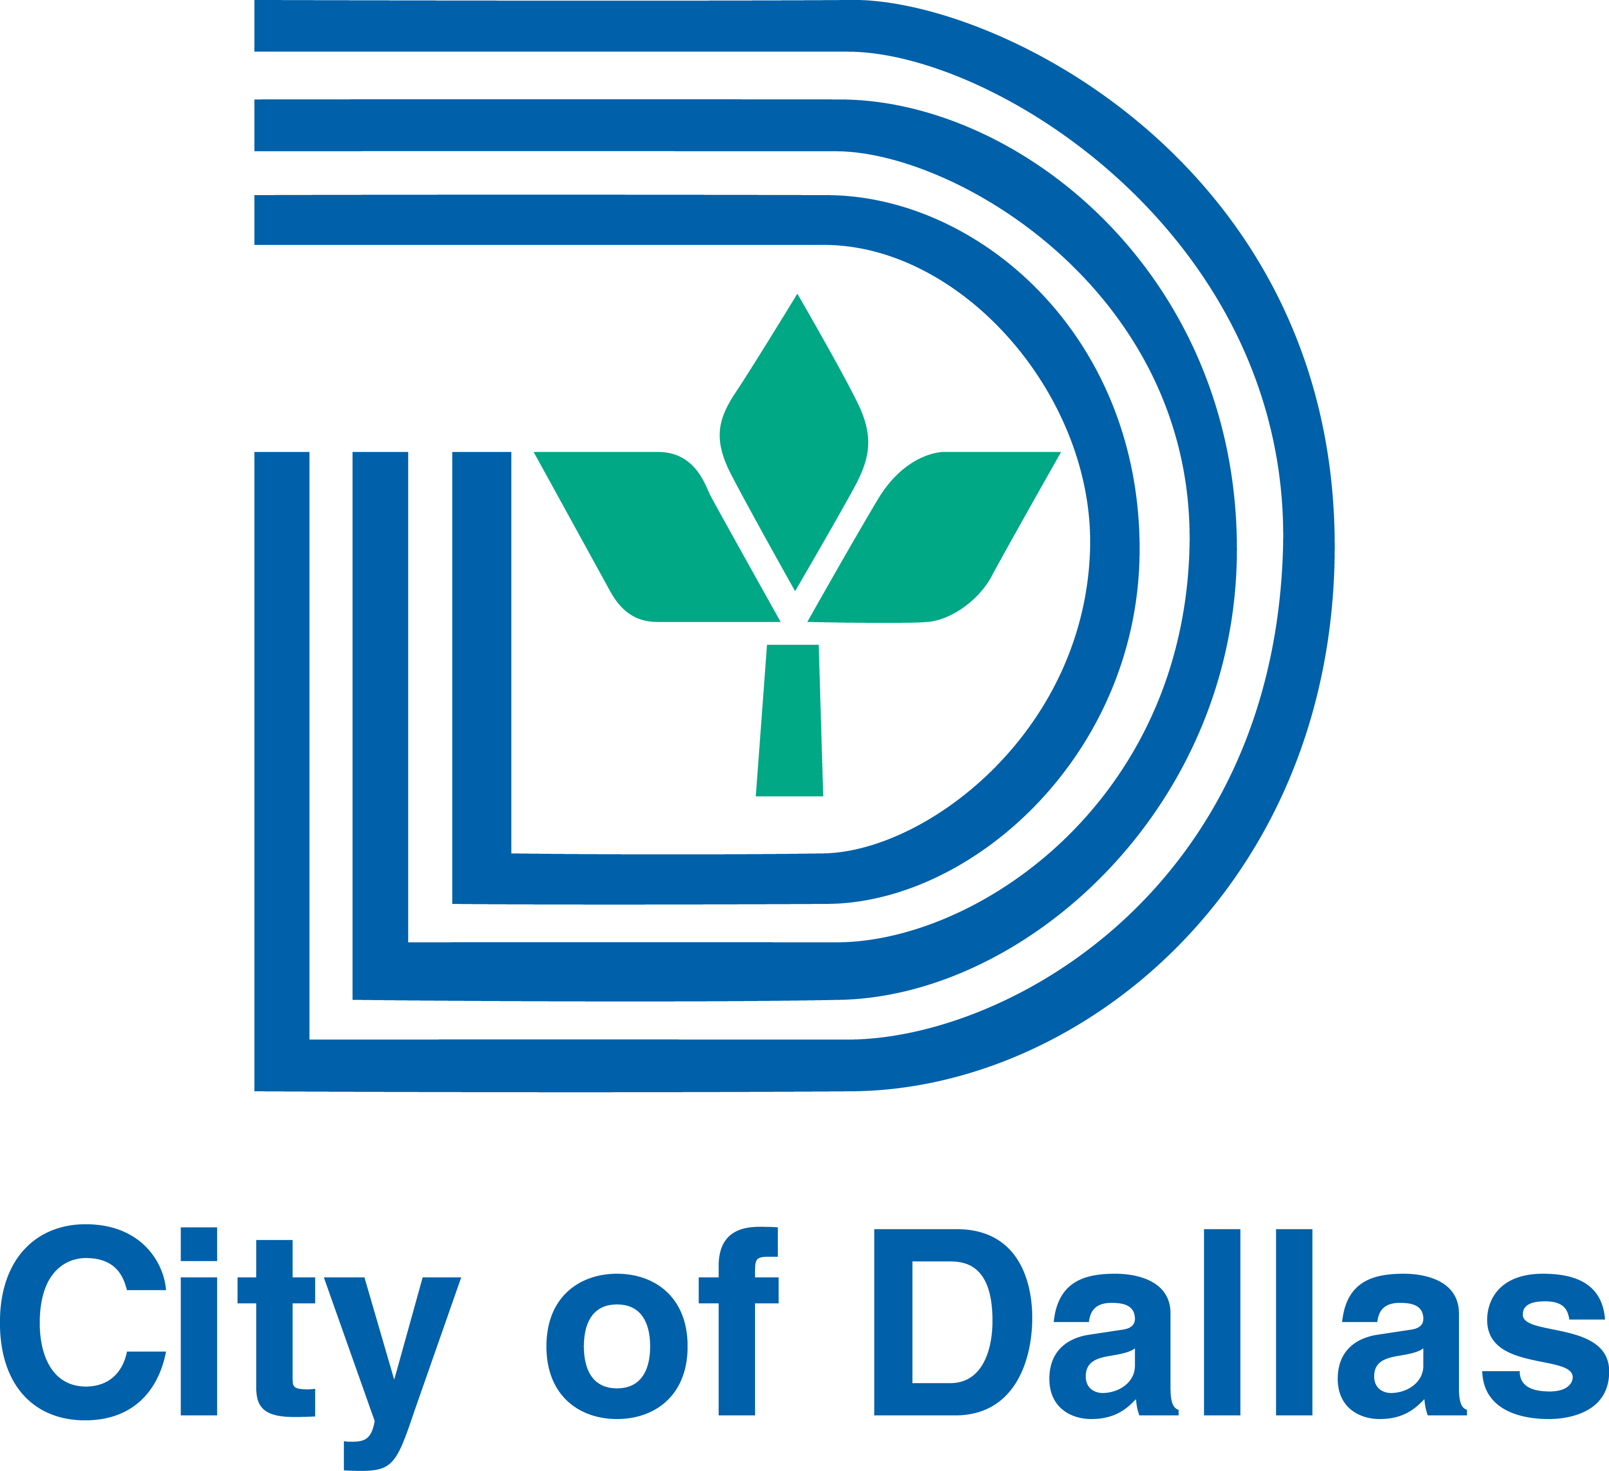


FOR IMMEDIATE RELEASE
Nov. 10, 2016

Contact:
Erik Wheater
ewheater@burns-360.com
Cell: 515-554-2937
Deep Ellum ribbon cutting ceremony/media open house set for Friday

WHAT: The revitalization of Deep Ellum, one of Dallas’s most vibrant communities continues as a combination of four unique bars and restaurants are set to move into properties where large scale restoration projects were completed earlier this month by Dallas-based construction and engineering firm C1S. This Friday, Council Member Adam Medrano, Dallas officials and the Deep Ellum Foundation will join the companies responsible for these restoration efforts in a ribbon cutting ceremony and open house event.

Not only was a multi-million-dollar investment made in the restoration of these properties, but the Deep Ellum community was also the benefactor of $1.6 million in TIF funding from the City of Dallas. This allowed for civil upgrades to utilities, pedestrian access, public space, and beautification throughout Deep Ellum. While the economic impact of the project is yet to be determined, City officials say tax revenue generated from the new businesses is expected to be significant.

WHO: C1S; Westdale; Dallas City Councilmember Adam Medrano, District 2; Jon Hubach, Economic Development Analyst, City of Dallas; Jessica Burnham, Executive Director, Deep Ellum Foundation; Evan Sheets, Senior Urban Designer City of Dallas Design Studio; Droese Raney Architecture.

WHAT: Ribbon cutting ceremony and media open house to celebrate the Deep Ellum restoration project.

WHERE: 115 Malcolm X Blvd.

WHEN: 10 a.m. Friday Nov. 11

WHY: With history and landmarks dating back to the 1800’s, there has been a significant investment made in restoring Deep Ellum back to the vibrant community it once was. Today, this new corridor will boast four new bars and restaurants, all of which will add something new and unique to the area, attracting visitors from not only North Texas, but across the country.

BARS/RESTAURANTS COMING TO NEW CORRIDOR:
Hide Bar (2816 Elm Street): Expected to open by the end of 2016, Hide will use technology like centrifuges and vaporizers to create clear, clean cocktails and will feature a menu of fresh fare, including small plates, salads, and sandwiches.

The Table (2826 Elm Street): With a location in Flower Mound, this restaurant offers American cuisine with global influences in a refined, yet rustic setting. It will also feature innovative and classic craft and pre-prohibition style cocktails, as well as new and old world wines and quality beers on tap.

Harlowe MXM (2823 Main Street): Also expected to open by the end of the year, this location will be a brunch goer’s favorite. This bar-restaurant will feature both a ground level patio, as well as a rooftop patio.

Baker and Company (2820 Elm Street): Opening in February of 2017, the bar/restaurant will feature small plates and old-fashioned cocktails. Guests will enjoy jazz music and a 1920’s theme at this unique addition to Deep Ellum.

Note: Members of the media will have opportunities to get photographs and B-roll of the newly finished properties, as well as interviews with key stakeholders.

###

