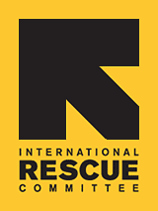
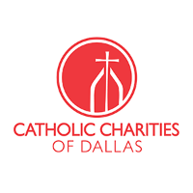
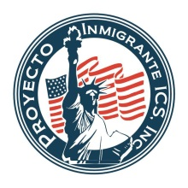

May 16, 2016

FOR IMMEDIATE RELEASE FOR MORE INFORMATION CONTACT:

Jessica Hernandez, Catholic Charities Dallas
(214) 634-7182, ext. 1424
jhernandez@ccdallas.org

Jasmine Kallenberg, Dallas Public Library
(214) 670-1635 jasmine.kallenberg@dallascityhall.com

Free citizenship application help provided Saturday at library workshop

Dallas – The Dallas Public Library, Catholic Charities Dallas and International Rescue Committee and Proyecto Inmigrante will host a workshop for legal permanent residents who need assistance completing the N-400 application.

The Citizenship Mega Workshop is open to the first 300 applicants and will be held at 9 a.m. Saturday on the first floor of the J. Erik Jonsson Central Library, 1515 Young St. Immigration attorneys and BIA Accredited representatives will be available to help applicants complete the N-400 application and review the application when completed. Applicants must still provide the application fee of $680 in money order form with their application.

“Most legal permanent residents want to become citizens,” said Dallas Public Library Adult Services Administrator Jasmine Kallenberg. “They just don’t know where to start or how to navigate the process without spending a lot money.”

According to the New Americans Campaign, 61 percent of citizen-eligible legal permanent residents have never received information on how to become citizens. Organizations like Catholic Charities Dallas, International Rescue Committee and Proyecto Inmigrante help offset the cost of becoming a citizen by helping people through the application process and offering legal advice.

“There are so many qualified green-card holders who hesitate to take the final step for a variety of reasons, including the cost of legal representation,” said Catholic Charities of Dallas Citizenship Program Manager Luis Miguel Arango. “Our team has the knowledge and experience to easily guide applicants through this process to become naturalized citizens, and we hope people will take advantage of this opportunity.”

Applicants should bring Green Card, Social Security Card and driver’s license or State ID, two passport-style color photos, dates of travel outside the U.S. over the last five years, list of addresses of residence over the last five years and dates and information related to marriage, divorce, spouse, children or arrests, if applicable.

For more information, interested applicants should call Jessica Hernandez, Catholic Charities Dallas (214) 634-7182, ext. 1424.

The Dallas Public Library is committed to supporting lifelong learning and civic engagement. The library offers an array of adult education and literacy classes including English as a Second Language (ESL), High School Equivalency (HSE), Citizenship and computer classes. For more information on literacy program offerings visit www.dallaslibrary.org/literacy.

Catholic Charities of Dallas exists to serve, advocate, and empower people in need regardless of race, religion, age, gender, or national origin. Charities of Dallas’ Immigration and Legal Services (ILS) program offers free to low-cost citizenship services to applicants who qualify for citizenship. For more information visit http://www.catholiccharitiesdallas.org/

The International Rescue Committee (IRC) responds to the world’s worst humanitarian crises and helps people to survive and rebuild their lives. At work in over 40 countries and 26 U.S. cities to restore safety, dignity and hope, the IRC leads the way from harm to home. The IRC provides a range of services for refugees, asylees, and immigrants. Amongst these, the IRC in Dallas offers free civics classes, as well as low-cost immigration and citizenship services for qualified applicants. For more information, visit http://www.rescue.org/us-program/us-dallas-tx

Proyecto Inmigrante is committed to serve, educate, and assist the immigrant community in matters concerning immigration and education. Our agency is recognized and accredited by the U.S. Department of Justice, Executive Office for Immigration Review, and Board of Immigration Appeals with offices in the cities of Dallas, Fort Worth and Wichita Falls Texas. Through our legal representation programs and immigration counseling services centers, we have made a positive impact on the lives of thousands of low income families in our community affected by the inefficient immigration laws.For more information visit http://www.proyectoinmigrante.org/

###

