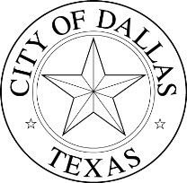
COUNCILMEMBER
CAROLYN ARNOLD
DISTRICT 4

MEDIA ADVISORY
__________________________________________________________

April 7, 2016
FOR IMMEDIATE RELEASE

Ozella M. Lewis
Executive Assistant
ozella.lewis@dallascityhall.com
(214) 670-0781

Franklin Meredith, Executive Office Assistant
franklin.meredith@dallascityhall.com
(214) 671-9347

District 4 first annual Fair Housing Symposium to be held April 28

What: The Honorable Councilwoman Carolyn King Arnold presents her first annual Fair Housing Symposium for District 4. This event will consist of breakout sessions that cover the topics of home ownership, energy efficiency and go-green strategies, City of Dallas code chapter 27 review, and Fair housing landlord/tenant issues. This event is free and designed for all homeowners and renters in the Dallas area.

Please register online at: http://district4fairhousingsymposium.eventbrite.com.

Online registration is highly encouraged and will be open until all spots are filled. This event will showcase private community partners, and City of Dallas resources.

When: Thursday April 28

Registration/check-in: 8:30 to 9 a.m.

Event time: 9 a.m. to 2:30 p.m.

Where: Oak Gardens Church, 4008 S. Polk St.

