
FOR IMMEDIATE RELEASE
Jan. 7, 2015

MEDIA CONTACTS:
Katrina Keyes, Public Relations Director Jose L. Torres, Public Information Officer
Love Field Modernization Program City of Dallas
E: kkeyes@kstrategies.com E: jose.torres@dallascityhall.com
C: 214-403-2583 O: 214-670-3484

Dallas Love Field Cell Lot has been relocated

DALLAS – Dallas Love Field Airport relocated its cell phone lot on Monday, Jan. 4, 2016 to a new area on the east side of Herb Kelleher Way, south of Aviation Place. The new lot is depicted in red on the map below.

The cell phone lot gives vehicles picking up arriving passengers a place to wait, since curbside parking is prohibited. Only attended, non-commercial vehicles are allowed in the lot. The lot will include 110 parking spaces, allowing 50 more cars than the previous location and it has a one-hour parking limit for attended cars. The relocated cell phone lot is a long-term adjustment to allow for the construction of Parking Garage C.

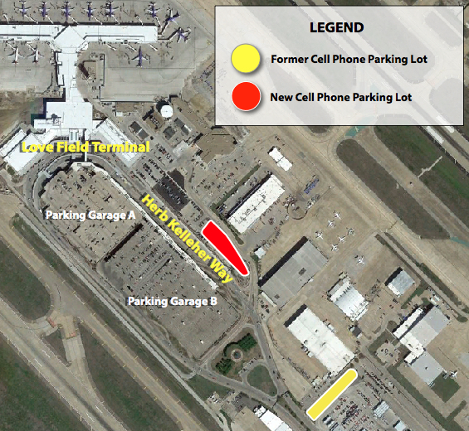

The relocation of the cell phone lot is part of the ongoing Love Field Modernization Program (LFMP), which works to create a cohesive and modern facility to serve the needs of Dallas citizens and travelers for many years to come. To date, LFMP has included the opening of a new centralized concourse with 20 gates, a remodeled lobby, expanded baggage claim and a new ticketing/check-in hall. LFMP continues with the design and construction of Parking Garage C, slated to open in 2018.

