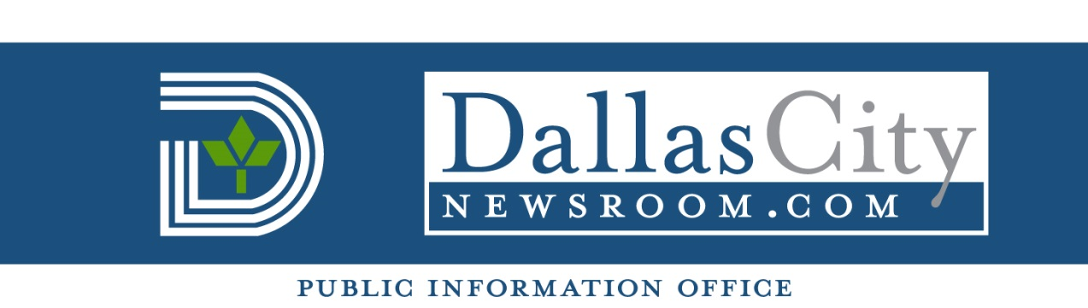

For Immediate Release Contact:
April 10, 2015 Kay Kallos
Public Art Manager
City of Dallas/Office of Cultural Affairs
214.670.3281
Kay.Kallos@dallascityhall.com

Margaret Fullwood
Marketing Manager
City of Dallas/Office of Cultural Affairs
214.670.4428
Margaret.Fullwood@dallascityhall.com

ORIGINAL DALLAS PEGASUS
FINDS NEW HOME AT THE OMNI HOTEL
DALLAS: The original Pegasus that once perched atop the downtown Dallas headquarters of the Magnolia Petroleum Co. from 1934 to 1999 will have a new home. The familiar icon of the City of Dallas skyline will soon dazzle residents and visitors from its new location in front of the Omni Hotel, 555 S. Lamar, Dallas 75202. Restoration of the original sign panels began in 2013 and, now complete with a new set of neon lights, the restored sculpture will be installed over the next two weeks.
“We are excited and grateful for the opportunity to be able to display this cultural artifact once again,” says Office of Cultural Affairs Interim Director David Fisher. “The original Pegasus that once flew over the Dallas skyline will now serve as an wonderful counterpart to the Omni Hotel. It will become a cultural destination for everyone who visits downtown Dallas.”

The restoration and installation of the Pegasus is the result of a partnership between the Office of Cultural Affairs and Matthews Southwest. In the fall of 2013, the two parties entered into an agreement allowing Matthews Southwest to restore the original Pegasus panels that had been in storage for many years. The agreement outlined the understanding that the Pegasus would be displayed on City of Dallas property in front of the Omni Hotel. The restoration of the Pegasus was done by Van Enter Studios, which has overseen numerous restorations for the City of Dallas. The Pegasus will rotate atop a derrick built by Tony Collins of Tony Collins Art, the company that will conduct routine maintenance on the mechanism and structure for the next 10 years.

ABOUT THE PEGASUS
The original 1934 Pegasus, fabricated by Texlite Signs of Dallas, is one of the City’s most enduring emblems. The Pegasus became the logo of Mobil Oil when it merged with Magnolia Petroleum in 1959. The Pegasus atop the Magnolia Hotel received Landmark Status in 1973 and became City of Dallas property in 1976. The Magnolia Building was listed in the National Registry of Historic Places in 1978 and, in 1997 was converted to the present-day Magnolia Hotel. In anticipation of the City of Dallas’ Millennium Celebration, the original Pegasus, which had deteriorated, was removed and a new one was commissioned in 1999. It was lit for the first time at the stroke of midnight January 1, 2000. The 1934 Pegasus was on view at the Dallas Farmer’s Market and later carefully crated and put into storage. The metal panels were reviewed for restoration in 2013, with restoration taking place over the following two years.

ABOUT THE PUBLIC ART PROGRAM
The Public Art Program works to enrich the quality of life for the citizens of Dallas and enhance the cultural appeal of the City to visitors by overseeing the integration of high-quality visual art into public spaces. The Program provides opportunities for local and regional artists as well as visual artists from around the globe through commissions of works of public art. The program also supports donations of public art to the City of Dallas that are subject to a review process for acceptance that includes members of the Public Art Committee and the Cultural Affairs Commission. The Public Art Program is a division of the City of Dallas Office of Cultural Affairs. http://www.dallasculture.org/publicArt.asp

ABOUT THE OFFICE OF CULTURAL AFFAIRS
The Office of Cultural Affairs (OCA) provides opportunities for all Dallas citizens and visitors to have access to the arts and the means of cultural expression. The Office of Cultural Affairs works with its citizen advisory board, the Cultural Affairs Commission, to foster the development of the cultural system in Dallas. OCA provides a variety of programs and services, including the management and operations of seven cultural facilities, a public art program, cultural funding programs and WRR Radio. More information on the Office of Cultural Affairs’ programs can be found on its website at http://www.DallasCulture.org.

Image Credits –Van Enter Studio LTD

