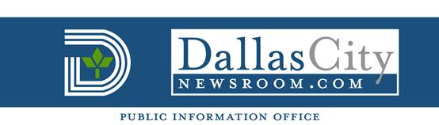

FOR IMMEDIATE RELEASE FOR MORE INFORMATION CONTACT:
Nov. 19, 2014 Monica Huerta – Council Assistant
(214) 670-4048
Councilmember Adam Medrano joins NALEO “boot camp” training

Washington, D.C. - Dallas City Councilmember Adam Medrano will join other newly-elected Latino officials for an intensive “boot camp” training seminar at the National Association of Latino Elected and Appointed Officials (NALEO) Nov. 20-23 in Washington, D.C.

The three-day “boot camp” is a comprehensive introduction to public service, with seminars addressing budgeting, staffing, policymaking, and other key governance issues and is part of the group’s National Institute for Newly Elected Officials.

“I’m looking forward to working with my fellow elected officials from across the country,” said Councilmember Medrano. “This is a great opportunity to sharpen my skills and learn from professionals and experts at all levels of government.”

Medrano will join NALEO President Alex Padilla, the first Latino elected to serve as California Secretary of State; Nellie Gorbea, the first Latino Secretary of State in Rhode Island; Victoria Seaman, the first Latina Republican elected to the Nevada State Assembly; and NALEO Educational Fund Chair Pauline Medrano, former Dallas City Councilmember and the first Latina elected Dallas County Treasurer.

For more information visit http://www.naleo.org/institutes/newlyelected/.

###

