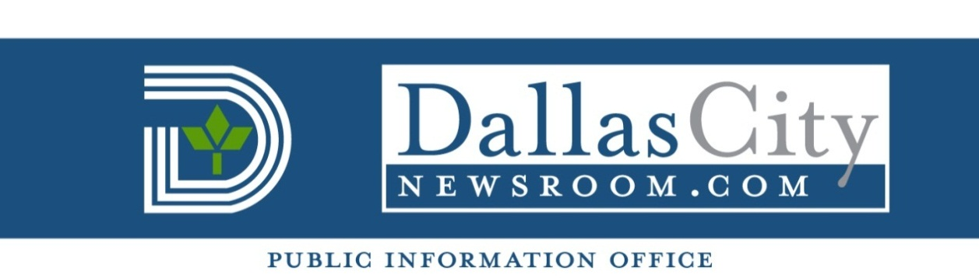
FOR IMMEDIATE RELEASE For more information contact:
Nov. 6, 2014 Mina Ramon – Council Assistant
(214) 670-0776

  - Councilmembers Griggs and Caraway to host
turkey giveaway and health fair on Nov. 21

  - Who: District 1 Councilmember Scott Griggs and District 4 Councilmember Dwaine R. Caraway will present a turkey giveaway and health fair on Friday, Nov. 21. The event will include free health screenings and flu shots for $10.

  - To register for a free turkey call (214) 671-8922 (while supplies last - limit one per household). The turkey giveaway is for Dallas residents only and is not available to city employees. Sponsors of the event include Advantage Healthcare Systems, Central Market, Walmart, HEB, Costco, and University General Hospital of Dallas.

When: 2 to 6 p.m. Friday Nov. 21

Where: Advantage Healthcare Systems, 214 W. Colorado Blvd.

###

