

FOR IMMEDIATE RELEASE FOR MORE INFORMATION CONTACT:
May 23, 2014 Dee Ann Bell, Fair Park
(214) 670-8508
Fair Park Sparks! brings fireworks and music to Fair Park June 13 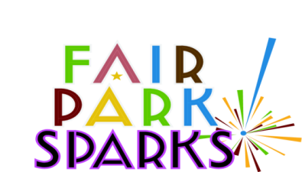

Dallas - The public is invited to attend Fair Park Sparks!, a fun-filled event for the entire family from 5:00 to 10:30 p.m. on Friday, June 13. The free outdoor festival celebrates the addition of thousands of new decorative enhancement lights that will illuminate Fair Park’s historical buildings, grounds and the ever-popular Esplanade Fountain.

"Turning on the lights and fountains reflects the city's commitment to improving Fair Park and its surrounding neighborhoods as we continue to grow south," Mayor Mike Rawlings said. "I encourage all citizens to drop by Fair Park Sparks! to enjoy the live music, food, fireworks and family activities and experience one of our city's greatest assets in a whole new way."
Musical entertainment will include nationally recognized bands Sugar Ray with guest Big Bad Voodoo Daddy. Synchronized fountain shows will take place at the Esplanade, along with an artist gallery, wine bar, concessions, food trucks, event booths and museums. Children’s activities will include face painting and roving entertainers. The evening will conclude with a spectacular fireworks display.

“Fair Park is the premiere year-round destination for visitors and offers many events and entertainment opportunities for the entire family,” said Fair Park General Manager Daniel Huerta. “Everyone is invited to join us for Fair Park Sparks! and experience live entertainment under one million lights.”

Admission to Fair Park Sparks! is free. Parking will be available at gates 5 and 6 for $5. Visitors can also take the DART Green Line to Fair Park.

Fair Park is host to eleven of the top 29 festivals in the DFW metroplex. Annually, more than 5.3 million visitors enjoy 1,200 festivals, shows, concerts, performances, including the North Texas Irish Fest, Kwanzaa, Taste of Dallas, Festival de Mayo, Earth Day, 5k and 10k and half marathon runs and other special events.

###

