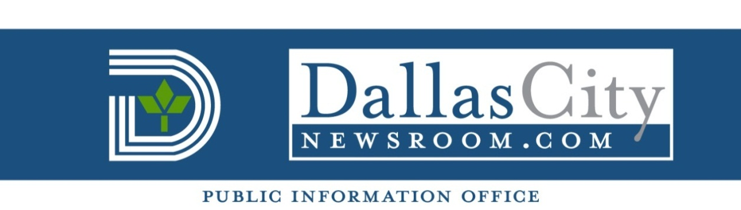
FOR IMMEDIATE RELEASE For more information contact:
Nov. 22, 2013 Norma Olvera – Council Assistant
(214) 670-0781

  - Councilmember Caraway and Dallas Youth Council
turkey giveaway to be held Saturday
  - Who: District 4 Councilmember Dwaine R. Caraway and the Dallas Youth Council will give away 300 Thanksgiving turkeys tomorrow. This event is to help those families in need enjoy this holiday season with their loved ones.

The giveaway is for Dallas residents and surrounding areas. Sponsors of the event include Kroger and HEB.

When: 10 a.m. to 2 p.m. Saturday, Nov. 23

Where: Big T Bazaar, 4515 Village Fair Drive

###

