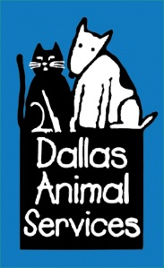


For Immediate Release
Oct.21, 2013
Contact:
Jennifer Douglas, GolinHarris for PetSmart Charities
972-341-2552
jdouglas@golinharris.com

PetSmart Charities, Dallas Animal Services team up to save hundreds of pets

Phoenix - Homeless pets in Dallas will have a better chance of finding a loving home thanks to a partnership between PetSmart Charities and Dallas Animal Services. The two have teamed up with support from PetSmart®, Inc., to open a pet adoption center inside the PetSmart store at 16821 Coit Road. Since the center opened on Sept. 10, 151 pets have found forever homes.

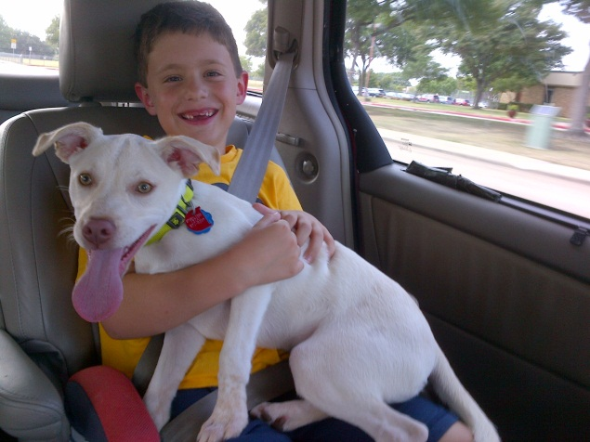
Kona’s Story
Glenn and Karen Garfield and their kids, Zach (right) and Lily, had been following Dallas Animal Services on Facebook for quite some time and were thrilled when the new everyday adoption center opened near their home. The Garfields were quickly drawn to Kona. After spending lots of time with her in the play room and watching her interact with Zach and Lily, they knew she was the perfect fit for their family. Kona’s been enjoying car rides, long walks, and lots of quality time with her new family.

The new cat and dog everyday adoption center will officially open on Nov. 2, freeing up kennel space at Dallas Animal Services’ main shelter and allowing adoptable pets to live in a new pet-friendly venue until they are adopted. The 2,000 square foot center will house approximately 46 dogs, cats, puppies and kittens and about 20 pets are expected to be adopted from the new adoption center each week.

“Our partnership with Dallas Animal Services allows us to promote pet adoptions and reduce pet homelessness in the local community,” said PetSmart Charities, Inc. Executive Director Jan Wilkins. “We are thrilled to bring this everyday adoption center model to Dallas; each of these adoption centers allows us to save on average more than 1,000 pets every year.”

“Dallas Animal Services is proud to be a partner with PetSmart Charities,” said Dallas Animal Services Division Manager Jody Jones. “The everyday adoption center will provide us the opportunity to bring pets to a whole new audience in our community. We are excited about this wonderful opportunity to find additional homes for the homeless pets in our care.”

The Dallas everyday adoption center will be open seven days a week during the store’s operating hours. Amenities include:
- Kennels for adult dogs, puppies and small dogs
- Cat adoption center
- Play areas for dogs awaiting adoption
- Meet‐and‐greet areas for prospective adopters and their families to get acquainted with the pet(s) they want to take home

The everyday adoption center is part of a nationwide initiative from PetSmart Charities with the goal of saving more homeless pets. Since May 2010, PetSmart Charities has helped save more than 45,000 pets by opening similar adoption centers in 11 states.

About PetSmart Charities®
PetSmart Charities, Inc. is a nonprofit animal welfare organization that saves the lives of homeless pets. More than 400,000 dogs and cats find homes each year through our adoption program in all PetSmart® stores and our sponsored adoption events. PetSmart Charities grants more money to directly help pets in need than any other animal welfare group in North America, with a focus on funding spay/neuter services that help communities solve pet overpopulation. PetSmart Charities is a 501(c)(3) organization, separate from PetSmart, Inc.
ABOUT DALLAS ANIMAL SERVICES
Dallas Animal Services (DAS) is the municipal open admissions shelter for the City of Dallas. We provide lost and found services to reunite owners with their pets, pet adoptions, and transfer animals to animal welfare partners. DAS also provides animal control for the City of Dallas. DAS and our partners provide community outreach by hosting spay days and vaccination clinics to help citizens comply with City ordinances, which DAS is responsible for enforcing.

