FOR IMMEDIATE RELEASE FOR MORE INFORMATION CONTACT:
Thursday May 30, 2013 Pamè La Ashford - Central Liaison
pame_la.ashford@dallascityhall.com
(214) 671-8875

City of Dallas to be acknowledged for Urban Gardens success;
Deep Ellum Community Association holds official welcome and appreciation ceremony

Dallas, TX – City of Dallas councilmembers and executive staff will be acknowledged for their vital role in helping the Deep Ellum Community Association turn an open grassy median into a vibrant focal point of the downtown area. Expected attendees include State Representative Dan Branch, City Manager Mary Suhm, Councilmember Pauline Medrano, Councilmember Angela Hunt and newly- elected Councilmember Adam Medrano.

What: Deep Ellum Urban Gardens Welcome & Appreciation Ceremony
When: 10 a.m. Saturday June 1
Where: Deep Ellum Urban Gardens - 2620 Canton St. (corner of Canton & Good Latimer)

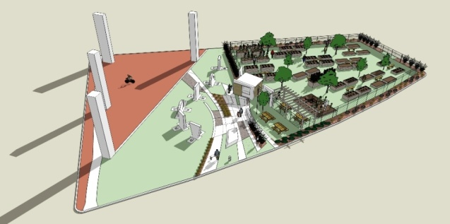

Developed in compliance with City’s ordinances, the Deep Ellum Urban Gardens was created to promote daytime community interaction and improve the image of the Deep Ellum neighborhood. Serving as a social connector between the Deep Ellum, Downtown and Farmers Market neighborhoods, the Deep Ellum Urban Gardens is one of many examples of how the City of Dallas and area neighborhoods are working together to improve the quality of life in communities citywide.

