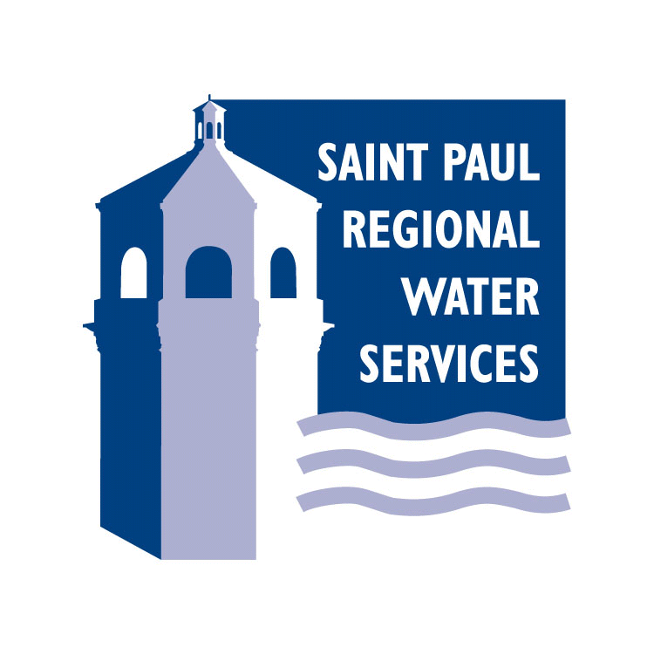
1900 Rice St
Saint Paul MN 55113-6810

NEWS RELEASE
Media Contact:
Jodi Wallin, Public Information
651-266-6308
Come! Find Out About Your Drinking Water!
SPRWS Announces McCarrons Water Treatment Plant Tours in Celebration of Drinking Water Week
SAINT PAUL, MINN. April 26, 2017: Saint Paul Regional Water Services is hosting an open house at its treatment facility from 2 p.m. to 7 p.m. on Thursday, May 11, as one of several activities it will be holding as part of National Drinking Water Week, May 7 - 13.
Get to know the water you use every day. Where does it come from? What does it take to make it drinkable? If you are curious about your water, take advantage of the chance to see the work done behind the scenes to ensure high quality drinking water is reliably delivered to your tap every day.
“Few people have any idea of how their water is treated and actually gets to their home,” said Jim Bode, production division manager. “This is an opportunity for people to see a process that is normally taken for granted.”
Come take a taste test and see how good your taste buds are at detecting differences in water. You will be able find out whether or not you have lead water services lines providing water to your home and see what lead pipes look like. You can learn how to clean out the aerator in your faucet to reduce exposure to lead. You can also find out about jobs at the water utility. The utility will have water bottles, activity books for children, and flash drives with water-related videos to take home.
Meet in the lobby in the administration building to register for tours. Tours take about an hour. They begin at 2 p.m. and the last one starts at 6:30 p.m. You should wear sturdy shoes with closed toes, be able to walk about a half mile, and be able to navigate stairs. We welcome children accompanied by adults.
McCarrons Center is located at 1900 Rice Street, just north of Larpenteur Avenue. Prominent signs for SPRWS and the open house will be located along Rice Street near the entrance. The public can also enter on Sylvan Street from Larpenteur Avenue. Free parking will be available in the parking lot next to the administration building.
For more than 35 years the American Water Works Association and its members have celebrated Drinking Water Week as a unique opportunity for both water professionals and the communities we serve to join together in recognizing the vital role water plays in our daily lives.
For further information, please call SPRWS at 651-266-6350.
###

