How to Create an Account in CivicRec
You will register for our LL@RH courses using the CIVIC REC program.
Note: The sample screens shown on this page are what you would see if working on a desktop or laptop computer. The screens on a mobile device will look different.

[1] Begin by visiting the website: cityofrockhill.com/lifelonglearning
[2] On this page, click on PROGRAM REGISTRATION
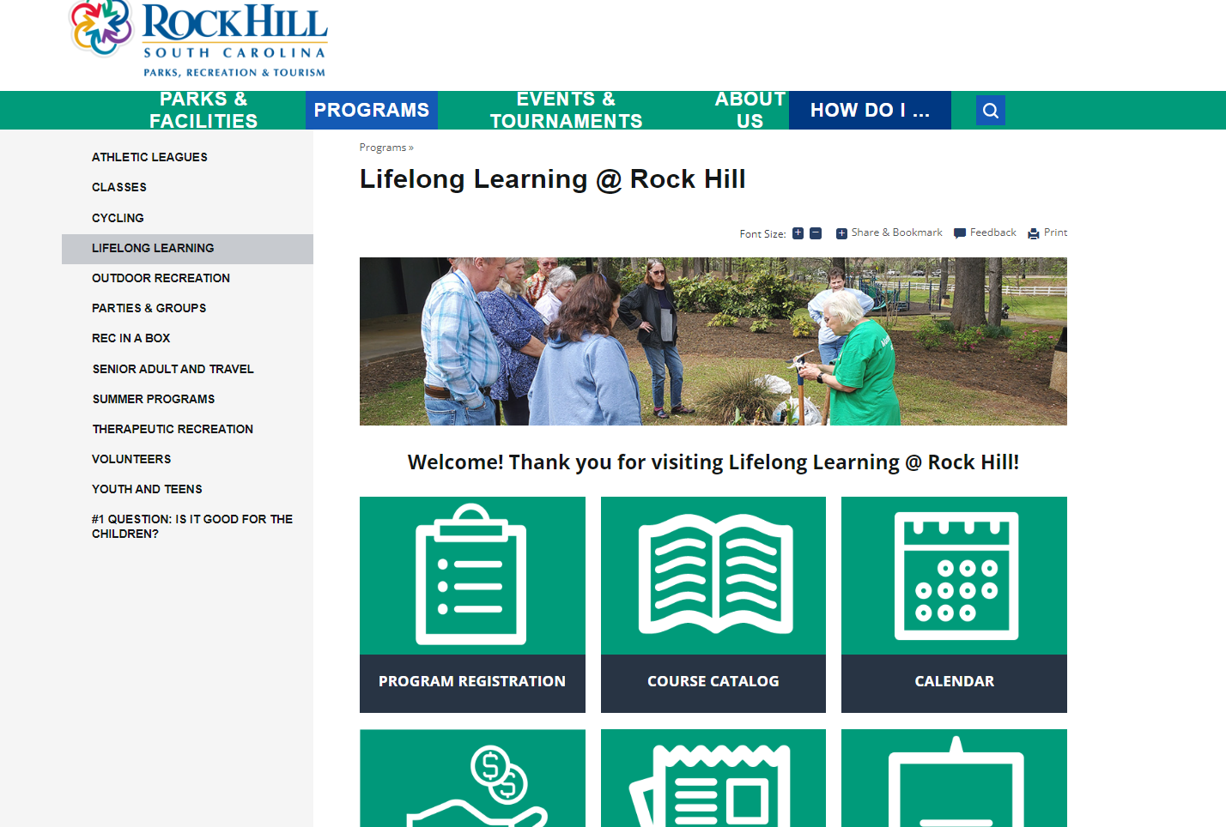

- Click the Log In/Create Account box on the top left of the screen. This will appear:
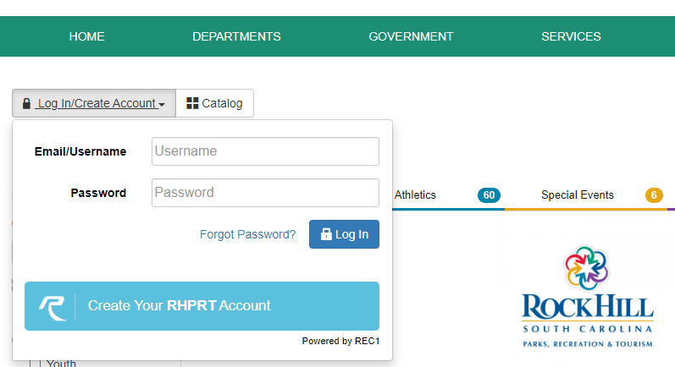
OVER
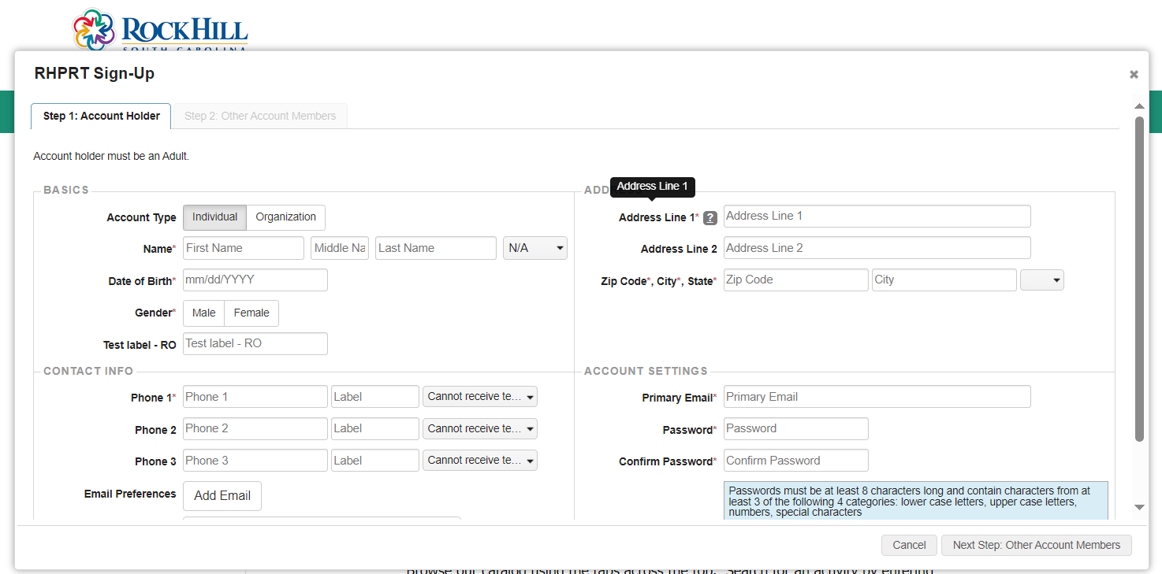
- You do not need legal names, please use your preferred name.

- Enter your Phone number. * Be sure to use a MOBILE phone number if you wish to receive TEXT updates and announcements from us. Change this box to: CAN RECEIVE TEXT MESSAGES. (unless you do not wish to receive TEXT updates from Lifelong Learning)

- Include your Address and Email. You will then choose a PASSWORD that you will use to access CivicRec in the future.

- Click on the NEXT STEP button to continue.

- The next screen will allow you to add another user (if you choose to) and then SAVE your account.

CONGRATULATIONS!!

