Summer 2021: Supporting Unfinished Learning
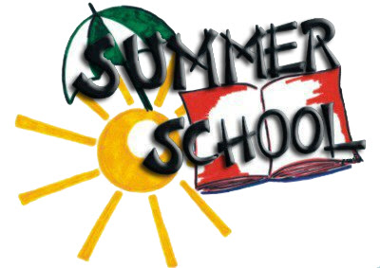
HB 5042, enacted during Oregon’s 2021 Legislative Session and signed into law by Governor Kate Brown, created the Summer Learning Program Account providing state funding to districts to support unfinished learning for grades K-12. Along with federal funds, made available through ESSER III as well as traditional title programs, districts have the opportunity to build toward a comprehensive summer programming model that extends beyond summer 2021.
To support districts in their planning, ODE has developed a new guidance document - Summer Learning Best Practice Guide 2021: Supporting Mental Health, Addressing Unfinished Learning and Providing Enrichment Opportunities - which draws upon research and best practices for how to design and implement summer learning programs and is intended to help districts as they develop a variety of summer programming. In addition, this guide recognizes the heightened need for summer learning programs to provide a strong foundation of care, connection, and healing for students and their families as our communities continue to grapple with the ongoing impacts of the COVID-19 pandemic and racial injustice.

Summer programs provide a unique opportunity to deepen learning and restore social connections that promote growth, resiliency and success for every student. Stay tuned for more information from ODE (including webinars) and consider reviewing these additional resources - Supplemental Guidance for Learning Outside and Student Learning: Unfinished, Not Lost as you plan.

