July 7, 2017 17-27

For more information: Katelyn Jackson, 503-731-8503

Katelyn.Jackson@odot.state.or.us

Weekly Construction Update:
July 8-15, 2017*
*Schedules are subject to change due to weather and site conditions.
The following highways have projects included in this week’s construction report. Scroll down to see traffic impacts in the following order (interstate, U.S., and state highways).
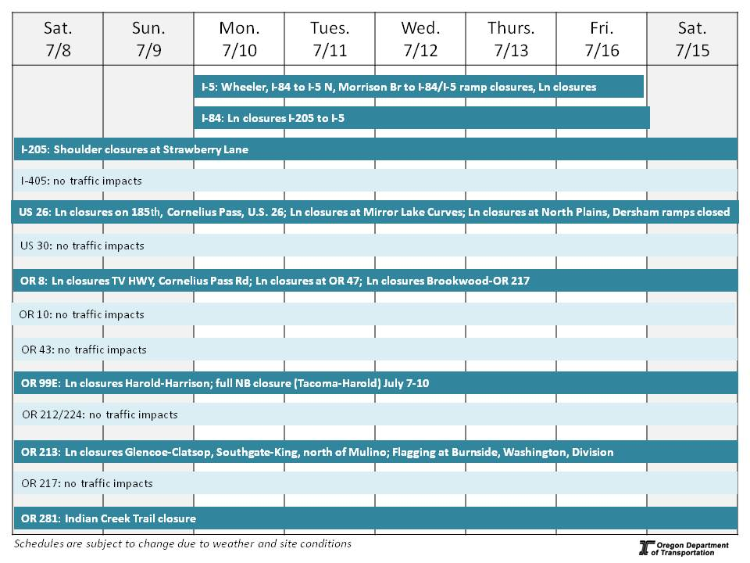

Interstate 5 – Pacific Highway – Bridge Deck Rehabilitation (17T054760)
Project description: This project will repair and resurface two ramps at the I-5 Morrison Bridge interchange and over the Rose Quarter Transit Center, as well as install median barrier on I-5 from the Rose Quarter to north of the Hawthorne Bridge. Multnomah County is working on the Morrison Bridge. For information on their work, visit multco.us/bridges/morrison-bridge-lift-span-deck.
Traffic impacts: Periodic nighttime lane and ramp closures.
Periodic closures of the Wheeler Ramp and I-84 to I-5 NB ramp Monday through Friday from 10 p.m. to 5 a.m. (until 8 a.m. Saturday) with lane closures on I-5 in both directions.
For more information: www.oregon.gov/odot/projects/pages/project-details.aspx?project=18564

Interstate 84 – Columbia River Highway – Paving Sandy River to Multnomah Falls (16T041855)
Project description: This project will pave about 14-miles of Interstate 84 from the Sandy River (just east of Troutdale) to Multnomah Falls. Bikes are advised to use the Historic Highway State Trail during construction.
Traffic impacts: No traffic impacts.

Interstate 84 – Banfield Expressway – Regional Connections Project (17T058969)
Project Description: This project is the next phase of ODOT RealTime, a system that provides real-time traffic information on roads to help travelers get where they're going more safely and efficiently. New electronic signs will be installed on U.S. 26 between I-405 and OR 217. During sign installations, there will be several full nighttime freeway closures. Work will be complete fall 2017.
Traffic Impacts: Double lane closures in both directions of I-84 (from I-5 to I-205) from 8 p.m. to 5:30 a.m. weekdays.
For more information: www.odotrealtime.org

Interstate 205 – East Portland Freeway – SE Strawberry Lane (15T078378)
Project Description: ODOT increased the overhead vertical clearance of the SE Strawberry Lane overcrossing structure from 17 feet 2 inches to 18 feet 8 inches. ODOT will also seismically retrofit the structure.
Traffic Impacts: Daytime shoulder closures from 7 a.m. to 5 p.m. in both directions.
For more information: www.oregon.gov/ODOT/HWY/REGION1/Pages/I-205-at-Strawberry-Lane.aspx

U.S. 26 – Sunset Highway – NW Glencoe Road to Mile Post 53 (17T048454)
Project description: This project will repave both directions of U.S. 26 from NW Glencoe Road to milepost 53, including some ramps and resurfacing of four highway bridges. Rumble strips and cable median barrier will also be installed.
Traffic impacts: Dersham on- and off-ramp closures Sunday and Monday nights. Nighttime lane closures Sunday through Thursday from 8 p.m. to 6 a.m.
Day shoulder closures from 7 a.m. to 5 p.m.
For more information: www.oregon.gov/odot/projects/pages/project-details.aspx?project=18777
--more--

U.S. 26 – Sunset Highway – Cornelius Pass Road to 185th Avenue (16T083291)
Project description: This project will widen U.S. 26 to three lanes in each direction between Cornelius Pass Road and NW 185th Avenue, replace the two Rock Creek bridges with one bridge, improve the north side of the Cornelius Pass Road interchange and build a sound wall on the north side of U.S. 26 westbound in the Rock Creek neighborhood.
Traffic impacts: Monday night expect rolling slowdowns with delays.
Monday through Friday, expect night lane closures in both directions of U.S. 26 (between Brookwood and Bethany).
Shoulder closures on U.S. 26 (between Cornelius Pass Road and NW 185th Avenue).
For more information: www.cornpass185.org

U.S. 26 – Sunset Highway – Regional Connections Project (16T063336)
Project Description: This project is the next phase of ODOT RealTime, a system that provides real-time traffic information on roads to help travelers get where they're going more safely and efficiently. New electronic signs will be installed on U.S. 26 between I-405 and OR 217. During sign installations, there will be several full nighttime freeway closures. Work will be complete fall 2017.
Traffic Impacts: Night lane closures on U.S. 26 in both directions beginning at 8 p.m. weekdays.
Shoulder closures on SW 185th and Cornelius Pass Road, Murray Boulevard, Scholls Ferry Road and U.S. 26 in both directions from 9 a.m. to 3 p.m. Monday to Friday.
Lane closures on Murray Boulevard (between U.S. 26 and Scholls Ferry Road).
Periodic nighttime closures of the multi-use path along the south side of U.S. 26 (between SW 79th Avenue and SW Katherine Lane) with detours. Path users should expect a section of path reduced to 6 feet.
For more information: www.odotrealtime.org

U.S. 26 – Mt. Hood Highway – east of Kiwanis Camp Road to Oregon 35 (15T023866)
Project description: Construction of safety improvements to prevent severe and fatal crashes on an eight mile stretch of U.1S. 26 (from east of Kiwanis Camp Road to east of the Mirror Lake Curves) and preserve the highway to Oregon 35 is underway on Mt. Hood.
Traffic Impacts: Periodic lane closures in both directions (Milepost 50-52 at the Mirror Lake Curves) from 10 p.m. to 5 a.m. Saturday, July 8.
For more information: www.US26MtHoodSafety.org

U.S. 26/OR 35 – Mt. Hood Highway – ODOT RealTime (17T052456)
Project description: Construction is underway on a project that will place 13 electronic message signs along U.S. 26 and OR 35. These signs are part of the ODOT RealTime system and will provide travelers with real time information so they can make safe decisions.
Traffic impacts: Periodic single lane closures from 7 a.m. to 5 p.m. with flaggers directing traffic.
Work will occur in multiple locations along U.S. 26 between Rhododendron and the Wapanitia Junction and OR 35 in Parkdale.
For more information: www.oregon.gov/odot/projects/pages/project-details.aspx?project=18219
--more--

Oregon 8 – Cornelius Pass/TV Highway Intersection Project (Private Developer) (17T007850)
Project description: As part of private development, construction is underway to extend Cornelius Pass Road south across TV Highway and the railroad tracks. Improvements on TV Highway also include adding a right turn lane on TV Highway eastbound and a left turn lane on TV Highway westbound for Cornelius Pass Road, adding new street lighting on the north side of TV Highway, and building a buffered bike lane on westbound TV Highway.
Traffic impacts: Single lane closures on westbound TV Highway (214th-Cornelius Pass) from 9 a.m. to 3 p.m.
For more information: www.corneliuspassintersection.com

Oregon Highway 8 – TV Highway – Regional Connections Project
Project Description: This project is the next phase of ODOT RealTime, a system that provides real-time traffic information on roads to help travelers get where they're going more safely and efficiently. This project is on TV Highway from Brookwood Avenue to Oregon 217.
Traffic Impacts: Lane closures from 9: 30 a.m. to 3:30 p.m. from Brookwood to OR 217.
For more information: www.odotrealtime.org

Oregon 8 – Pacific Avenue – at OR 47 (Quince Street) Improvement Project (17T040797)
Project description: The improvement project at OR 8 and OR 47 (Quince Street) in Forest Grove will build turn lanes for people driving on Quince Street and Pacific Avenue, as well as build bike lanes and make sidewalk upgrades.
Traffic impacts: Single lane closure on westbound OR 8 from 9 a.m. to 3 p.m.
Shoulder closures on southbound Quince Street. Speed lowered to 30 mph in the construction zone.
For more information: www.oregon.gov/odot/projects/pages/project-details.aspx?project=18003

Oregon 99E – McLoughlin Boulevard – Harold to Harrison Paving (17T039034)
Project description: This project will pave OR 99E in both directions between Harold Street in Portland to Harrison Street in Milwaukie. Also included in the project is replacing the Crystal Springs Bridge with a box culvert and reconstructing parts of the highway. Four weekend closures of OR 99E northbound from Tacoma Street to Harold Street will take place in the summer. Work will be complete by the end of the year.
Traffic impacts: Full closure of northbound OR 99E (Tacoma-Harold) from 10 p.m. Friday, July 7 until 5 a.m. Mon. July 10. Southbound open.
Nighttime southbound single lane closures between Tacoma and Harrison from 7 p.m. to 5 a.m. Wednesday and Thursday.
Beginning 10 p.m. Friday, July 14 until 5 a.m. Monday, July 17, please be aware and look for traffic changes. One lane will be open in both directions.
Right turns from SE Tolman Street and/or SE Bybee Street onto OR 99E southbound may be periodically restricted.
For more information: www.oregon.gov/odot/projects/pages/project-details.aspx?project=18776
--more--

Oregon 213 – SE 82nd Avenue – SE King Road to Mt. Scott Creek Bridge Projects (17T036796)
Project description: This project is the second phase of a three-year project to install new sidewalk curb ramps at the corner of major intersections. In fall 2017, the final phase will pave and add new sidewalk curb ramps between SE Lindy Street and SE King Road.
Traffic impacts: Periodic lane closures in both directions (between SE Southgate Street and King Road) from 6 a.m. to 3 p.m. weekdays.
For more information: http://lmsc.82ndaveprojects.com or 24-hour noise hotline 503-412-2374.

Oregon 213 – SE 82nd Avenue – Intersection Improvement Projects (16T006859)
Project description: This project will improve safety and increase traffic flow on SE 82nd Avenue (OR 213) at six intersections (E Burnside, SE Stark, SE Washington, SE Yamhill, SE Mill and SE Division streets) by upgrading the sidewalk ramps, traffic signals, and adding lighting. Additionally, three enhanced crossing will be added for pedestrians at SE Ash Street, Salmon Street, and just north of SE Division Street at Portland Community College.
Traffic impacts: Burnside, Washington and Division Street intersections will be directed by flaggers from 7 p.m. Sunday until 6 a.m. Monday. Expect delays.
For more information: www.82ndAvenueIntersectionImprovements.org or 24-hour noise hotline 503-412-2348
Oregon 213 – SE 82nd Avenue – Waterline Abandonment Project (Clackamas River Water) (17T030825)
Project description: Clackamas River Water will remove older, undersized waterlines and improve system hydraulics in advance of an ODOT paving project.
Traffic impacts: Lane closures in both directions weekdays from 9 a.m. to 3 p.m. and from 9 p.m. to 5 a.m. between SE Glencoe Road and SE Clatsop Street.
Periodic side street closures with detours.
For more information: www.crwater.com/wp-content/uploads/82nd-Ave-Waterline-Abandonment-project_fact-sheet.pdf
Oregon 213 – Cascade Highway South – Embankment work (17T030796)
Project description: Crews are conducting investigative work on the hillside along OR 213 just north of South Freeman Road near Mulino.
Traffic impacts: Please be aware and look for traffic changes. One lane of OR 213 will be open in both directions.
Speed lowered to 45 mph between Union Hall Road and Mulino Road.

Oregon 281 – 12th Street – Indian Creek Culvert Repair (17T058968)
Project description: This project will repair the culvert that carries Indian Creek under 12th Street.
Traffic impacts: Indian Creek trail closures with detours.
For more information: www.oregon.gov/odot/projects/pages/project-details.aspx?project=19401
--more--

Tips for driving safely in work zones
An inattentive driver is the most common cause of work zone crashes. Drivers and their passengers — not workers — make up the majority of work zone fatalities.
What you can do:
- SLOW DOWN!
- Pay attention
- Obey signs and flaggers
Know before you go! Call 511 or visit www.TripCheck.com to check routes, work zones and road and weather conditions before you head out.​

##ODOT##

