Marie Dodds
Director of Government and Public Affairs
AAA Oregon/Idaho
600 SW Market St., Portland, OR 97201
Direct: 503.222.6729
May 4, 2016
AAA to Drivers: Ditch the Distractions and Slow Down
May is National Work Zone Awareness Month

PORTLAND, Ore., – May is National Work Zone Awareness Month and Oregon’s Transportation Safety Awareness Month. AAA urges drivers to slow down, ditch the distractions, and focus on driving when they’re behind the wheel to help keep highway workers safe. AAA also wants to remind drivers that hands-free is not risk-free. Research done by the AAA Foundation for Traffic Safety shows that using voice-activated infotainment systems or smart phones while driving can cause unsafe mental distractions, even when a driver’s eyes are on the road and hands are on the wheel.

AAA is also on the front lines when it comes to highway safety. Every week, AAA’s technicians rescue thousands of stranded drivers on the roadside. “Sometimes our techs come into harm’s way due to inattentive or speeding drivers,” says Marie Dodds, Director of Public Affairs for AAA Oregon/Idaho. “We’ve had many close calls over the years, and some of our technicians have been hit. We ask all drivers to slow down and pay attention so that all highway workers can get home safely at the end of each day.”

Drivers admit to Distracted Driving
A recent study by the AAA Foundation for Traffic Safety shows that about 87 percent of drivers engaged in at least one risky behavior in the past month. These unsafe behaviors include driving while distracted, impaired driving, drowsy driving, speeding, running red lights or not wearing a seat belt. These disturbing results come as nearly 33,000 Americans died in car crashes in 2014, and preliminary estimates project a nine percent increase in deaths for 2015.

- More than 2 in 3 drivers (70 percent) report talking on a cell phone while driving within the past 30 days. Nearly 1 in 3 drivers (31 percent) report doing this fairly often or regularly.
- More than 2 in 5 drivers (42 percent) admit to reading a text message or email while driving in the past 30 days, while 12 percent report doing this fairly often or regularly. Nearly 1 in 3 drivers (32 percent) admit to typing or sending a text or email over the past month, while eight percent say they do so fairly often or regularly.
- More than 80 percent of drivers view distracted driving as a bigger problem than three years ago.
- Previous research by NHTSA estimates that distracted driving is a factor in at least 3,000 deaths per year, though the actual number is likely much higher. Drivers who take their eyes off the road for more than two seconds can double their risk of being in a crash.

“As in previous years, the 2015 AAA Foundation study shows that most drivers have a ‘do as I say, not as I do’ attitude as they admit to doing many risky behaviors that they criticize in others, says Marie Dodds, Public Affairs Director for AAA Oregon/Idaho.

The new survey results are part of the AAA Foundation’s annual Traffic Safety Culture Index, which identifies attitudes and behaviors related to driver safety.
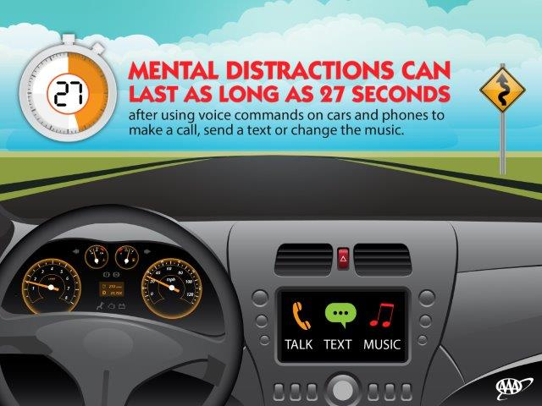
Hands-free is not risk-free
The AAA Foundation for Traffic Safety has also conducted groundbreaking research into cognitive distractions while driving. The results show that hands-free technologies can mentally distract drivers if their eyes are on the road and their hands are on the wheel. The results raise new and unexpected concerns regarding the use of phones and vehicle information systems while driving.

Using hands-free technology while driving can create lasting a mental distraction of up to 27 seconds after a driver dials, changes music or sends a text using voice commands on a voice-activated system. In this time, drivers can miss stop signs, pedestrians, bicyclists and other vehicles while the mind is readjusting to the task of driving. That’s enough time for the driver to travel nearly the length of three football fields when moving at just 25 mph.

“AAA urges drivers to avoid interacting with your hands-free phone or infotainment system when you’re stopped at a red light or there’s a lull in traffic. The mental distractions can persist and impact your ability to drive safely, even after you stop interacting with the system when the traffic starts moving again,” says Dodds.

This research represents the third phase of the AAA Foundation’s comprehensive investigation into cognitive distraction. Click here for the complete Phase III reports, photos and graphics. Select b-roll video of the research is available to download and for news media purposes. The previous findings from Phase I and Phase II of the Foundation’s research into cognitive distraction also are available.

Established by AAA in 1947, the AAA Foundation for Traffic Safety is a 501(c)(3) not-for-profit, publicly-supported charitable educational and research organization. Dedicated to saving lives and reducing injuries on our roads, the Foundation’s mission is to prevent crashes and save lives through research and education about traffic safety. The Foundation has funded over 200 research projects designed to discover the causes of traffic crashes, prevent them and minimize injuries when they do occur. Visit www.AAAFoundation.org for more information on this and other research.

AAA news releases, high resolution images, broadcast-quality video, fact sheets and podcasts are available on the AAA NewsRoom at NewsRoom.AAA.com.

Visit www.AAA.com. Founded in 1905, AAA Oregon/Idaho provides more than 775,000 members with travel, insurance, financial and automotive-related services, and is an affiliate of AAA National, serving more than 55 million motorists in North America.

