EDPlan Help Desk

Introduction
PCG will be releasing an update to the Oklahoma EDPlan message board on November 1, 2021. The new messaging functionality will remain secure and allow you to directly contact our help desk. Enhancements consist of:
- The ability to easily provide details of your inquiry, including the capability to attach files
- The ability to easily search your past messages and filter by status
- The ability to add information to a previously sent message

Message EDPlan Help Desk
- To message us from within EDPlan, click the Envelope icon ( ) on the top-right hand corner of your screen. The window pop-up allows for you to send new messages or view replies from our help desk. Click on the Send Message button to send a new message.

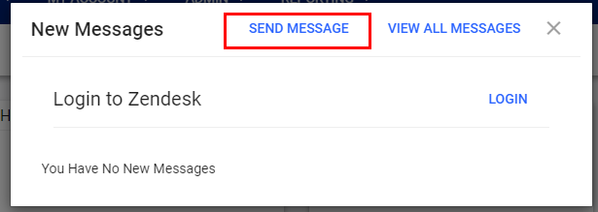

- Detail your inquiry from the new pop-up window located on the bottom right-hand of your screen. Include the following required fields: Subject, Description, and Topic/Area. Page Title and Student field are optional. Additionally, you may attach up to five files for our review (e.g. screenshots, reports, etc.). Select the Send button to submit your message.
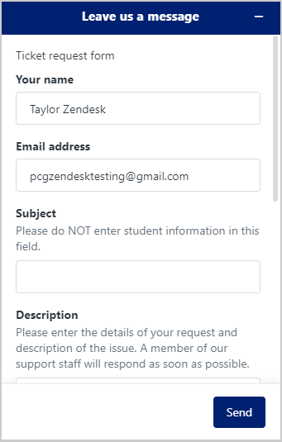
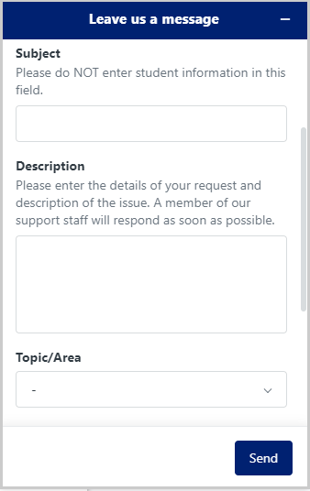
- * Upon submission of your ticket, you will receive a confirmation e-mail. Once PCG responds to your ticket, you will receive an email notification informing you of our reply. PCG’s Help Desk will respond within 24-hours during business hours.
Access Your Support Tickets
- To review your support tickets, click the Envelope icon ( ) on the top-right hand corner of your screen. From the window pop-up select the “Login” button. This will take you to your support dashboard within the EDPlan Help Desk (note: the EDPlan Help Desk dashboard will open in a new browser tab).
  - Selecting the ‘View All Messages’ option will show you all messages submitted prior to this update as well as allow you to log into your support dashboard.
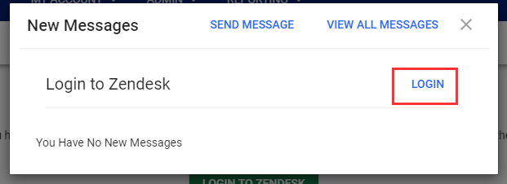

- In the EDPlan Help Desk window, you may review the response from your most recent ticket as well as your past inquiries in the My requests tab. To access a ticket, select the subject name. Replies can be added from within the open ticket. The open status will turn to “awaiting your reply” if the support team needs additional information from you before moving forward with the ticket.

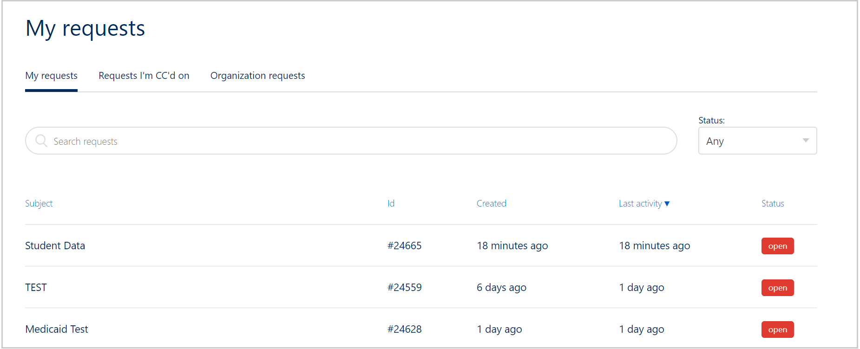

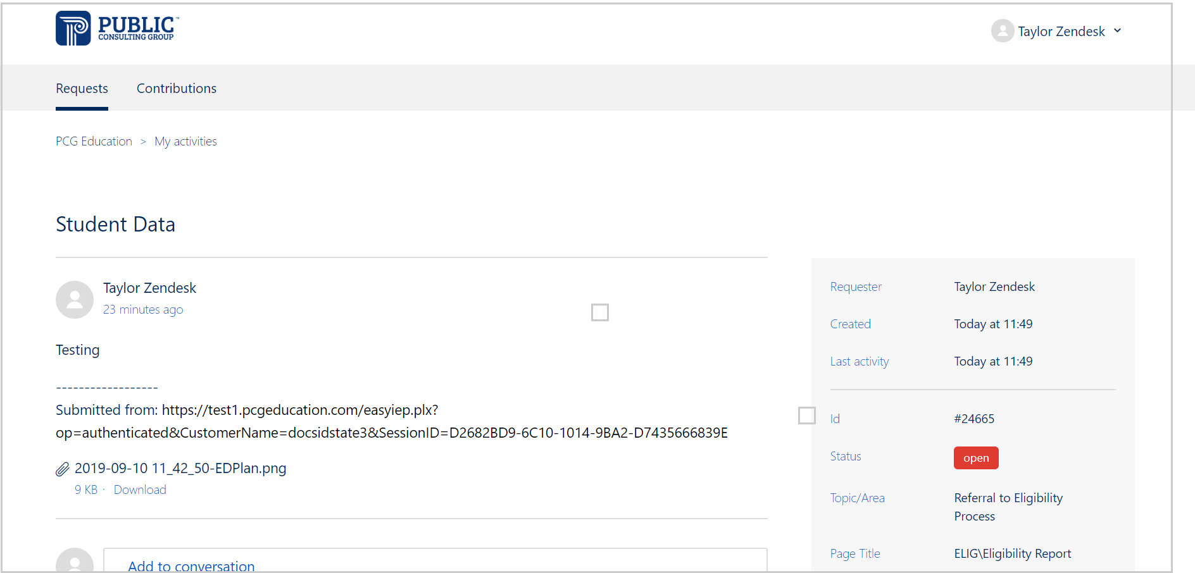

  - Once a ticket has been solved, you will receive a notification in your email. Users will have 48 hours to respond or ask any additional questions before the ticket closes.

- You may follow-up on a previous ticket that is solved and closed. This is helpful for when a past situation has recurred. Select the “Create a follow-up” hyperlink at the bottom of the original ticket. You may now provide additional details for your follow-up in the new form.

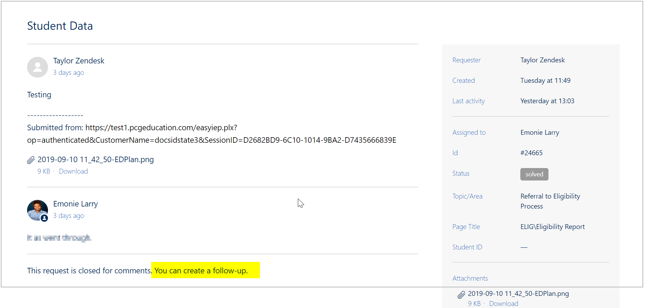

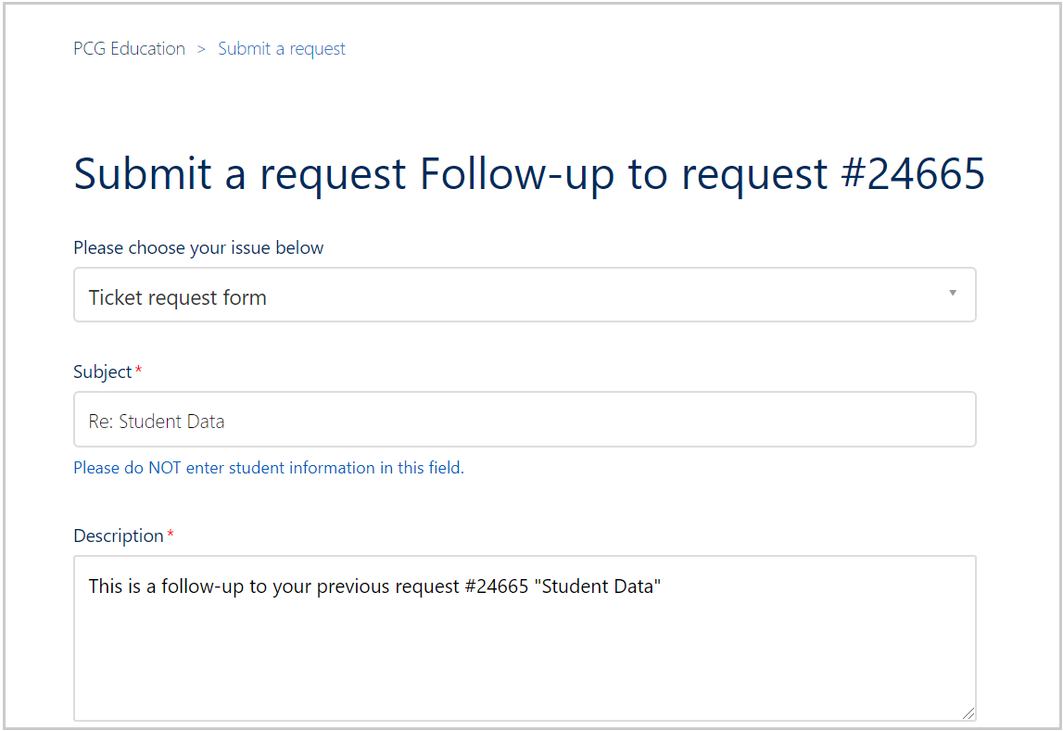

  - * Once submitted, you will receive an email notification informing you of our reply. EDPlan’s Help Desk will respond within 24-hours during business hours.

