Guide to Scoring and Reporting
for Data Managers
Year-End Model 2020-2021
The Dynamic Learning Maps® (DLM®) alternate assessment is for students with the most significant cognitive disabilities. Students show their performance on content standards called Essential Elements in English language arts, mathematics, and science (in states that administer DLM science assessments). This guide explains the Individual Student Score Reports and aggregate results provided by the DLM Consortium. This guide is designed for local administrators, such as superintendents, district test coordinators, and other district staff.
For questions about school and state accountability, please contact your district or state department of education.

Reports Provided by the Dynamic Learning Maps Consortium
Each Individual Student Score Report includes a Performance Profile and a Learning Profile. Also, several aggregate reports are available, including Class, School, District, and State Results.

How Results Are Calculated
DLM results are not based on raw or scale scores; all results are calculated using an approach called diagnostic classification modeling. This approach determines whether the student showed mastery of specific skills. Based on evidence from the DLM assessments, the student either mastered or did not master each skill. For each Essential Element tested, a student may master up to five skills in English language arts and mathematics or up to three skills in science at different levels, called linkage levels. The student’s overall performance in the subject is based upon the number of linkage levels mastered across the tested Essential Elements. This performance is reported using the four achievement levels chosen by the consortium:
- The student demonstrates emerging understanding of and ability to apply content knowledge and skills represented by the Essential Elements.
- The student’s understanding of and ability to apply targeted content knowledge and skills represented by the Essential Elements is approaching the target.
- The student’s understanding of and ability to apply content knowledge and skills represented by the Essential Elements is at target.
- The student demonstrates advanced understanding of and ability to apply targeted content knowledge and skills represented by the Essential Elements.
Each state determines how the DLM performance levels translate into its own definitions of proficiency for accountability purposes.

Individual Student Score Reports
Individual Student Score Reports have two parts: (1) the Learning Profile, which reports specific skills mastered for each Essential Element, and (2) the Performance Profile, which summarizes skill mastery for related content (e.g., conceptual area/domain) and for the subject overall. Each student has one score report per subject.

Learning Profile
The Learning Profile shows one row for each Essential Element in that subject. For every Essential Element, there are skills at five linkage levels in English language arts and mathematics: Initial Precursor, Distal Precursor, Proximal Precursor, Target, and Successor. For every Essential Element, there are skills at three linkage levels in science: Initial, Precursor and Target. These levels are shown in columns on the Learning Profile. The Target level represents the grade-level expectation for students with the most significant cognitive disabilities.
Each student is assessed on one or more linkage levels for Essential Elements on the blueprint. Students are typically not assessed at every linkage level and may not be assessed on every Essential Element.
On the Learning Profile below, green (or medium gray in grayscale) shading shows skills that were mastered, and blue (or dark gray in grayscale) shows Essential Elements in which no skills were mastered. Light gray shading shows skills that were not tested.
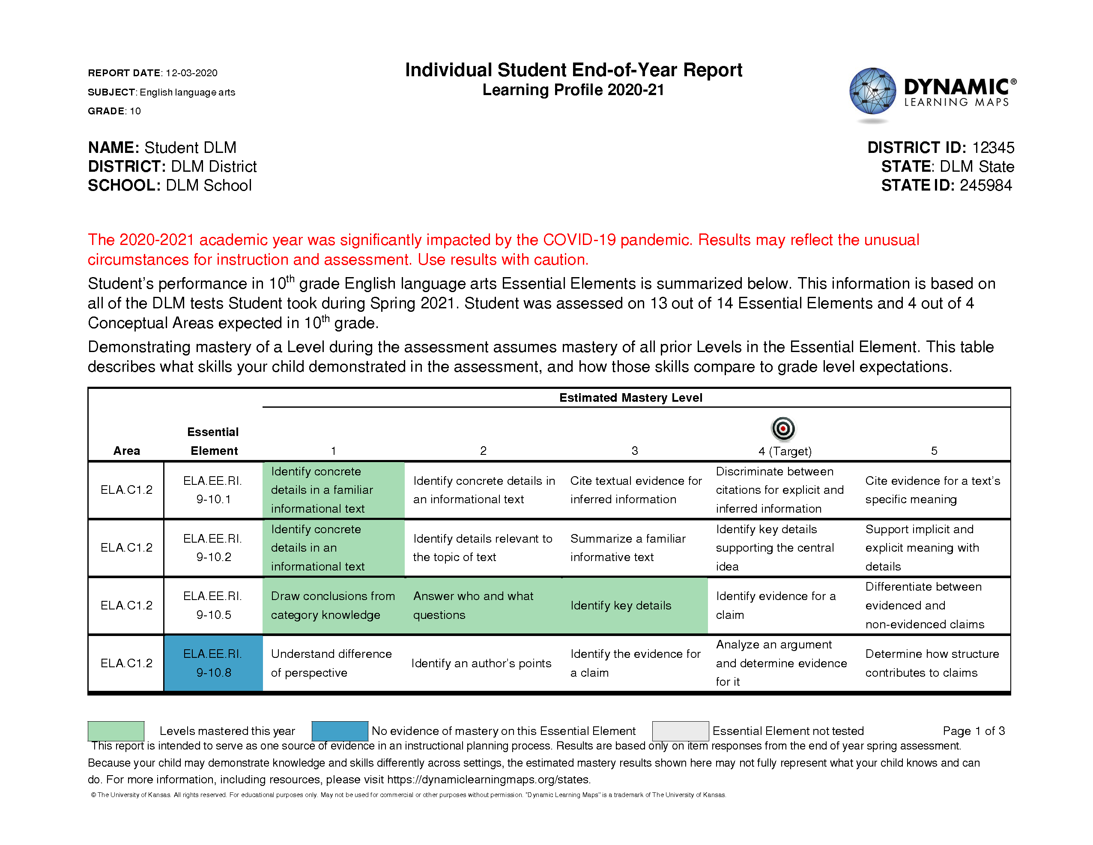

Performance Profile
The Performance Profile provides a report of the student’s overall performance in a subject. The total number of skills that must be mastered to reach a certain performance level was determined at the consortium level by a group of educators from the consortium states, including content experts and experts in teaching students with the most significant cognitive disabilities. There is no exact correspondence between mastering a particular linkage level on a specific Essential Element and an overall performance level in the subject.
The bar graphs on the Performance Profile below demonstrate the student’s mastery of skills for groups of related Essential Elements (e.g., conceptual areas).
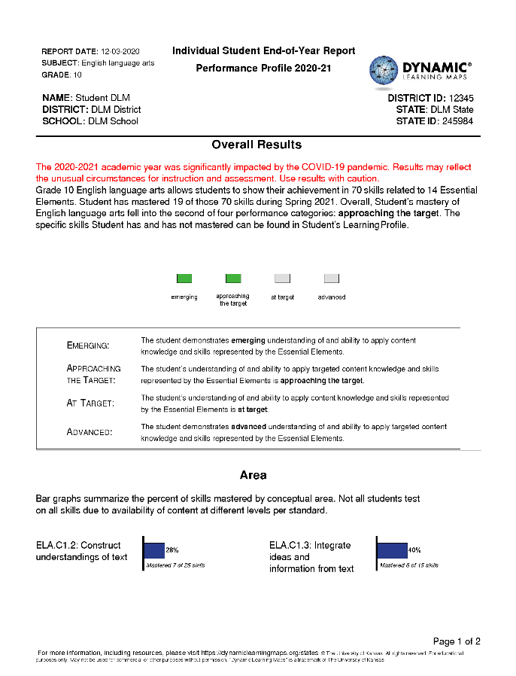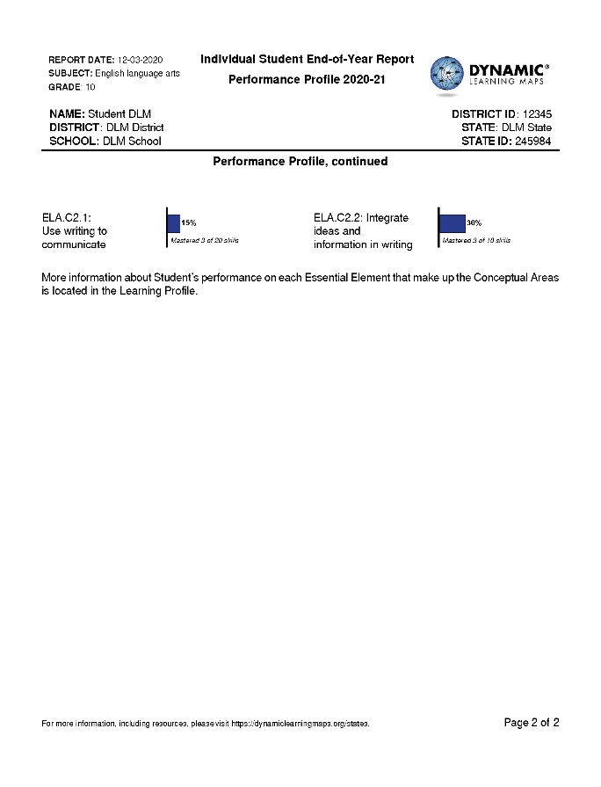

Hints for Interpreting the Learning and Performance Profiles
- Remember that the judgment of skill mastery is based on what the student demonstrated on the DLM assessments. A student may have demonstrated a similar skill during instruction but not demonstrated the skill during a DLM assessment.
- The assessment measures where students are with regard to the grade-level target. Not all students will perform at the Target level, and that is to be expected.
- The number of skills mastered does not mean that a student answered a certain percent of items correctly.
- The amount of white space on the Learning Profile does not necessarily reflect a lack of instruction. The DLM assessment is designed so students may be instructed at a linkage level that is an appropriate level of challenge for them.
- Students with the most significant cognitive disabilities have a variety of educational goals. Academics are one part of their educational program. Teachers provide instruction beyond what is reflected in the student’s Learning Profile, including other academics, functional skills, and other priorities identified in the Individualized Education Program (IEP).
- Reports include only valid student records as determined by state-level review of results. If a student record was invalidated during the state’s two-week review window, the student will not have an Individual Student Score Report.

You may use these results to support teachers by
- helping them consider how the results can be used for planning in the subsequent year and the limitations of the data
- identifying areas of academic skills where instruction may be focused
- reflecting on how a student's overall performance informs the IEP

Class and School Level Results
The Class Results report provides a summary of results for all student who were rostered to the teacher. The report lists individual students, the number of Essential Elements tested, number of skills mastered, and their final achievement level.
Each school receives Class Results reports for every teacher with students enrolled in the DLM alternate assessment. The students are arranged alphabetically by grade level. All subjects are included on the report.
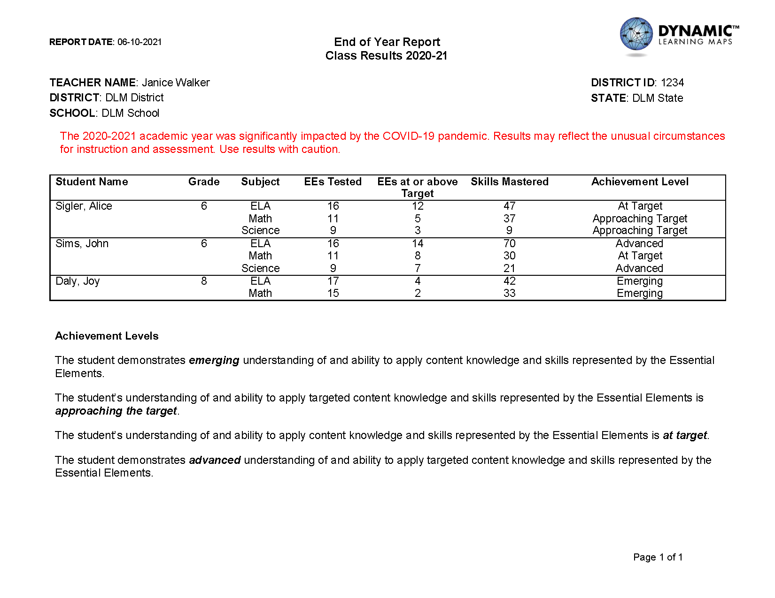

The School Results report contains the same information as the Class Results report along with the teacher for each student added in an additional column. Records for the entire school are organized by grade and then by teacher and student in alphabetical order.

Hints for Interpreting the Class and School Results
- Students appear in the School Results based on the roster and school where they were assessed. This may not be the same school where they are counted for accountability purposes.
- If a student was enrolled in DLM assessments but did not complete a single item in any testlet in any subject of the assessment, the student is included, but with dashes in place of results.
- Reports include only valid student records as determined by state-level review of results. If a student record was invalidated during the state’s two-week review window, the student is not included in these results.
- Remember that total skills mastered is based on what the student demonstrated on the DLM assessments. A student may have demonstrated similar skills during instruction but not demonstrated the skill during a DLM assessment.
- The assessment measures where students are with regard to the grade-level target. Not all students perform at the at target level, and that is to be expected.
- These results provide a summary of overall performance in the grade/subject at the class and school level. More useful information for instructional planning is located in each student’s Individual Student Score Report.

District- and State-Level Results
The District Results report provides one table of results. Each row shows the number of students assessed at that grade and subject and the number of students who achieved at each performance level. The last column indicates the percent of students at the at target or advanced levels.
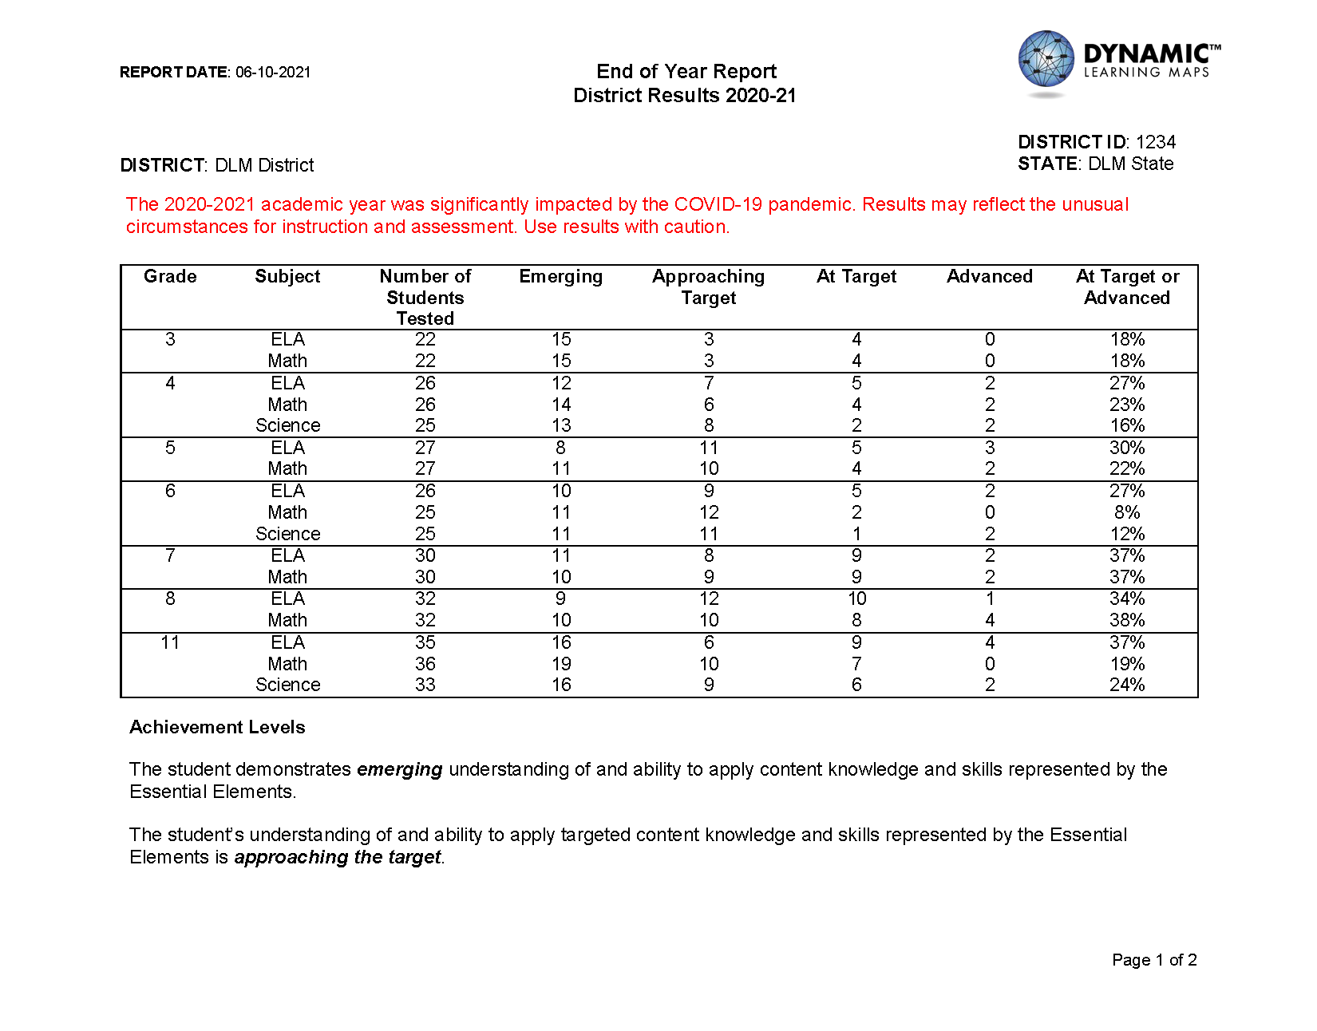

The State Results report has the same formatting and provides the same type of information for all student records in the state.

Hints for Interpreting Final District and State Results
- Student results are reported for the district where they were assessed. This may not be the same district where they are counted for accountability purposes.
- If a student was enrolled in DLM assessments but did not complete any items in any testlet in any subject, the student is not included in these results.
- Reports include only valid student records as determined by state-level review of results.
- These reports provide a high-level summary of all students at the district or state level. More useful information for instructional planning is located in each student’s Individual Student Score Report.
- The assessment measures where students are with regard to the grade-level target. Not all students perform at the at target level, and that is to be expected.

How Reports Are Distributed
Individual Student Score Reports are generated as separate PDF files. There is one PDF per student per subject. Individual Student Score Reports are packaged for delivery in individual PDF files, organized by district name, school name, and grade. These reports are also generated as a bundle of PDF files at the district level.
Aggregate reports at the Class, School, District, and State level are also generated as PDF files and delivered in Educator Portal. All subject areas are included in each report.

